We’re Learning About Blends

Learning about blends helps us to spell words correctly and increases our vocabulary.

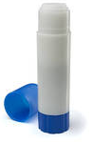
Words that begin with
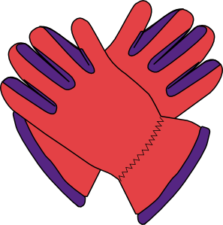gl

What words have a ‘gl’ blend?
Would a dictionary help?

What words have a ‘gl’ blend?

glad | glitter | glow
glide | glass | glove
glue

Word Search for ‘gl’ Blend Words
Y H F G C C E Y G E K O X G Z  Z H S S L D T N S Z J P L V X  C C J H I O Z F X H J O H J Z  L W H L R M V M S M W E S E U  I B G Y E G T E Q X I U W G O  U N W G T G I Y W B M A Z A X  Y B O D T H J W W D T Z V V J  N M G D I V F K R K E S N W V  E U L G L Q E Y X R N V R P M  Z J A B G K I E H C M C V A J  D B D K Z A L H O W H B X D P  T Y A N M K W P Z E X L O L M  V E H B X X P W M N B R V M N  T R X N E J C F I G L A S S I  E K S S X V V K W U O I W A T | GLAD  GLITTER  GLOW  GLIDE  GLASS  GLOVE  GLUE

Make a Flip Book

gl

Words you can do  (Verbs) | Words that are something  (Nouns)
Words that describe something  (Adjectives) | Not sure

My glider glitters
and glows in the dark.
It flies like an eagle
and makes the dogs bark.

