We’re Learning About Blends

Learning about blends helps us to spell words correctly and increases our vocabulary.

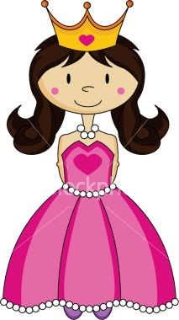
Words that begin with
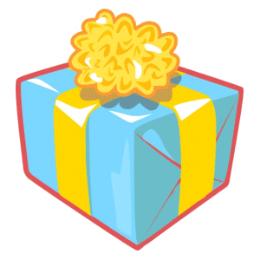pr

What words have a ‘pr’ blend?
Would a dictionary help?

What words have a ‘pr’ blend?

present | prepare | press
price | print | pretty
proud | promise | protect

Word Search for ‘pr’ Blend Words
W N V Q N Y T M R E Y P Q N Q  D U O R P A W M Y S T R B M U  W R Q R J G L W N I O I J U V  M L I F R B P I V M K C O U Z  P N F M Y P R J A O P E G K A  T M Y J E C R T P R E T T Y N  L L R W M R C E H P J F J C N  D P O X Y E A R S F T M H Z Z  L S B V T S M P A S N H E A H  W T M O L R W D E N U W M W B  N G R L V A V S B R J Z A D N  P P F Q T N E S E R P T S U P  E T X T P E X G P Z E O V B T  O R E W B Y Q G F A Y T P H Y  M I O A W J X Q F G X Z H X U | PRESENT  PREPARE  PRESS  PRICE  PRINT  PRETTY  PROUD  PROMISE  PROTECT

Make a Flip Book

pr

Words you can do  (Verbs) | Words that are something  (Nouns)
Words that describe something  (Adjectives) | Not sure

Abracadabra... Hey presto,
first prize!
A wonderful present.
Oh what a surprise!
And now for a princess...
Please open your eyes.

