We’re Learning About Blends

Learning about blends helps us to spell words correctly and increases our vocabulary.

Words that begin with
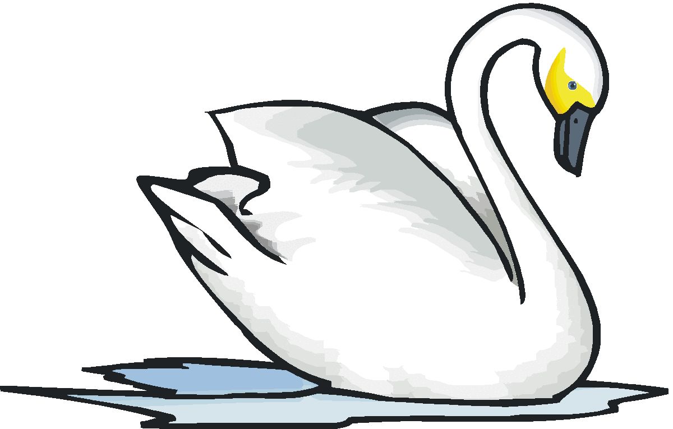
sw

What words have a ‘sw’ blend?
Would a dictionary help?

What words have a ‘sw’ blend?

swan | sweet | sweater
swell | swing | swim
sweep

Word Search for ‘sw’ Blend Words
Q P Q W S G D S B M X Z M X C  J L N W P Z U M W E E T D T Z  Y B E N A W S T Y E E C R N S  U E U O M R D L Y U L G S E V  P G R K S I R D T G B L W P F  Q Z T B N E W K N T O E I Y Q  W Q N L T G K S Y I H I N C Y  D X I A W F P P C K T P G E E  M J E E L C R D D L K R L V I  Y W D Y X P Y D S N R X R B D  S T X F J D Q Q M T I D F Z J  E G V J V I S P Y Z X T N I Z  R J Z P B X T M E K V S I K U  I E E T W M U O P A F L S U S  T V P I E S M B A M S W E E T | SWAN  SWEET  SWEATER  SWELL  SWING  SWIM  SWEEP

Make a Flip Book

sw

Words you can do  (Verbs) | Words that are something  (Nouns)
Words that describe something  (Adjectives) | Not sure

Acrobats swing
on the flying trapeze
and swirl through the air
with the greatest of ease.
Swishhhh...

