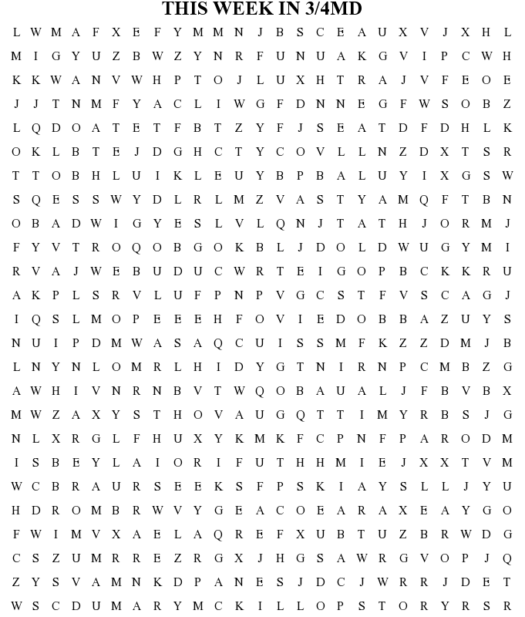

ANZAC  PRAYER  MDS GOT TALENT  RAIN  MORE RAIN  LOTS OF RAIN  REALLY A LOT OF RAIN | DATA  COLLECTION  REPRESENTATION  GRAPH  FUN MATHS  DICE SNATCH  BEST MATHS EVER | ELBOWS  MARY MCKILLOP STORY  MRS FARRAR  BULLY NO MORE  WHAT DID YOU LEARN THIS WEEK

