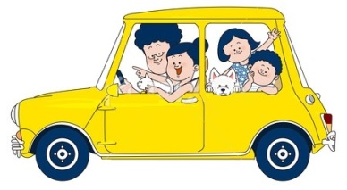
their
shows ownership
‘See their new car.’

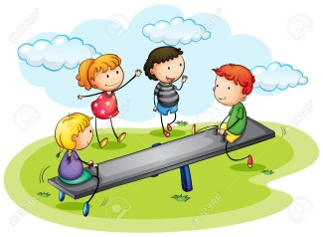
they’re
short for they are
‘They’re going to the park.’

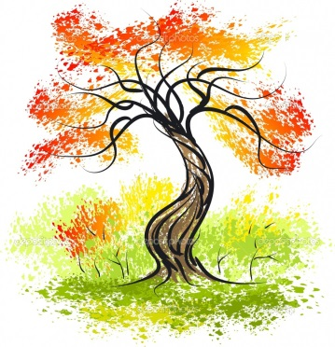
there
a place
‘The tree is over there.’

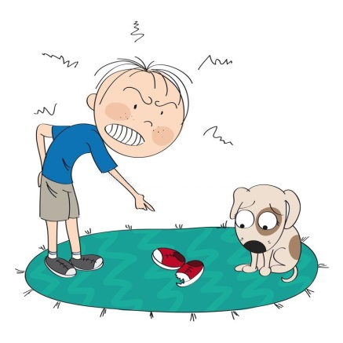
whose
which person
‘Whose shoe is that?’

who’s
short for who is
‘Who’s coming to
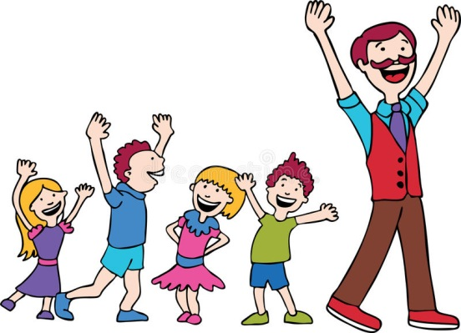
the beach?’

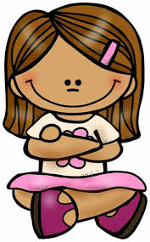
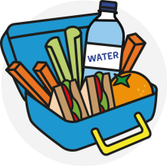
your
belonging to you
‘Get your lunchbox out.’

you’re
short for you are
‘Tell me if you’re going
to the show.’
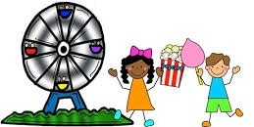

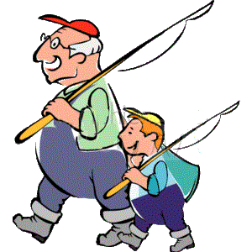
where
a place
‘Where will we go fishing?’

we’re
short for we are
‘I think we’re ready to go.’
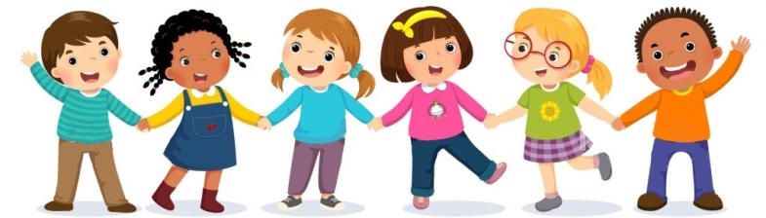
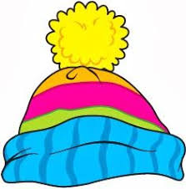
wear
to put on clothes
‘Wear your warmest hat.’

which
what one?
‘Which colour do
you like best?’
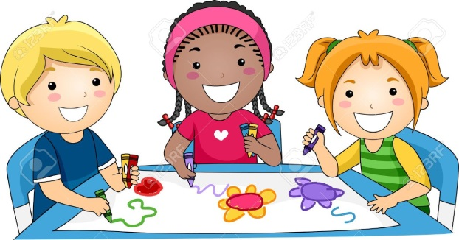
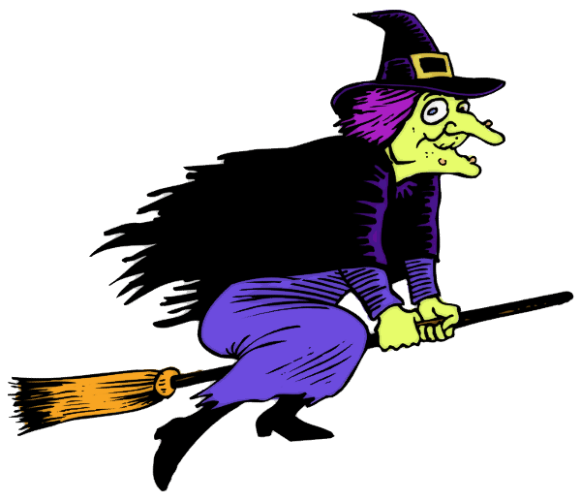
witch
female character
with magical powers
‘The witch waved
her wand.’

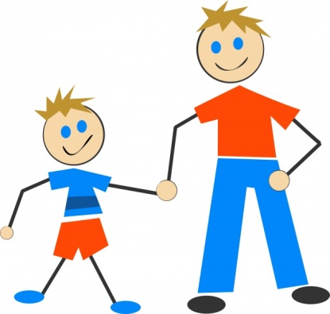
to
a preposition
‘We went to the footy.’
too
as well as, lots of
‘The birds were too noisy.’
‘I thought that too.’

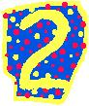
two
a number
‘We have two turns each.’

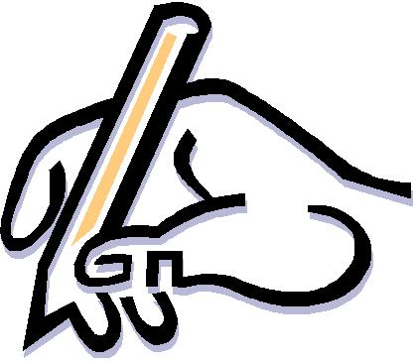
write
create text
‘He will write a funny story’

right
correct, this side >>>>>>
‘Is the answer right?’
‘Turn right at the corner.’
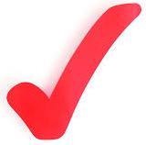

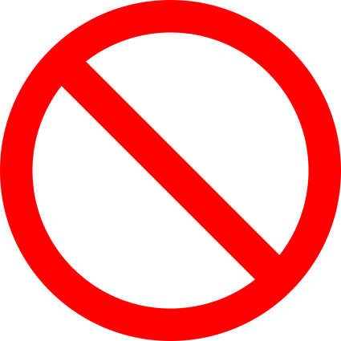
no
not at all, not any, a negative
‘Mum said no when I asked. ’

know
knowledge you have
‘Do you know the time?’

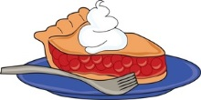
piece
a part of something
‘Gran had a piece of pie.’
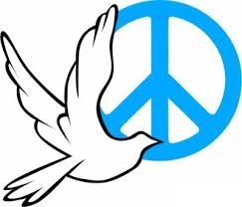
peace
freedom from stress or
worry or war, tranquillity
‘He found peace and quiet in the garden, away from the noise.’

be
a
‘Where?’

bee
short
‘Tell
.’

threw
what
‘Which
?’

through
female

‘The.’

hole
what
‘Which
?’

whole
female

‘The.’

see
what
‘Which
?’

sea
female

‘The.’

I
what
‘Which
?’

eye
female

‘The.’

new
what
‘Which
?’

knew
female

‘The.’

for
what
‘Which
?’

four
female

‘The.’

