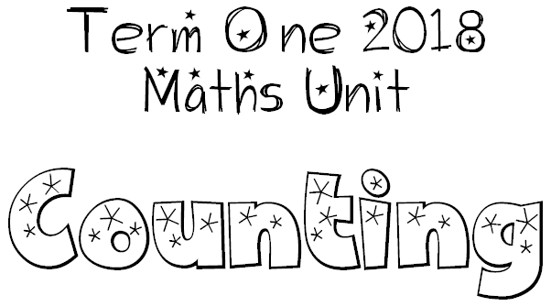
We are learning to recognize a quantity immediately (subitizing).
I will be successful if…
I am able to quickly identify the number of a set (like on dice).
I am able to add sets of numbers together quickly.
I am able to use ‘friends of’ numbers to get results quickly.

We are learning the laws of odd and even numbers to make problems easier.
I will be successful if…
I am able to quickly identify odd and even numbers.
I am able to investigate odd and even numbers and learn how they work when added or subtracted.

We are learning to skip count forwards and backwards.
I will be successful if…
I am able to skip count forwards and backwards from different starting points.

We are learning to create patterns that increase or decrease in a consistent manner.
I will be successful if…
I am able to create and continue patterns.
My patterns can go forwards and backwards.
My patterns begin at different starting points.

We are learning that the value on each side of the equals sign is the same.
I will be successful if…
I am able to complete 20 Sum Challenges.
I am able to solve and create all sorts of equations.
I am able to use equations to solve word problems.

