MATHEMATICS UNIT PLANNER
Level: Gr 3/4 Term: 1 2018 Weeks: 2-4/5
Teachers: Sinead, Fran and Marg
Dimension: Number and Algebra
Specific Focus for Unit: Counting
Victorian Curriculum Content Descriptions  http://victoriancurriculum.vcaa.vic.edu.au/mathematics/introduction/rationale-and-aims | Key Concepts  https://drive.google.com/file/d/0B3ydL4IWBSAbbk5laWtLOEprYXc/edit
Gr 2:  Investigate number sequences, initially those increasing and decreasing by twos, threes, fives and ten from any starting point, then moving to other sequences (VCMNA103)  Recognise, model, represent and order numbers to at least 1000 (VCMNA104)  Group, partition and rearrange collections up to 1000 in hundreds, tens and ones to facilitate more efficient counting (VCMNA105)  Describe patterns with numbers and identify missing elements (VCMNA112)  Gr 3:  Investigate the conditions required for a number to be odd or even and identify odd and even numbers (VCMNA129)  Recognise, model, represent and order numbers to at least 10 000 (VCMNA130)  Apply place value to partition, rearrange and regroup numbers to at least 10 000 to assist calculations and solve problems (VCMNA131)  Use a function machine and the inverse machine as a model to apply mathematical rules to numbers or shapes (VCMNA139)  Gr 4:  Investigate and use the properties of odd and even numbers (VCMNA151)  Recognise, represent and order numbers to at least tens of thousands (VCMNA152)  Apply place value to partition, rearrange and regroup numbers to at least tens of thousands to assist calculations and solve problems (VCMNA153)  Investigate number sequences involving multiples of 3, 4, 6, 7, 8, and 9 (VCMNA154)  Gr 5:  Use estimation and rounding to check the reasonableness of answers to calculations(VCMNA182)  Recognise, represent and order numbers to at least hundreds of thousands (VCMNA186) | Patterns – have elements that increase or decrease in a consistent manner.  Equation - a mathematical statement where two numbers or algebraic expressions are equal  in value. An equation must include an equal sign (ACARA 2012), e.g. 3 + 14 = 11 + 6  or x + 2 = 5.  Properties / Laws - Properties make an expression easier to work with, e.g. the commutative property  for addition and multiplication.  Subitising - The immediate and correct recognition of a quantity.  Skip counting – forwards and backwards.

Pre-Assessment | Insights | Learning Intentions & Success Criteria
Task:  SINE Number Assessment Year A | NAPLAN  Understandings of equal signs (same as)  Algorithms can be written backwards and forward  Creating visual representations of multiplication and division  Recognising that zero is a place holder  1000 more and 1000 less  10 less than 201 is 191.  Understanding of more and less (question 10)  Understanding of ‘same as’ equations and knowing how to count on (question 33)  Strengths:  Sequencing numbers  Transferring words to numbers  SINE  Big difficulty with the equal sign presented first  Counting was okay  One more/one less, 10 more/10 less, 100 more/100 less was confusing for many especially when crossing 10s and 100s. | We are learning to recognize a quantity immediately (subitizing).  I will be successful if…  I am able to quickly identify the number of a set (like on dice).  I am able to add sets together quickly.  I am able to use ‘friends of’ numbers to get results quickly.  We are learning the laws of odd and even numbers to make problems easier.  I will be successful if…  I am able to quickly identify odd and even numbers.  I am able to investigate odd and even numbers and learn how they work when added or subtracted.  We are learning to skip count forwards and backwards.  I will be successful if…  I am able to skip count forwards and backwards from different starting points.  We are learning to create patterns that increase or decrease in a consistent manner.  I will be successful if…  I am able to create and continue patterns.  My patterns can go forwards and backwards.  My patterns begin at different starting points.  We are learning that the value on each side of the equals sign is the same.  I will be successful if…  I am able to complete 20 Sum Challenges.  I am able to solve and create all sorts of equations.  I am able to use equations to solve word problems.

SESSION NUMBER  KEY IDEA  LEARNING INTENTION | TOOL SESSION  A short, sharp task relating to fluency in mental computation or the focus of the lesson.  WHOLE CLASS FOCUS  Sets the scene/context for what students do in the independent session. | INVESTIGATION SESSION  Extended opportunity for students to work in pairs, small groups or individually. A time for teacher to probe children’s thinking or work a small group for part of the time. | WHOLE CLASS REFLECTION  Focused teacher questions and summary to draw out the mathematics and assist students to make links. At end, or 20 mins before end | TEACHER ASSESSMENT  We are looking for...
Session 1  LEARNING INTENTION  We are learning to recognize a quantity immediately (subitizing).  SUCCESS CRITERIA  I will be successful if…  I am able to add sets together quickly. | TOOL SESSION  20 Sum Challenge  WHOLE CLASS FOCUS  Introduction of topic and guide through learning intentions & success criteria on the unit cover sheet  Video – You Tube  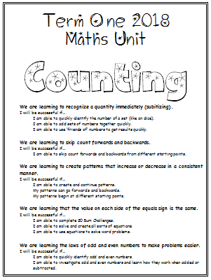  https://www.youtube.com/watch?v=lAQ2HTqTl2w I Can Show Numbers In So Many Ways (very corny – go with it!)  Discuss – What do we use numbers for? Collect answers. Focus on counting and talk about effective ways of counting. | INVESTIGATION  Task: Counting Cars  Students are given the task of counting the cars that pass the school in a 10 minute period. Discuss what would be effective strategies for this – marks on whiteboards/clipboards, colouring squares on maths paper, tallies, using a calculator, using a ‘clicker’, using an abacus.  10 minute session outside counting.  Discuss strategies that worked/didn’t work. Follow up tallies with discussion on how skip counting can help us be more efficient.  Students write a short statement about what they did and how it went.  Extending Prompts:  How could you give us more information than just a total: What type of vehicles? What colour?  Enabling Prompts:  Work with a partner. Give guidance re: method to use. | REFLECTION  How have you been successful?  What would you do differently next time?  Study Ladder: Set pods  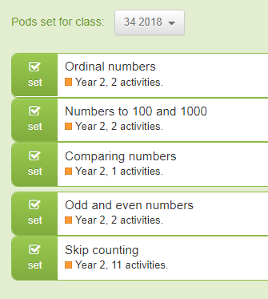  Extra: use magazines to make a number mural for the maths wall. | ASSESSMENT  Check student write ups to see how they’ve been able to articulate their strategy and experience.

Session 2  LEARNING INTENTION  We are learning to recognize a quantity immediately (subitizing).  SUCCESS CRITERIA  I will be successful if…  I am able to quickly identify the number of a set (like on dice).  I am able to add sets together quickly. | TOOL SESSION  20 Sum Challenge  WHOLE CLASS FOCUS  Video – You Tube  https://www.youtube.com/watch?v=ib5Gf3GIzAg Subitize Rock  Powerpoints –  https://www.slideshare.net/khrycan/dot-cards dot card subitizing  https://www.slideshare.net/LPonton/subitizing-ppt-b harder one  Use the ‘Flashie Numbers’ (to 10 or to 20) to show students various arrangements of sets of numbers.  How are they organized and what makes them easy or hard to immediately recognize (subitize)  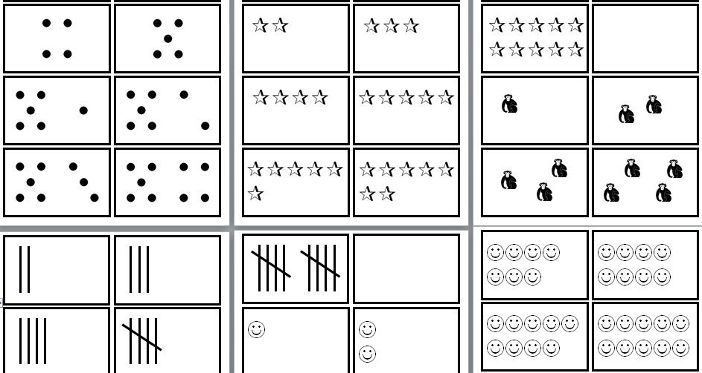 | INVESTIGATION  Game: ‘Call and Collect’  Use tally cards, tens grid cards, dice and dominoes to practise subitizing.  Groups of 3  Dealer flips the card (domino, rolls the dice) and other 2 players compete to call the number. First one collects the card. Play for 3 mins, then switch roles. Keep tallies of points won by each player for totals at end.  Extending Prompts:  Dealer can flip 2, 3 or 4 cards at a time and players must add.  Enabling Prompts:  Work with one type of material (eg dice first) for several sessions | REFLECTION  What was easy?  Was there anything that was confusing?  Revisit success criteria and use the ‘Where Am I At with My Learning?’ poster:  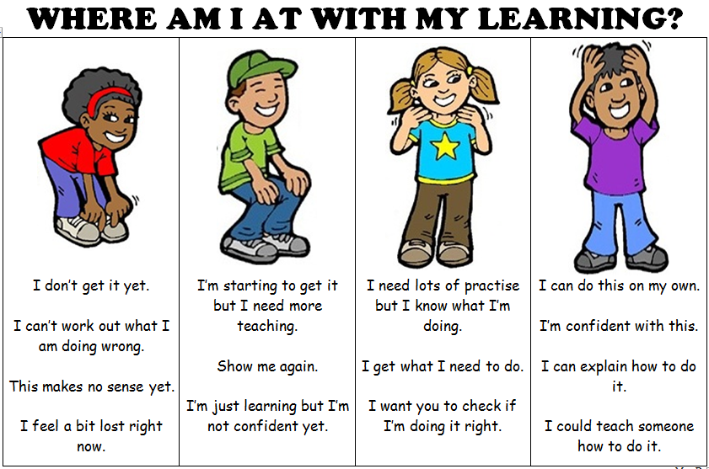  Keep working for 10 more minutes then we’ll finish  Study Ladder: Set pods | ASSESSMENT  Which students can quickly subitize and which need support?  Who could use some L.S.O. sessions to practise this skill?

Session 3  LEARNING INTENTION  We are learning to recognize a quantity immediately (subitizing).  SUCCESS CRITERIA  I will be successful if…  I am able to quickly identify the number of a set (like on dice).  I am able to use ‘friends of’ numbers to get results quickly. | TOOL SESSION  20 Sum Challenge  WHOLE CLASS FOCUS  Video – You Tube  https://www.youtube.com/watch?v=ib5Gf3GIzAg Subitize Rock again ‘cause it’s soooo bad.  Stepping Up from Subitizing  As well as recognizing sets quickly (subitizing) we should be able to identify the relationships between numbers. Eg. 10  1 + 9  2 + 8  3 + 7 etc  Use tens grids with dots to demonstrate  By grades 3 and 4 we should be able to do these for numbers as high as 20. This will make our 20 Sum Challenge quicker and build our confidence in maths | INVESTIGATION  Activity: ‘Friendly Flowers’  Use friendly flowers template (or create your own using kinder squares or dot stickers) to show all the combinations that can be made to create a number. Put number in middle and use petals to show the combinations that make that number  Extending Prompts:  Could you time yourself to see how fast you are?  Enabling Prompts:  What equipment (dice, dominoes, tens frame) could you use to make this easier? | REFLECTION  What was easy?  Was there anything that was confusing?  Revisit success criteria  Keep working for 10 more minutes then we’ll finish  Study Ladder: Set pods | ASSESSMENT  Which  Grade 4s should work up to 20  Grade 3s should work up to 12 – then further  Grade 4s should work confidently above 10 and Grade 3s should work confidently up to 10/12 (if not, LSO intervention needed)

Session 4  LEARNING INTENTION  We are learning the laws of odd and even numbers to make problems easier.  SUCCESS CRITERIA  I will be successful if…  I am able to quickly identify odd and even numbers.  I am able to investigate odd and even numbers and learn how they work when added or subtracted. | TOOL SESSION  20 Sum Challenge  WHOLE CLASS FOCUS  Defining Odd and Even Numbers  Do a couple of pairing exercises to demonstrate odd and even.  Come up with class definitions for what odd and even numbers are.  Videos – You Tube  https://www.youtube.com/watch?v=hMSd7wGuTT4 Odd Number Song  https://www.youtube.com/watch?v=Ei19HMn1BxM Even Number Song  Game: ‘Odd Stand, Even Sit’  Use a bunch of flash cards with random numbers. Flash the card.  Kids stand if the number is odd  Kids sit if the number is even.  Eliminate to the end. | INVESTIGATION  Investigation – ‘Odd and Even Numbers’  Talk about the importance odd and even numbers have in helping us understand numbers and checking our answers  Lead students through the instructions on the sheet for an odd and even investigation.  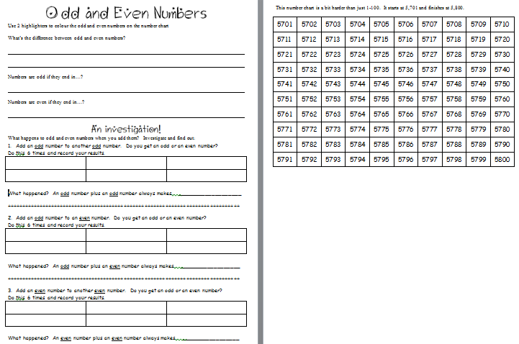  Extending Prompts:  What happens if you do the same investigation with subtraction?  Enabling Prompts:  What equipment (dice, dominoes, tens frame) could you use to make this easier? | REFLECTION  (20 mins before lesson end)  How have you been successful?  How do you know when you’ve got this?  Who’d like a study buddy to help them finish?  What’s the tricky bit we have to watch for?  Keep working for 10 more minutes then we’ll correct together  Study Ladder: Set pods | ASSESSMENT  Collect sheets for assessment

Session 5  LEARNING INTENTION  We are learning to skip count forwards and backwards.  We are learning to create patterns that increase or decrease in a consistent manner.  SUCCESS CRITERIA  I will be successful if…  I am able to skip count forwards and backwards from different starting points.  I will be successful if…  I am able to create and continue patterns. | TOOL SESSION  ‘Odd Stand, Even Sit’  20 Sum Challenge – use today’s row of sums to indicate which ones are odd + odd = even, even + odd = odd, even + even = even – use different coloured highlighters.  WHOLE CLASS FOCUS  Videos – You Tube  https://www.youtube.com/watch?v=PiW1zKaGbyM&index=36&list=PLDQlSh98XAywTatIwQKMAyPa4rtMl6Ft5  Numbers from 0 to 1,000,000 with colours  Whole thing goes for 9 mins so just watch what you need and skip. Pause in various spots.  Point of the video is we can’t count as fast as this so we need more efficient ways to count large numbers – i.e. skip counting  Whiteboards: Skip Counting  Practise skip counting using a variety of amounts to skip by and a variety of starting points | INVESTIGATION  Investigation – ‘Skip Counting Discovery’  Pose the question: ‘What numbers come up when I count by 2s and is there a pattern?’ .  Demonstrate on a 100 chart.  Come up with answer and conclusion statement and make a simple poster.  Students work to complete the same process with a different skip count Grade 3 - 5s, 10s, 3s, 4s,  Grade 4 – 3s, 4s, 6s, 7s,  Have lots of hundreds charts available  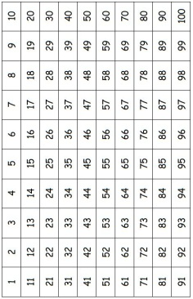  Make connections to multiplication tables  Extending Prompts:  Further skip counting patterns  Enabling Prompts:  What | REFLECTION  (20 mins before lesson end)  How have you been successful?  How do you know when you’ve got this?  Who’d like a study buddy to help them finish?  What’s the tricky bit we have to watch for?  Keep working for 10 more minutes then we’ll correct together  Study Ladder: Set pods | ASSESSMENT  Posters should show whether the students have been able to notice patterns and complete the skip counting.

Session 6  LEARNING INTENTION  We are learning to skip count forwards and backwards.  We are learning to create patterns that increase or decrease in a consistent manner.  SUCCESS CRITERIA  I will be successful if…  I am able to skip count forwards and backwards from different starting points.  I will be successful if…  I am able to create and continue patterns.  My patterns can go forwards and backwards.  My patterns begin at different starting points. | TOOL SESSION  ‘Odd Stand, Even Sit’  20 Sum Challenge  WHOLE CLASS FOCUS  Review SINE  Relook at the SINE problems 1, 2 and 3 so students have correct model of how to complete this.  Whiteboards: Skip Counting  Practise skip counting using a variety of amounts to skip by and a variety of starting points. Try forwards and backwards.  Calculators:  Practise skip counting with calculators | INVESTIGATION  Activity – ‘Skip Counting From Different Starting Points’  Model how this activity is completed including how to use a calculator to check answers.  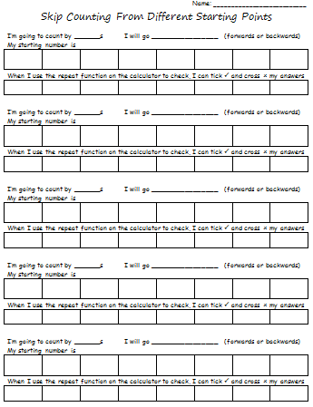  Extending Prompts:  Work in the 1000s  Enabling Prompts:  Use some of the patterns we did yesterday to get you started. | REFLECTION  (20 mins before lesson end)  How have you been successful?  How do you know when you’ve got this?  Who’d like a study buddy to help them finish?  What’s the tricky bit we have to watch for?  Keep working for 10 more minutes then we’ll correct together  Study Ladder: Set pods | ASSESSMENT  Collect sheets for assessment

Session 7  LEARNING INTENTION  We are learning to create patterns that increase or decrease in a consistent manner.  SUCCESS CRITERIA  I will be successful if…  I am able to create and continue patterns. | TOOL SESSION  ‘20 Sum Challenge  WHOLE CLASS FOCUS  Number charts – noticing the patterns on numbers charts – not just 1-100 charts but higher ones, to see the consistent patterns that appear.  Show how 1 more/1 less and 10 more/10 less make a ‘cross’ | INVESTIGATION  Investigation – ‘Number Crosses’  Students complete the sheet then complete their own.  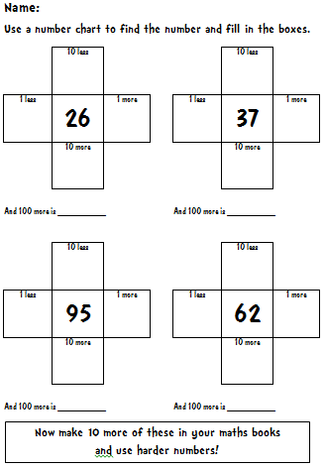  Extending Prompts:  What numbers can you challenge yourself with  Enabling Prompts:  Use the number charts as a guide | REFLECTION  (20 mins before lesson end)  How have you been successful?  How do you know when you’ve got this?  Who’d like a study buddy to help them finish?  Study Ladder: Set pods | ASSESSMENT  Who’s picked up the concept?  What more needs to be covered?

Session 8  LEARNING INTENTION  We are learning that the value on each side of the equals sign is the same.  SUCCESS CRITERIA  I will be successful if…  I am able to complete 20 Sum Challenges.  I am able to solve and create all sorts of equations.  I am able to use equations to solve word problems. | TOOL SESSION  20 Sum Challenge  WHOLE CLASS FOCUS  Videos – You Tube  https://www.youtube.com/watch?v=t86mi117IP8  Origins of the Equal Sign  https://www.youtube.com/watch?v=LwLjZOI86Jg  The 'Equal Sign by Grade 1/2  Basic at first, but lends itself to good discussion further in eg 5= 4+1  Point out that in an equation the + or – doesn’t have to come first (though we most often do it that way). As long as both sides of the equal sign are the same, the equation is correct.  Write some different sums on the board and have students put in = or ≠  6 5+1  30 + 30 90  8-2 7-1  2x5 10  100 50+50  15 20-5  Those with ≠ could be changed to make equal | INVESTIGATION  Task: Writing Equations Poster  Students make a poster showing all the types of equations they can write.  Extending Prompts:  Challenge yourself by using x and ÷ as well  Enabling Prompts:  Watch the second video again to get some ideas for some equations you can use.  Extra:  Revisit some of the SINE problems  10, 11, 12 | REFLECTION  (20 mins before lesson end)  Finish the sentence: I’ve learnt that…  Who’s got questions?  Revisit success criteria and use the ‘Where Am I At with My Learning?’ poster:  Keep working for 10 more minutes then we’ll finish. | ASSESSMENT  Check posters for accuracy and levels of difficulty attempted

Session 9  LEARNING INTENTION  We are learning that the value on each side of the equals sign is the same.  SUCCESS CRITERIA  I will be successful if…  I am able to use equations to solve word problems. | TOOL SESSION  20 Sum Challenge  WHOLE CLASS FOCUS  Review – revisit the ‘highlights of the unit so far – what we’ve covered, what we’ve learned  Problem Solving  Most of the maths you will do as you grow up is solving word problems. This might be at your job or at the shops or paying your bills. Most of the time they’ll be spoken word problems, not written word problems and you’ll do most in your head or with a calculator. The important thing to learn is what sort of equation will help you solve whatever problem you have.  Use ‘Mighty Mentals’ book B (red) to present some word problems and model how to work them out using equations. | INVESTIGATION  Task: Problem Solving  ‘Mighty Mentals’ book B (red). Students practise the problems  Extending Prompts:  Harder problems in yellow book  Enabling Prompts:  Easier problems in blue book | REFLECTION  (20 mins before lesson end)  What tricky questions would you like to talk about together?  What parts of this do you think we might need to do more of?  Which bits are you confident of?  Keep working for 10 more minutes then we’ll finish. | ASSESSMENT  Which students can problem solve and which need support?

Do we need extra lessons on > < ordering numbers?

