MATHEMATICS WEEKLY/UNIT PLANNER
Level: Gr 3/4 Term: 1 2017 Weeks: ?
Teachers: Sinead, Kellie and Marg
Dimension: Number and Algebra
Specific Focus for Unit: Counting
Victorian Curriculum Content Descriptions  http://victoriancurriculum.vcaa.vic.edu.au/mathematics/introduction/rationale-and-aims | Key Concepts  https://drive.google.com/file/d/0B3ydL4IWBSAbbk5laWtLOEprYXc/edit
Gr 2:  Investigate number sequences, initially those increasing and decreasing by twos, threes, fives and ten from any starting point, then moving to other sequences (VCMNA103)  Recognise, model, represent and order numbers to at least 1000 (VCMNA104)  Group, partition and rearrange collections up to 1000 in hundreds, tens and ones to facilitate more efficient counting (VCMNA105)  Describe patterns with numbers and identify missing elements (VCMNA112)  Gr 3:  Investigate the conditions required for a number to be odd or even and identify odd and even numbers (VCMNA129)  Investigate the conditions required for a number to be odd or even and identify odd and even numbers(VCMNA129)  Recognise, model, represent and order numbers to at least 10 000 (VCMNA130)  Apply place value to partition, rearrange and regroup numbers to at least 10 000 to assist calculations and solve problems (VCMNA131)  Use a function machine and the inverse machine as a model to apply mathematical rules to numbers or shapes (VCMNA139)  Gr 4:  Investigate and use the properties of odd and even numbers (VCMNA151)  Recognise, represent and order numbers to at least tens of thousands (VCMNA152)  Apply place value to partition, rearrange and regroup numbers to at least tens of thousands to assist calculations and solve problems (VCMNA153)  Investigate number sequences involving multiples of 3, 4, 6, 7, 8, and 9 (VCMNA154)  Gr 5:  Use estimation and rounding to check the reasonableness of answers to calculations(VCMNA182)  Recognise, represent and order numbers to at least hundreds of thousands (VCMNA186) | Counting  - Subitising: The immediate and correct recognition of a quantity  - Number Patterns: Skip counting – forwards and backwards

Pre-Assessment | NAPLAN 2016 misconceptions | Learning Intentions
Task:  SINE Number Assessment Year A  Misconceptions:  - Understandings of equal signs (same as)  - Algorithms can be written backwards and forward  - Creating visual representations of multiplication and division  - Recognising that zero is a place holder  - 1000 more and 1000 less  - 10 less than 201 is 191.  Strengths:  - Sequencing numbers  - Transferring words to numbers | - Repetitive addition  - Counting backwards by ones  - Difference: being able to identify the numbers between two numbers (question 10) and how many numbers are between two numbers (question 13)  - Understanding of more and less (question 10)  - Understanding of ‘same as’ equations and knowing how to count on (question 33) | Counting is a skill we need to make maths quicker and easier.  We need to count forwards, backwards, skip count and count from any starting point.  Numbers can be divided into odd and even  We need to count from 1 digit to 2 digit to 3, 4, 5 digit numbers (eg. Knowing what to do when we get to 99).  We can use the repeat function on a calculator to work more quickly

SESSION NUMBER  KEY IDEA  LEARNING INTENTION | TOOL SESSION  A short, sharp task relating to fluency in mental computation or the focus of the lesson.  WHOLE CLASS FOCUS  Sets the scene/context for what students do in the independent session. | INVESTIGATION SESSION  Extended opportunity for students to work in pairs, small groups or individually. A time for teacher to probe children’s thinking or work a small group for part of the time. | REFLECTION  Focused teacher questions and summary to draw out the mathematics and assist chn to make link/s. | TEACHER ASSESSMENT  We are looking for...
Session 1 (may run over a few days)  LEARNING INTENTION  Counting is a skill we need to make maths quicker and easier. | TOOL SESSION  ‘Next Nine Numbers’: students are given a choice of numbers (for differentiation) and must write the next nine numbers after their choice of number.  WHOLE CLASS FOCUS  Introduce topic of Counting and discuss some of the principles of counting: one-to-one correspondence, accuracy, sequence of numbers, subitizing.  Brainstorm situations in which people need to count. | INVESTIGATION  Task: ‘Counting Beans’ (directions found here - adapt to fit time)  Extending and Enabling Prompts:  Within article there are prompts that will help. | Is there a quick way to count these?  What’s the difference between these two numbers?  What are you noticing? | Students’ level of mastery of numbers for their grade standard (Vic Curric)  Gr 3: to at least 10 000  Gr 4: to at least tens of thousands

Session 2  LEARNING INTENTION  We need to count forwards, backwards, skip count and count from any starting point.  Numbers can be divided into odd and even | TOOL SESSION  ‘Next Nine Numbers’: students are given a choice of numbers (for differentiation) and must write the next nine numbers after their choice of number. Get a partner to check.  WHOLE CLASS FOCUS  Use a hundreds chart to talk about how our numbers sequence works and why it’s called the Base Ten Number System.  What patterns can the students see? Where are the odd and even? Do we get 2 odd numbers beside each others? What about 2 even numbers? What are some quick ways around our chart? (eg. moving down a row is adding 10, moving up a row is subtracting 10) | INVESTIGATION  Task: ‘Number of the Moment’  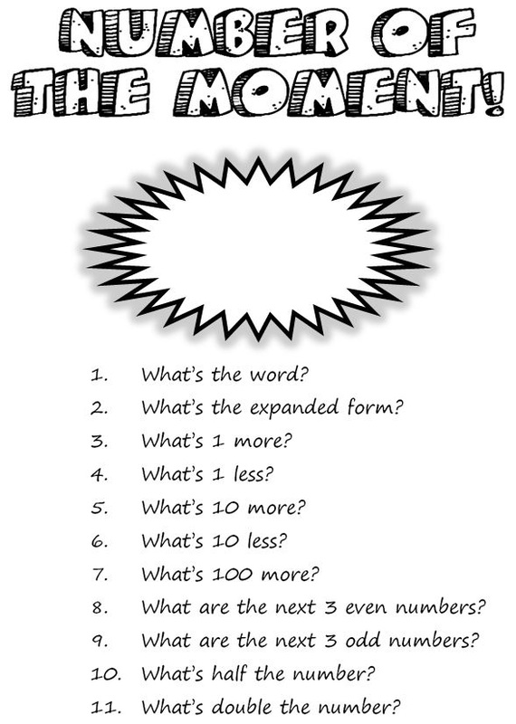  Extending Prompts:  Suggest higher numbers for students (fractions, negative numbers)  Enabling Prompts:  Suggest easier numbers for students and use the counting charts to assist | Students choose 1 or 2 of the sentences to complete  (could be done orally or written in Learning Journal)  ‘Number of the Moment’  I’m a champion at...  I’m completed...  I need to work on...  I struggled with... | Yr 3:  Students count and order numbers to and from 10 000. They classify numbers as either odd or even, continue number patterns involving addition or subtraction, and explore simple number sequences based on multiples.  Yr 4:  Students identify unknown quantities in number sentences. They use the properties of odd and even numbers. Students continue number sequences involving multiples.

Session 3  LEARNING INTENTION  We need to count forwards, backwards, skip count and count from any starting point.  Resources:  -Class 100 chart  - Print out 100 charts for kids books?  - long strips of coloured paper | TOOL SESSION  Roll and add: pairs share 2 or 3 dice. 5 minute timer, record the number rolled/ total once rolled, the highest number at the end of the 5 minutes is the winner.  WHOLE CLASS FOCUS  Practise number patterns referring to hundreds chart. Next step: start at different numbers and count on.  Students are given a strip of coloured paper or a roll of paper. Students record a counting sequence as far as they can. Teachers may assign the counting sequence and starting number or may allow students to choose their own. Teachers can place a time limit on this activity or allow students to explore the pattern as far as they are able. A hundreds grid or a calculator can assist students. Writing the numbers vertically assists the students to focus on any patterns that are formed. This is also an excellent activity to take home. | INVESTIGATION  The aim is that students notice patterns.  Enabling:  Focus on fives and twos. Choose appropriate starting numbers for student.  Extending:  For students at a higher level, this activity can use fraction or decimal skips. As an example, start at 9.1 and skip count by 0.2, to get the sequence 9.1, 9.3, 9.5, 9.7, 9.9, 10.1, 10.3, 10.5, 10.7 …  Higher level students can also count backwards (subtraction number patterns)  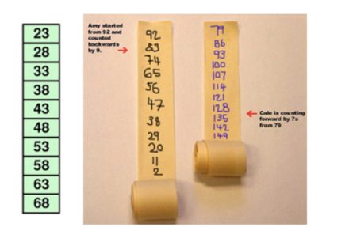 | REFLECTION  Odds and evens:  -Circle the odd and even numbers on your strip of paper. Do you notice any patterns?  Patterns:  -What pattern do you notice when counting by fives starting at 23  -When counting by fives starting at 23, will the number 70 be part of your counting pattern? How do you know?  -If you were counting by fives and started at 133, what would the next few numbers be?  -If you were counting backwards by fives from 98, what would the next few numbers be? | Yr 3:  Students count and order numbers to and from 10 000. They classify numbers as either odd or even, continue number patterns involving addition or subtraction, and explore simple number sequences based on multiples.  Yr 4:  Students identify unknown quantities in number sentences. They use the properties of odd and even numbers. Students continue number sequences involving multiples.

Session 4  LEARNING INTENTION  We need to count forwards, backwards, skip count and count from any starting point.  We can use the repeat function on a calculator to work more quickly | TOOL SESSION  ‘Odd and Even’: students are shown a series of random number cards and must stand for the evens and sit for the odds. Extend using the online random number generator:  https://www.google.com.au/search?safe=strict&site=&source=hp&q=random+number+generator&oq=random+nu&gs_l=hp.1.0.0l10.439.1978.0.6111.10.10.0.0.0.0.358.1642.2-4j2.6.0....0...1c.1.64.hp..4.5.1409.0..0i131k1.negAUofirbE  WHOLE CLASS FOCUS  Demonstrate how we use the repeat function on a calculator Online Calculator link: https://www.online-calculator.com/simple-full-screen-calculator/ | INVESTIGATION  Students choose a number (can use the random number generator) and choose a number to skip count by.  Students record the next 10 numbers then use the repeat function to check their answers  Enabling:  Smaller numbers as starting points and simpler skip counting options  Extending:  Higher numbers as starting points and more complex skip counting options  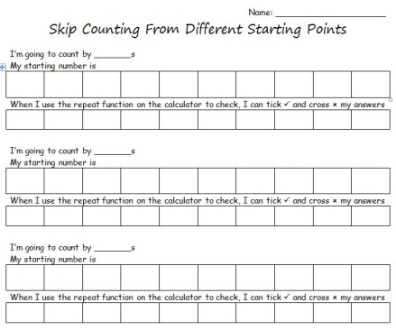 | REFLECTION  Students choose 1 or 2 of the sentences to complete  (could be done orally or written in Learning Journal)  I was able to…  My success rate…  I learnt that…  I can … (refer to learning intentions)  Next time I would...  This lesson could be repeated counting back instead of forward. | Yr 3:  Students count and order numbers to and from 10 000. They classify numbers as either odd or even, continue number patterns involving addition or subtraction, and explore simple number sequences based on multiples.  Yr 4:  Students identify unknown quantities in number sentences. They use the properties of odd and even numbers. Students continue number sequences involving multiples.  Students who did not complete SINE assessment questions 1-4 to repeat the questions. Has there been improvement
Counting and Place Value
http://obwm.weebly.com/working-with-34-and-5-digit-numbers.html

