Differentiated Spelling 2016/2017

Planning
(Types of words chosen were adapted from Kathy Ganski’s ‘Word Journeys’ book. Word lists were collected from a large range of spelling resources. The types of words may change in the future due to our school PD with ‘SMART Spelling’ later this year.)

The ‘Tracks’ (groups students are allocated to)
Use assessments to allocate student ‘Tracks’. Students may move in and out of tracks as year progresses according to weekly spelling test results. Students should also be encouraged to choose 1 or 2 words from other tracks should they wish an extra challenge every now and again – giving students voice and choice in their track is important and kids will often ask can they move up a track. Unless their results are disasterous, say yes!

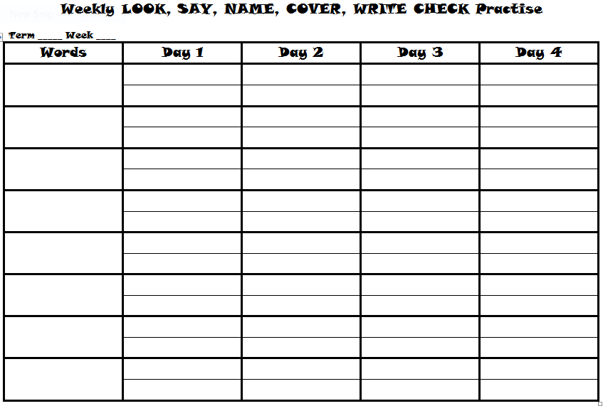
Monday
Introduce this week’s ‘type’ of words. Students choose 8 words for Look Say Name Cover Write Check, write these into the LSNCWC table and paste into their word work book.
Students should choose from their own ‘track’ but may choose from other tracks if they wish to challenge themselves or are unfamiliar with some words. Students who find Track A difficult may choose 5 words instead of 8. Highly competent spellers may choose 4 from Track C and 4 from other more challenging sources (like ‘Word a Day’) and their focus is more on word meanings. They should also be encouraged to do the ‘Word Ladders’ as often as possible.
Complete Day 1 Look Say Name Cover Write Check – teacher needs to check that words have been copied correctly.

Tuesday
Whole class lessons – looking at this week’s words. Defining any unknown words, noting patterns, anomalies, making connections.
Word sort – students work in multi-ability groups to sort the words and discuss their findings. Collect these on A3 sized posters and keep together in A3 display book.
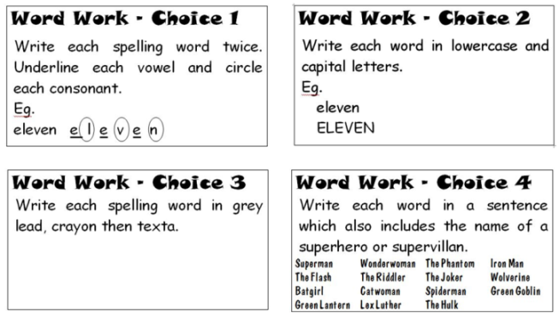
Complete Day 2 LSNCWC

Wednesday
Complete Day 3 LSNCWC – if students have time after LSNCWC they can practise their words using the word work choices at the front of their book.

Thursday
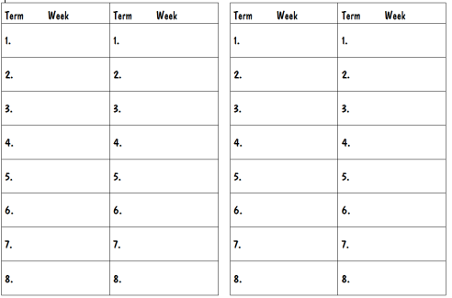
Day 4 LSNCWC – if students have time after LSNCWC they can practise their words using the word choices at the front of their book.

Friday
Spelling test – hand out test booklets and collect word work books. If students have done LSNCWC properly, they should know their words and be able to write them from memory into the test books. Handed to teacher for correction and results recorded in Assessment folder.

2016 Breakdown

Term II
Week 1 | Classification:– R-Controlled Vowels – ar
Week 2 | Classification:– R-Controlled Vowels – er
Week 3 | Classification:– R-Controlled Vowels – ir
Week 4 | Classification:– R-Controlled Vowels – or
Week 5 | Classification:– R-Controlled Vowels – ur
Week 6 | Classification:– Other Common Long Vowel Patterns – Long a
Week 7 | Classification:– Other Common Long Vowel Patterns – Long e
Week 8 | Classification:– Other Common Long Vowel Patterns – Long i
Week 9 | Classification:– Other Common Long Vowel Patterns – Long o
Week 10 | Classification:– Other Common Long Vowel Patterns – Long u
Week 11 | Classification:– Complex Consonant Patterns – qu, squ
Term III
Week 1 | Classification:– Complex Consonant Patterns – triple letter blends
Week 2 | Classification:– Complex Consonant Patterns – shr, thr
Week 3 | Classification:– Complex Consonant Patterns – final consonant k sound
Week 4 | Classification:– Complex Consonant Patterns – soft consonants
Week 5 | Classification:– Sounds for the ED inflectional ending
Week 9 | Classification:– Contractions
Week 10 | Classification:– Compound words
Week 6 | Classification:– Homophones
Week 7 | Classification:– Homophones
Week 8 | Classification:– Homophones

2017 Breakdown

Begin Term I Week 5ish – same order?

r-Controlled Vowels – ar
A-Track |  | B-Track |  | C-Track
carpet | warm | guard | towards | various | necessary
dark | sugar | quarter | garage | aquarium | exhilarated
large | kangaroo | dollar | charge | nightmare | terrarium
care | party | hardly | library | caterpillar | separate

r-Controlled Vowels – er
A-Track |  | B-Track |  | C-Track
over | very | interest | yesterday | permanent | daughter
sister | were | perfect | underneath | cemetery | jewellery
after | there | where | number | laughter | government
later | person | grandfather | answer | reverse | mermaid

r-Controlled Vowels – ir
A-Track |  | B-Track |  | C-Track
pirate | thirteen | environment | shirt | expiration | inspiration
birthday | iron | weird | circus | virtual | admiration
girl | first | thirsty | confirmation | perspiration | chiropractor
dirt | circle | squirm | direct | spiral | inquiry

r-Controlled Vowels – or
A-Track |  | B-Track |  | C-Track
more | born | force | scissors | scorched | category
north | horse | corner | explore | enormous | chorus
record | important | gorilla | junior | orchestra | normal
store | world | morning | doctor | humorous | alligator

r-Controlled Vowels – ur
A-Track |  | B-Track |  | C-Track
church | purr | cure | burst | urgent | accurate
Saturday | hurt | during | surface | furniture | surround
surprise | fur | bury | burger | surgeon | burglar
sure | surf | further | nurse | furious | disturb

Long a
A-Track |  | B-Track |  | C-Track
again | rainbow | April | always | failure | prayer
Sunday | anyway | against | mountain | campaign | straighten
pray | chain | entertain | amazing | persuade | available
train | holiday | nation | afraid | patient | creation

Long e
A-Track |  | B-Track |  | C-Track
easy | peanut | between | believe | achievement | succeed
deep | feed | agree | greedy | extreme | compete
beach | wheel | peace | piece | cheetah | creature
team | week | cleaning | leave | league | concealed

Long i
A-Track |  | B-Track |  | C-Track
fly | kind | ninety | excited | frightened | identify
right | write | climb | type | satisfy | magnifying
July | reply | child | divide | design | cider
wild | night | sign | lightning | umpire | advice

Long o
A-Track |  | B-Track |  | C-Track
road | boat | local | explode | suppose | throat
most | both | toast | chosen | approach | social
those | o’clock | spoke | alone | donate | microscope
only | ghost | broken | zone | clothes | moment

Long u
A-Track |  | B-Track |  | C-Track
use | glue | cube | tune | attitude | introduce
blue | do | clue | suit | amuse | nuisance
few | huge | drew | true | ruin | costume
grew | rule | knew | fruit | through | threw

qu, squ
A-Track |  | B-Track |  | C-Track
quit | quiet | square | equal | quality | question
squid | quiz | squash | equipment | earthquake | quarter
quack | quick | quilt | liquid | frequent | queue
quite | squad | squeal | squeeze | inquisitive | squeaked

Triple letter blends
A-Track |  | B-Track |  | C-Track
scrap | street | stream | strike | sprinkle | screw
strap | spray | scratch | spread | strength | strong
split | straight | splash | stretch | screen | screaming
string | spring | strange | splint | spread | stranger

shr, thr
A-Track |  | B-Track |  | C-Track
three | shrink | shrine | throw | through | throat
shrub | shrimp | throne | shred | thrash | shrine
shrug | thrill | shrugged | thrilled | thread | threatened
thrilling | thriller | throwing | thrown | threw | throbbing

final consonant k sound
A-Track |  | B-Track |  | C-Track
back | shark | talk | wake | Olympic | embark
neck | bake | picnic | break | classic | elastic
take | bank | shake | music | knock | basic
wink | clock | black | topic | attack | speak

soft consonants
A-Track |  | B-Track |  | C-Track
ice | place | edge | choice | knowledge | bridge
page | gem | judge | force | passenger | exceeding
face | space | badge | sauce | average | silence
giant | twice | once | large | challenge | century

ed inflectional ending
A-Track |  | B-Track |  | C-Track
jumped | lifted | wanted | dropped | walked | painted
filled | yelled | cared | cleaned | planned | squealed
rained | mixed | started | asked | happened | answered
ended | smiled | closed | stopped | cracked | waited

Contractions
A-Track |  | B-Track |  | C-Track
I’m | he’s | you’re | what’s | haven’t | should’ve
that’s | who’s | couldn’t | we’re | they’ll | shouldn’t
can’t | don’t | you’ll | let’s | aren’t | you’d
isn’t | we’ve | I’ll | they’re | there’s | they’ve

Compound words
A-Track |  | B-Track |  | C-Track
birthday | forever | breakfast | rainbow | nightmare | doorknob
backyard | runway | however | upstairs | suitcase | downstairs
upset | haircut | toothbrush | footprint | earthquake | toothache
cookbook | bedroom | handshake | outside | otherwise | watermelon

Homophones
A-Track |  | B-Track |  | C-Track
dear | deer | break | brake | allowed | aloud
sea | see | which | witch | altar | alter
hear | here | saw | sore | principal | principle
cell | sell | flower | flour | lesson | lessen

Homophones
A-Track |  | B-Track |  | C-Track
I | eye | made | maid | creak | creek
be | bee | wood | would | clothes | close
male | mail | sent | cent | pause | paws
by | buy | tow | toe | thrown | throne

Homophones
A-Track |  | B-Track |  | C-Track
role | roll | our | hour | patience | patients
no | know | die | dye | hangar | hanger
for | four | knew | new | chews | choose
son | sun | blue | blew | threw | through

