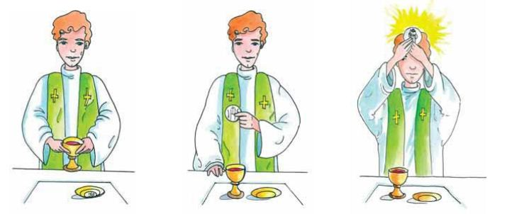

What are some of the words the priest uses during the Liturgy of the Eucharist to change the bread and wine into the body and blood of Jesus?

______________________________________

______________________________________

______________________________________

