A Fraction can be Part of a “Collection” (or group)

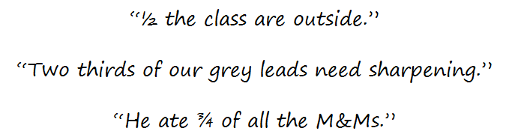

Show ½ of this group
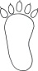

Show ¼ of this group
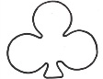

Show ¾ of this group
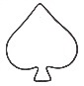

Now try these. Draw or use counters if that helps.

½ of 20 = ____
¼ of 40 = ____
1/3 of 15 = ____
1/5 of 40 = ____
½ of 28 = ____
1/10 of 80 = ____
¼ of 60 = ____
1/5 of 35 = ____
1/10 of 20 = ____
½ of 30 = ____
½ of 42 = ____
1/3 of 27 = ____
2/6 of 18 = ____
¾ of 40 = ____
3/5 of 50 = ____
4/10 of 60 = ____
4/5 of 10 = ____
¾ of 24 = ____
2/4 of 48 = ____
¾ of 20 = ____
2/5 of 20 = ____
3/6 of 24 = ____
3/10 of 70 = ____
6/10 of 400 = ____

A Fraction can be Part of a “Collection” Answers

Show ½ of this group

Show ¼ of this group

Show ¾ of this group

Now try these. Draw or use counters if that helps.

½ of 20 = 10
¼ of 40 = 10
1/3 of 15 = 5
1/5 of 40 = 8
½ of 28 = 14
1/10 of 80 = 8
¼ of 60 = 15
1/5 of 35 = 7
1/10 of 20 = 2
½ of 30 = 15
½ of 42 = 21
1/3 of 27 = 9
2/6 of 18 = 6
¾ of 40 = 30
3/5 of 50 = 30
4/10 of 60 = 24
4/5 of 10 = 8
¾ of 24 = 18
2/4 of 48 = 24
¾ of 20 = 15
2/5 of 20 = 8
3/6 of 24 = 12
3/10 of 70 = 21
6/10 of 400 = 240

