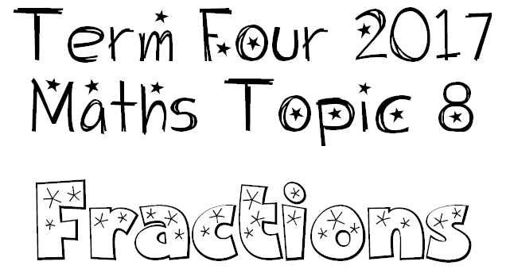
Quantity
We are learning to:
- Break up a whole number into equal parts to create a fraction
- Break up a collection into equal parts to create a fraction

Partitioning
We are learning to:
- Break up fractions in many different ways
Eg. ¾ can be broken up as ½ and ¼

Equivalence
We are learning to:
- Provide a variety of names for the same fraction
Eg. ½ is the same as 2/4
- Make connections between fractions (e.g .½) decimals (e.g. 0.5) and percentages (Eg. 50%)

Benchmarking
We are learning to:
- Use reference points to help determine the size of the fraction or whole number.
Eg. 1, 2, 0, ½,

Number Triad Relationships
We are learning to:
- Model and represent fractions including halves, quarters, thirds, fifths and eighths up to one whole.
- Recognise and represent fractions in a variety of ways
Eg. words, symbols, models

