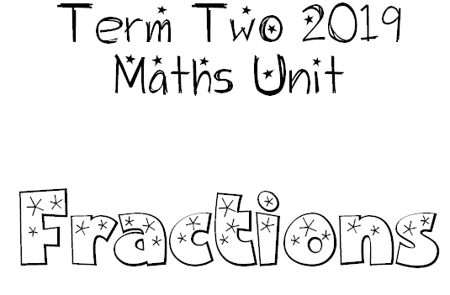

Year 3
Model and represent fractions including halves, quarters, thirds, fifths and eighths up to one whole.

Year 4
Recognise and represent fractions in a variety of ways.
Make connections between fractions and decimals.

