A narrative tells  a story, to  entertain the  reader with  an imaginary  adventure. | 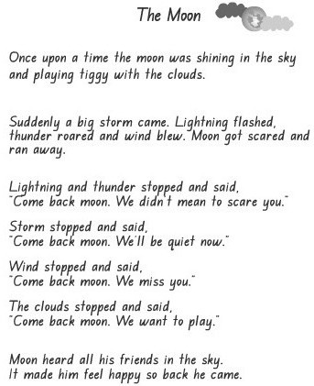

A persuasive text presents a point  of view with supporting  evidence. | 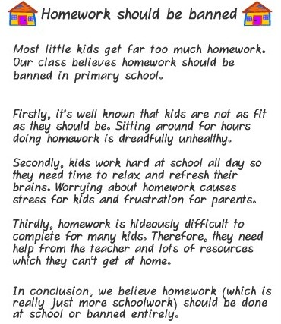

A report  provides  information  by stating  facts. | 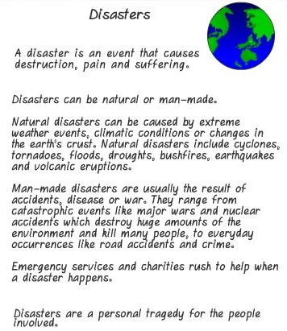

A procedure  tells how to  do something  or make  something. | 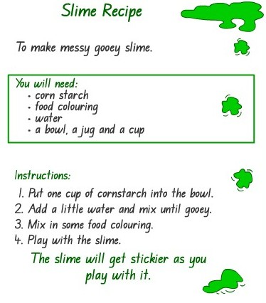

A recount  retells past  events or experiences. | 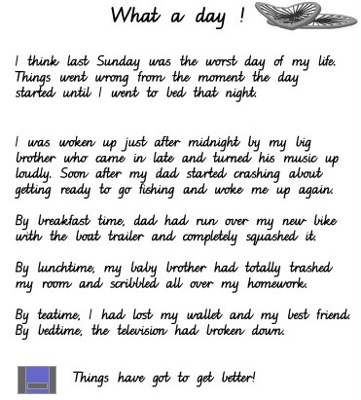

An explanation  tells how  something works  or why something happens. | 