 | 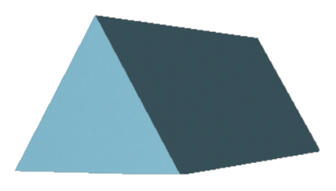
SPHERE | PYRAMID  (TRIANGULAR BASE) | CUBE | RECTANGULAR PRISM
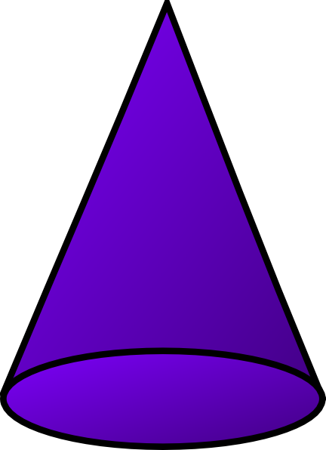 |  | 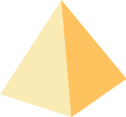 | 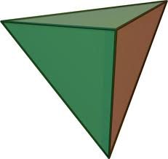
CONE | CYLINDER | PYRAMID  (SQUARE BASE) | TRIANGULAR PRISM

