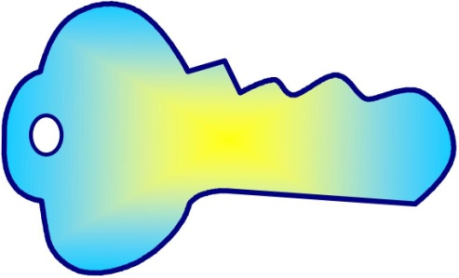

Key Understandings

Properties
Shapes and objects have distinguishable characteristics and are named because of their properties
The properties of two-dimensional (2D) shapes include the number of sides, the number of corners, the lines of symmetry, the length of sides, the size and types of angles
The properties of 3D objects include faces, edges, vertices and surfaces.

Point of View
Object can be seen from different perspectives

Categories/Classification
Relationships between shapes or objects are established because of shared properties:
A rectangle is a parallelogram, as well as a trapezium, as well as a quadrilateral, as well as a polygon
A cube is a prism, as well as a polyhedron.

Symmetry
One shape becomes exactly like another when it is translated, rotated and reflected: the shape appears unchanged after a transformation.
Reflective symmetry – when a shape can be folded on a line so the two halves match
Rotational symmetry – when a shape or object can be rotated about a point and appears unchanged from the original in any fraction of the turn.

Transformation
A change in the position (isometric) or size or shape (non-isometric) of a shape or object.
Isometric transformation
Translation (slide) – the process by which an object or figure changes position without turning
Rotation (turn) – the process by which an object or figure changes position by rotating about a fixed point through a given angle.
Reflection (flip) – the mirror image of an object or figure, where each point of the object is the same distance from the ‘mirror line’ as its corresponding point.
Non-Isometric transformation
Dilation – enlargements and reductions
Skew – distortion by changing the shape and size of an object

Learning Intentions:

??????
Our Wonderings
??????

