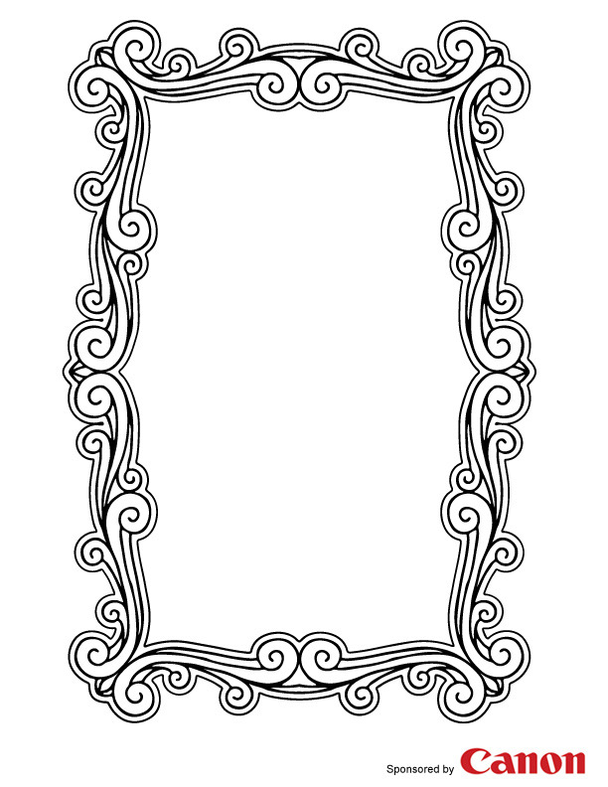

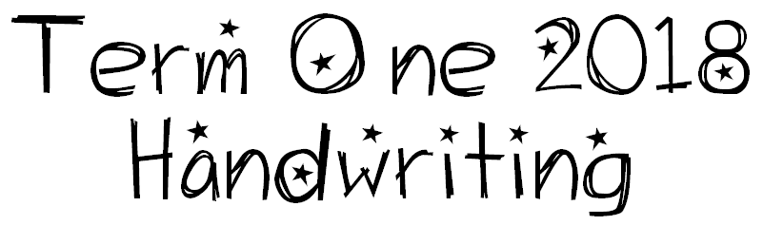

We are learning to write using joined letters that are clearly formed and consistent in size.

I will be successful if…
- I am able to sort letters by their formation features.

- I am able to correctly form letters.

- I am able to keep my writing ‘sitting’ on the lines.

- I am able to join letters correctly.

- I am able to keep the size of my letters accurate and consistent.

- I am able to use consistent spacing between letters and words.

- I am able to develop a clear, attractive and fluid writing style.

