Investigating the Year with a Calendar
2017

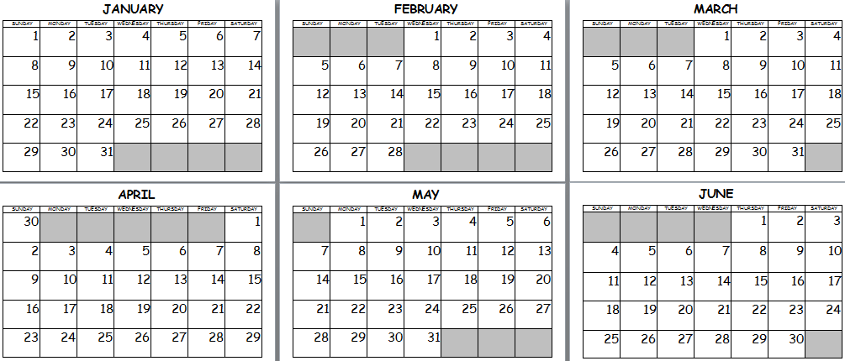
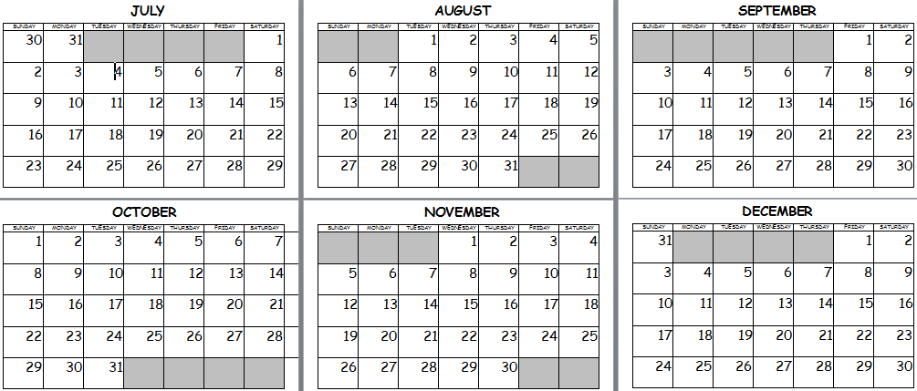
MargD
Investigating the Year with a Calendar
What day comes after Monday?
What day comes before Thursday?
What day comes between Wednesday and Friday?
What is the 2nd month?
What month comes after May?
What month starts with N?
What is the 8th month?
What month comes between May and July?
Name the first month that has 30 days.
What month is Christmas in?
Name the last month that has 31 days.
How many days in a week?
Name the 1st summer month.
What month comes before January?
What two days are the weekend?
What is the last day of the school week?
How many months in a year?
How many months start with J?
Name the 2nd winter month.
How many weeks in a year?
What is the 10th month?
What day comes after Tuesday?
Name the 3rd Autumn month.
What year is it next year?
How many days in a year (not a leap year)?
MargD
Investigating the Year with a Calendar Answers

 | What day comes after Monday? | Tuesday
 | What day comes before Thursday? | Wednesday
 | What day comes between Wednesday and Friday? | Thursday
 | What is the 2nd month? | February
 | What month comes after May? | June
 | What month starts with N? | November
 | What is the 8th month? | August
 | What month comes between May and July? | June
 | Name the first month that has 30 days. | April
 | What month is Christmas in? | December
 | Name the last month that has 31 days. | December
 | How many days in a week? | 7
 | Name the 1st summer month. | November
 | What month comes before January? | December
 | What two days are the weekend? | Saturday, Sunday
 | What is the last day of the school week? | Friday
 | How many months in a year? | 12
 | How many months start with J? | January June July
 | Name the 2nd winter month. | July
 | How many weeks in a year? | 52
 | What is the 10th month? | October
 | What day comes after Tuesday? | Wednesday
 | Name the 3rd Autumn month. | May
 | What year is it next year? | 2018
 | How many days in a year (not a leap year)? | 365
MargD

