Height in metres:  Height in centimetres:  Height in millimetres: |  | 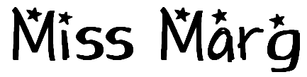  Height in metres:  Height in centimetres:  Height in millimetres:

Name  Height in metres:  Height in centimetres:  Height in millimetres: |  | Name  Height in metres:  Height in centimetres:  Height in millimetres:

Name  Height in metres:  Height in centimetres:  Height in millimetres: |  | Name  Height in metres:  Height in centimetres:  Height in millimetres:

Name  Height in metres:  Height in centimetres:  Height in millimetres: |  | Name  Height in metres:  Height in centimetres:  Height in millimetres:

