Name: __________________________

Title: _______________________________________________________

Author: ______________________________________________________

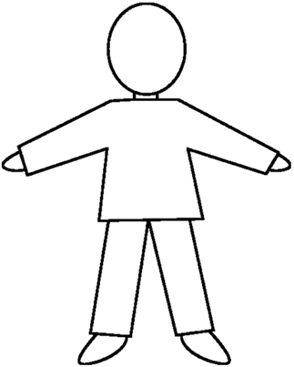 | Who am I?
 | What do I look like?
 | What do I do?
 | What sort of person am I?
MargD

