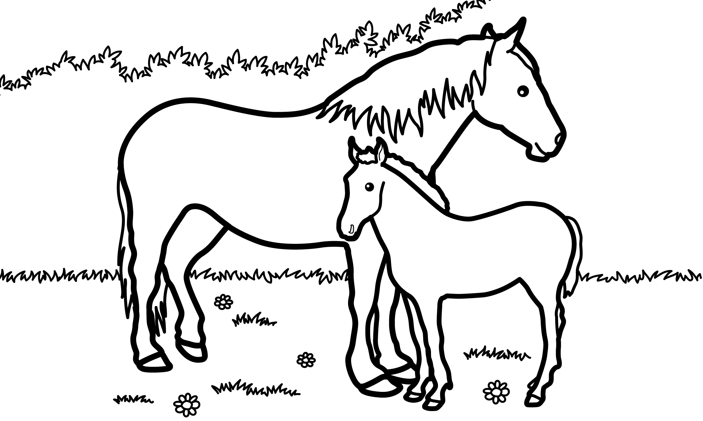
1st | 2nd | 3rd | 4th | last

MargD

