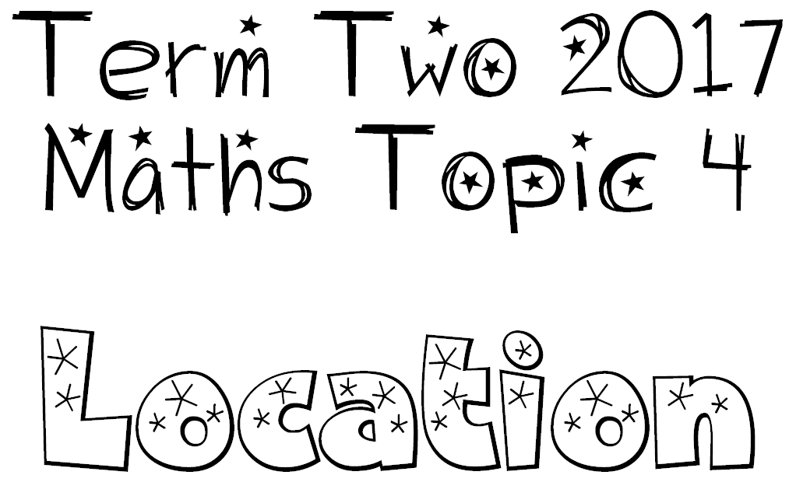

We can use a co-ordinate system or the language of direction and distance to specify locations and describe paths (position and orientation).

We can draw and interpret simple scale maps.

We can use maps or plans to propose actions.
We use a compass to specify and find directions.

