Magnetic Letter Task Cards
Set Four

Photocopy onto coloured paper (best enlarged to A3). You only need one set for small group work. Laminate and cut. Store with magnetic letters.

(Tip: Small flat oven trays make great individual work areas for magnetic letter work.)

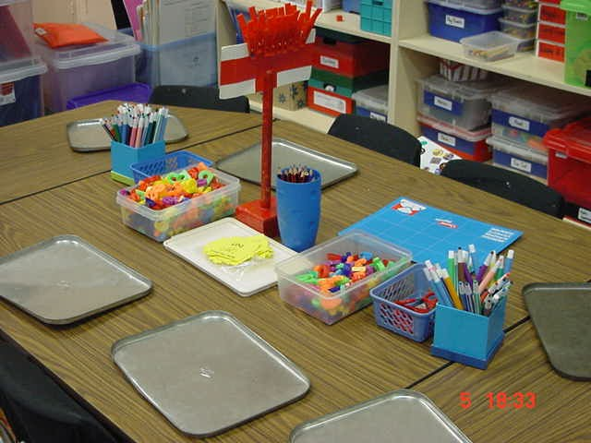

MAGNETIC LETTERS  Make the word  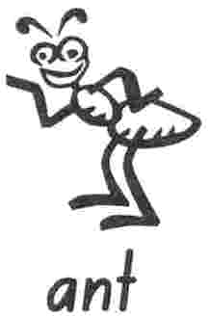 | MAGNETIC LETTERS  Make the word  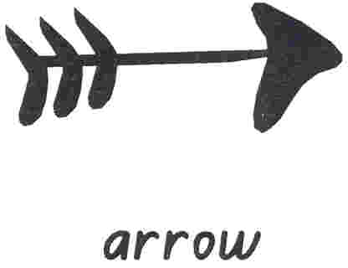
MAGNETIC LETTERS  Make the word  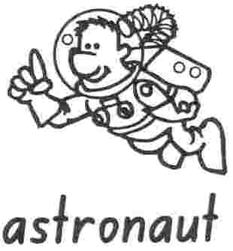 | MAGNETIC LETTERS  Make the word  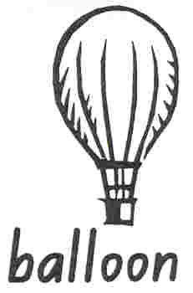
MAGNETIC LETTERS  Make the word   | MAGNETIC LETTERS  Make the word  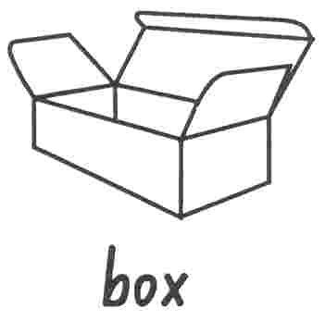
MAGNETIC LETTERS  Make the word  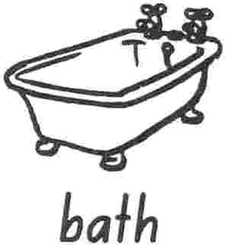 | MAGNETIC LETTERS  Make the word  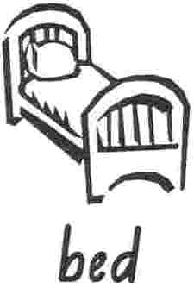

MAGNETIC LETTERS  Make the word  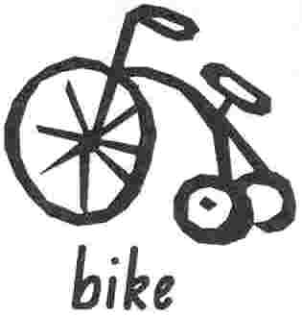 | MAGNETIC LETTERS  Make the word  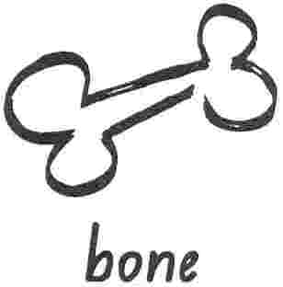
MAGNETIC LETTERS  Make the word  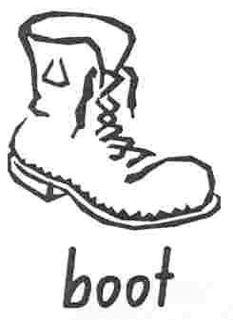 | MAGNETIC LETTERS  Make the word  
MAGNETIC LETTERS  Make the word   | MAGNETIC LETTERS  Make the word  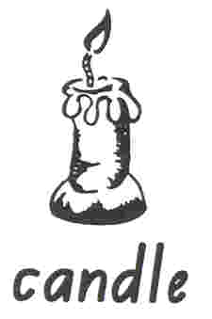
MAGNETIC LETTERS  Make the word  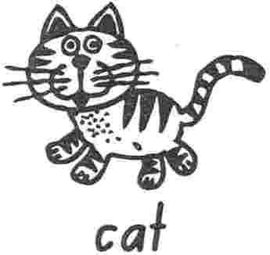 | MAGNETIC LETTERS  Make the word  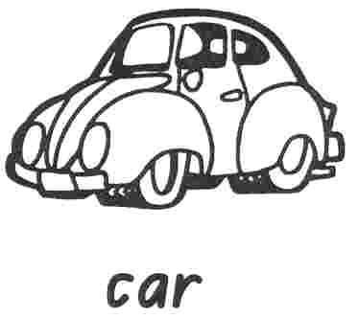

MAGNETIC LETTERS  Make the word  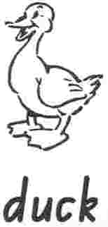 | MAGNETIC LETTERS  Make the word  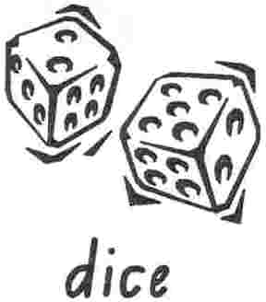
MAGNETIC LETTERS  Make the word  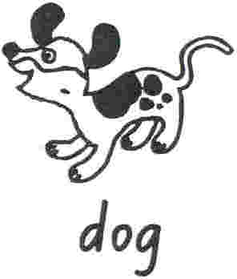 | MAGNETIC LETTERS  Make the word  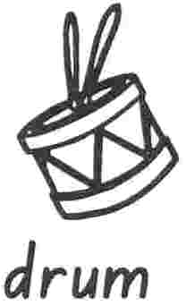
MAGNETIC LETTERS  Make the word  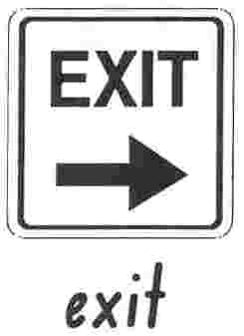 | MAGNETIC LETTERS  Make the word  
MAGNETIC LETTERS  Make the word  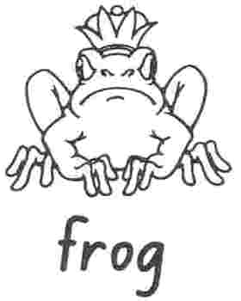 | MAGNETIC LETTERS  Make the word  

MAGNETIC LETTERS  Make the word  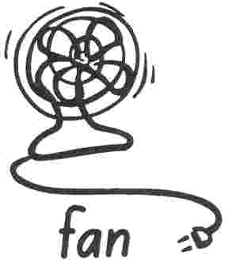 | MAGNETIC LETTERS  Make the word  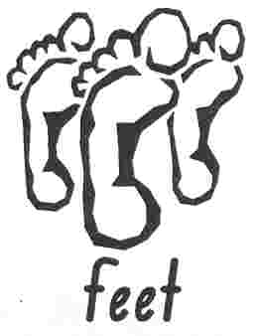
MAGNETIC LETTERS  Make the word  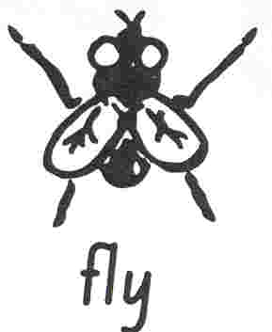 | MAGNETIC LETTERS  Make the word  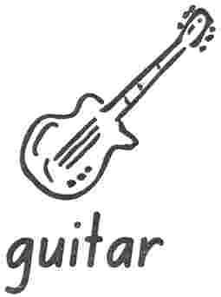
MAGNETIC LETTERS  Make the word  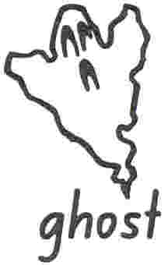 | MAGNETIC LETTERS  Make the word  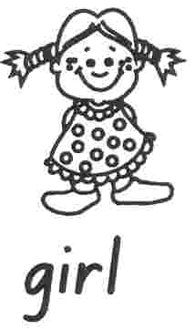
MAGNETIC LETTERS  Make the word   | MAGNETIC LETTERS  Make the word  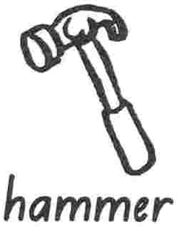

MAGNETIC LETTERS  Make the word  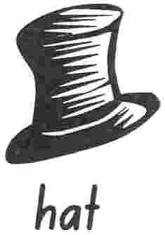 | MAGNETIC LETTERS  Make the word  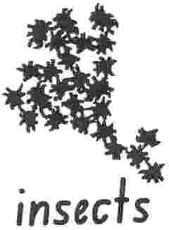
MAGNETIC LETTERS  Make the word  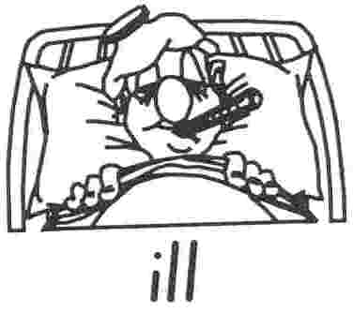 | MAGNETIC LETTERS  Make the word  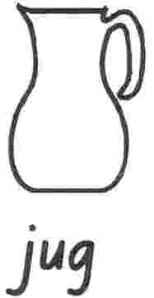
MAGNETIC LETTERS  Make the word  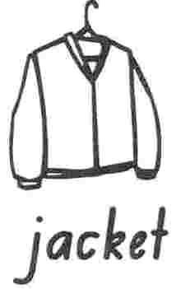 | MAGNETIC LETTERS  Make the word  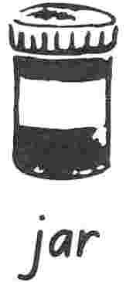
MAGNETIC LETTERS  Make the word   | MAGNETIC LETTERS  Make the word  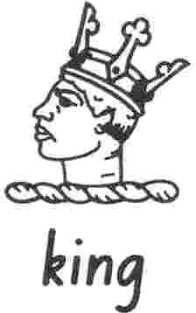

MAGNETIC LETTERS  Make the word   | MAGNETIC LETTERS  Make the word  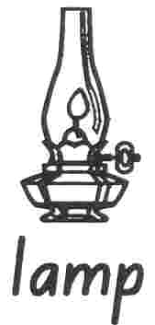
MAGNETIC LETTERS  Make the word  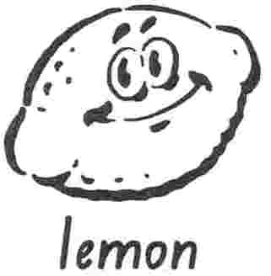 | MAGNETIC LETTERS  Make the word  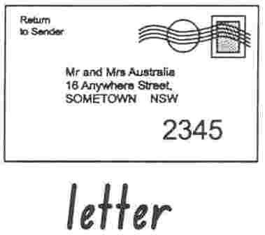
MAGNETIC LETTERS  Make the word  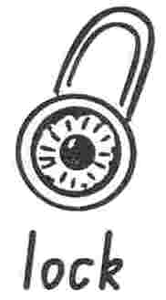 | MAGNETIC LETTERS  Make the word  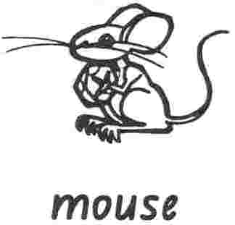
MAGNETIC LETTERS  Make the word   | MAGNETIC LETTERS  Make the word  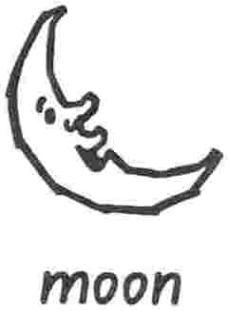

MAGNETIC LETTERS  Make the word  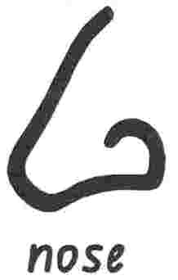 | MAGNETIC LETTERS  Make the word  
MAGNETIC LETTERS  Make the word  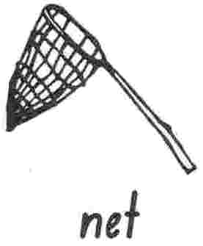 | MAGNETIC LETTERS  Make the word  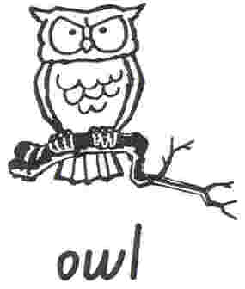
MAGNETIC LETTERS  Make the word   | MAGNETIC LETTERS  Make the word  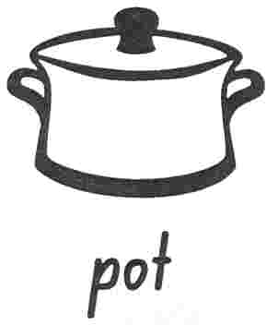
MAGNETIC LETTERS  Make the word  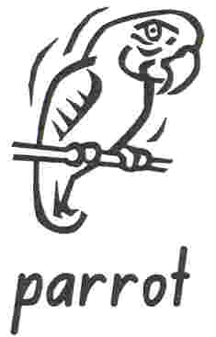 | MAGNETIC LETTERS  Make the word  

MAGNETIC LETTERS  Make the word  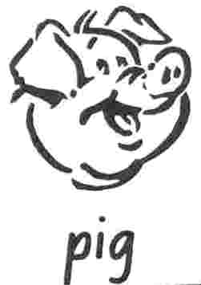 | MAGNETIC LETTERS  Make the word  
MAGNETIC LETTERS  Make the word  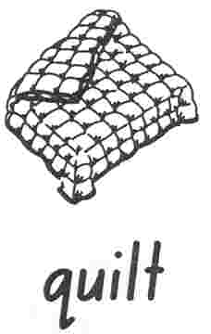 | MAGNETIC LETTERS  Make the word  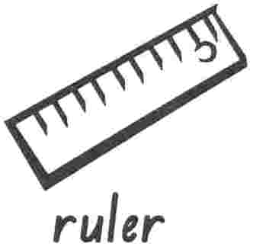
MAGNETIC LETTERS  Make the word  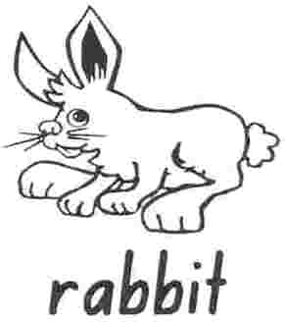 | MAGNETIC LETTERS  Make the word  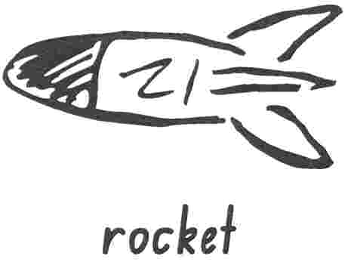
MAGNETIC LETTERS  Make the word   | MAGNETIC LETTERS  Make the word  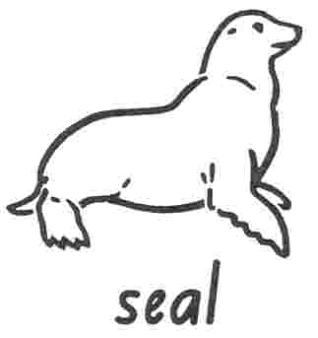

MAGNETIC LETTERS  Make the word  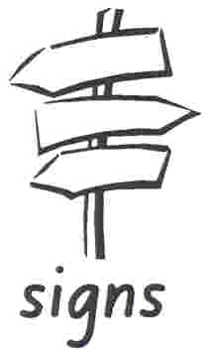 | MAGNETIC LETTERS  Make the word  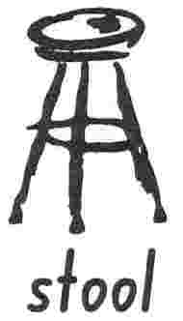
MAGNETIC LETTERS  Make the word  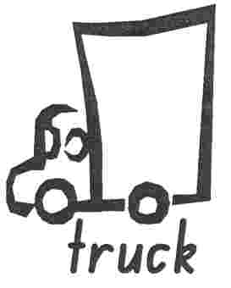 | MAGNETIC LETTERS  Make the word  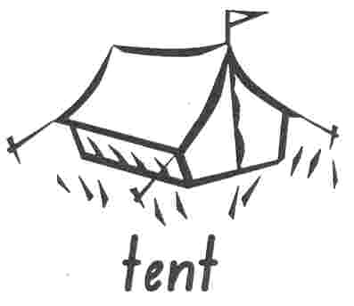
MAGNETIC LETTERS  Make the word   | MAGNETIC LETTERS  Make the word  
MAGNETIC LETTERS  Make the word  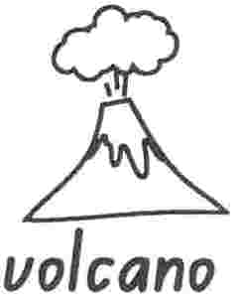 | MAGNETIC LETTERS  Make the word  

MAGNETIC LETTERS  Make the word  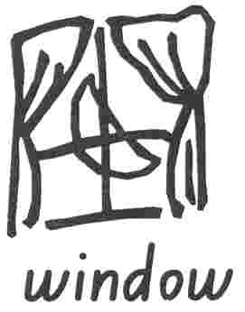 | MAGNETIC LETTERS  Make the word  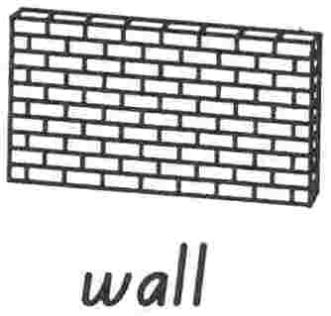
MAGNETIC LETTERS  Make the word   | MAGNETIC LETTERS  Make the word  
MAGNETIC LETTERS  Make the word  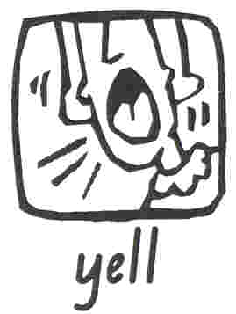 | MAGNETIC LETTERS  Make the word  
MAGNETIC LETTERS  Make the word  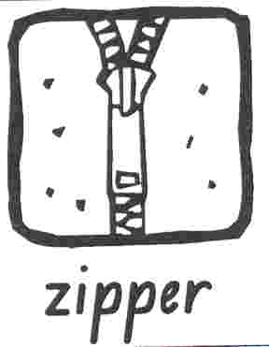 | MAGNETIC LETTERS  Make the word  

