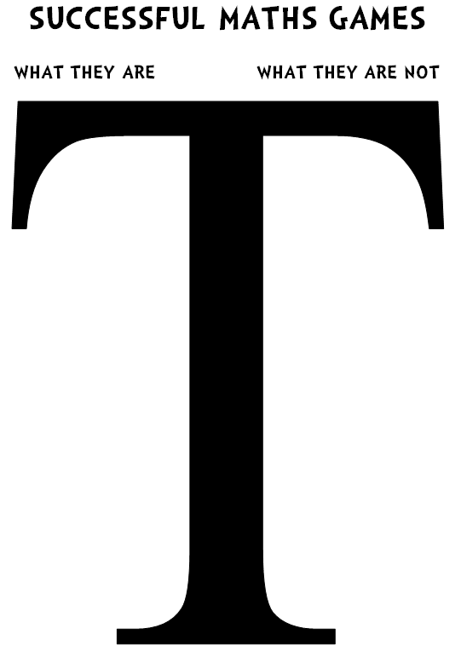
SUCCESSFUL MATHS GAMES

WHAT THEY ARE WHAT THEY ARE NOT

Roll the dice too far or so it falls off the table
Watch the other player play too to make sure everyone’s playing fairly
At the end of the game, shake hands and say well done
“Na na, I won and you lost!”
Cheating – changing the dice or being unfair
Roll the dice properly

