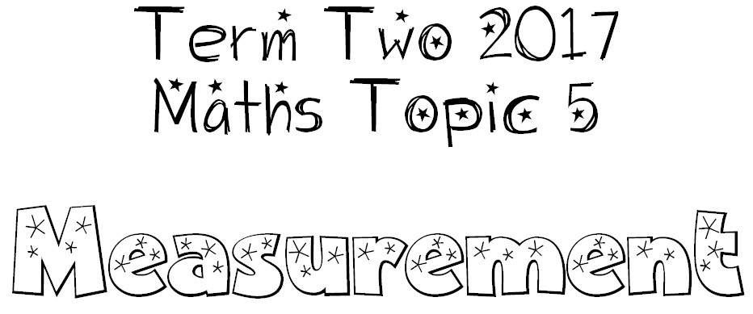

We can measure, order and compare objects using familiar metric units
- of length and perimetre. (km, m, cm, mm)
- of mass (weight). (g, kg)
- of capacity and volume (mL, L)

The way we measure needs to be uniform for measurements to be meaningful

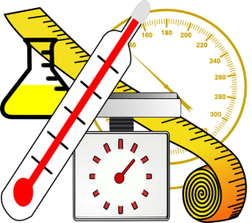
We can convert between standard units of measure

metre
gram
litre

