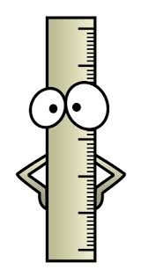
What do I know about measurement?
Name: __________________________
What unit of measurement would you use to measure the length of this paper?
cm m km (Circle the correct answer)
How long do you think the length of this paper is? ____________

What unit of measurement would you use to measure the length of a netball court?
cm m km (Circle the correct answer)
How long do you think the length of the netball court is? ________

Measure the objects below using the ruler provided.

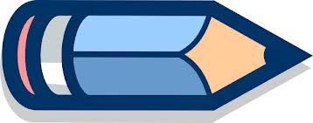
________cm
0 |  | 1 |  | 2 |  | 3 |  | 4 |  | 5 |  | 6 |  | 7 |  | 8 |  | 9 |  | 10 |  | 11

________cm
0 |  | 1 |  | 2 |  | 3 |  | 4 |  | 5 |  | 6 |  | 7 |  | 8 |  | 9 |  | 10 |  | 11

What is the area of this shape?
(Each grid square is 1cm²?)

What is the perimeter of this shape?

What is the area of this shape?

What is the perimeter of this shape?

3cm
8cm

4 cm
7 cm
4cm
8cm

What is the area of this shape? __________________

What is the perimeter of this shape? ___________________

List all the different ways you can measure this lunchbox.

