Make a Toy Activity

Working in pairs or individually

Model activity first

Using connecting cubes, children construct a small toy.

Each block they use costs 50c

Each person who works on the toy must be paid $5.00 salary

How much is your toy going to cost at the shop?

Model with giraffe

I used 15 cubes, so that’s $7.50 to pay for the cubes

I was the only one who made it, so I need $5.00 in salary

So my toy will cost $12.50 in the shop

Show kids how to work out the cost either on the whiteboard by drawing the coins or on the floor using the actual 50c pieces.

Students write and draw their results onto worksheet

My toy used ______ cubes, so that cost _______

My salary costs were _______ ($5 for each person)

The total cost of my toy is _______

Display toys on back wall

Photograph the originals

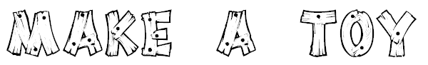
Name:
My toy looks like this:
My toy used ______ cubes, so that cost _______

My salary costs were _______ ($5 for each person)

The total cost of my toy is _______

