Maths Unit Planner
Money

Grade 2 Term III Weeks 1 - 3 2015
AusVELS
Count and order small collections of Australian coins and notes according to their value (ACMNA034)
- identifying equivalent values in collections of coins or notes, such as two five-cent coins having the same value as one 10-cent coin
- counting collections of coins or notes to make up a particular value, such as that shown on a price tag

Learning Activities
- Initial Assessment task – sheet to be used to form groups that Fran and I can use to keep tabs on each ability level and track progress
- Mini Maths Shows to tune in at the beginning of each lesson – Fran and I perform a quiz format to teach money concepts. Eg. ‘What coin am I?’ used to teach the features of coins
- Achievement sheet – each child receives a sheet to record their progress through the stations and to record the achievements of the targets set.
- Money vocab – integrated into Daily 5 word work
- Money stations – these are the major activities the children will be engaged in. Students will choose which stations they wish to do, but use an achievement sheet to record so teachers can check they’ve done them all and had fair access to all. Stations are set up in chair bags containing the equipment needed and ‘We can’ instructions on the front.
Matching Cards
We can...
use the cards to play snap.
use the cards to play memory.
match the cards that are the same value.
Money Ordering
We can...
lay all the cards out on the floor like a tall building, then put them in order from lowest value to highest value.
use coins to make each amount.
Money Spinners
We can...
spin the spinner and collect the coins the spinner lands on. After 10 goes we can add up our money.
Guess the Coin
We can...
take turns picking a coin or note from the bag and the others ask us questions so they can guess what the coin or note is. Only questions that can be answered with ‘yes’ or ‘no’ are allowed.
Catalogue Shopping
We can...
find items in the catalogue that we would like and find the right coins to match how much they cost.
Book Shop
We can...
take a purse and put money in it.
choose a book and pay the shop keeper for it.
take turns being shop keeper and give shoppers the right change.
Coin Lotto
We can...
take turns rolling a dice and covering the coin on our mat that matches with a blue counter.
use equal coins to cover.

Ways to Make
We can...
put coins and notes on the mats to show different ways of making the amount at the top of the page.
Money Dominoes
We can...
add up the value of one side of each tile and match it to another tile.
Shopping game
We can...
read the rules and play the game.
Counting Money sheets
We can...
add the money and write the totals in our maths books.
(Source: https://www.homeschoolmath.net/worksheets/australian-money.php)
Hard Cards!
We can...
match the cards that are the same value.
Money Videos
We can...
watch the videos to learn about Australian money.
(Sources: https://www.youtube.com/watch?v=NRWeQQ9qZ9I
https://www.youtube.com/watch?v=7_5_rX_1s-8
https://www.youtube.com/watch?v=5Mk6Tzno0ww
https://www.youtube.com/watch?v=rMy7WDt2Hr4
https://www.youtube.com/watch?v=KyNMYgZA8_E
Money Bags game
We can...
read the rules and play the game.

- Make a Toy Investigation – students build a toy keeping track of cost of materials and labour ($1 per cube, $5 for labour) Compare toys – display and discuss: Who made the cheapest, dearest, most popular etc.
- Worksheets from ‘All About Money’ book
- Maths Quiz powerpoint for whole class coin adding and discussion of strategies

Learning Wall
What do Grade 2s need to learn about Money?

We need to learn the names of all the coins and notes
We need to learn the properties of the coins and notes so we can identify them easily
We need to skip count by 5s, 10s, 20s and 50s so we can count coins quickly
We need to use notes and coins to make equivalent amounts
We need to order coins and notes by their value
We need to add coins and notes
We need to make change from $1.00 and higher (up to $10.00)

These are the coins...
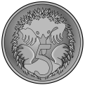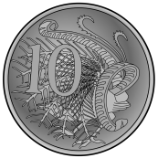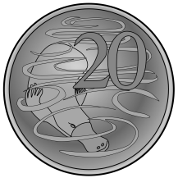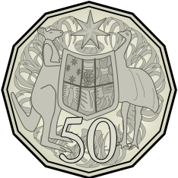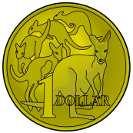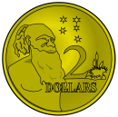
These are the notes...
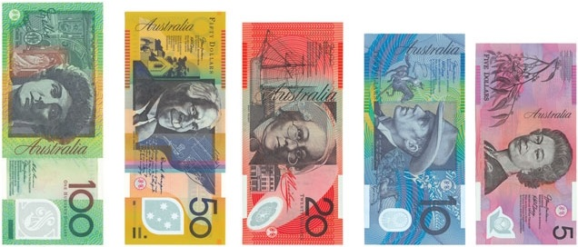

Words I need to know and understand...

value, amount, dollar, cent, coin, note, change, total, decimal, five, ten, twenty, fifty, one hundred,
one, two, $ c
Lesson Timetable
Week 1
Monday | Tuesday | Wednesday | Thursday | Friday
Teacher Inservice | Specialist Day | Assessment task – early finishers play shop and make coin rubbings  Mini Maths Show – ‘What coin am I?’  Introducing the achievement sheet and the money stations | Short session before PE  Number kits and games | Mini Maths Show – ‘What coin am I?’  Money stations – students work through various stations set up to practise money skills – adding, exchanging, coin and note recognition

Week 2
Monday | Tuesday | Wednesday | Thursday | Friday
Mini Maths Show – ‘What coin am I?’  Money stations – students work through various stations set up to practise money skills – adding, exchanging, coin and note recognition | Specialist Day | Mini Maths Show – ‘What coin am I?’  Money stations – students work through various stations set up to practise money skills – adding, exchanging, coin and note recognition | Short session before PE  Number kits and games | Mini Maths Quiz – ‘How much?’ powerpoint  Money stations – students work through various stations set up to practise money skills – adding, exchanging, coin and note recognition

Week 3
Monday | Tuesday | Wednesday | Thursday | Friday
Green  Hats  Planks  Workshop | Specialist Day | Mini Maths Quiz – ‘How much?’ powerpoint  Maths worksheets  Money stations – students work through various stations set up to practise money skills – adding, exchanging, coin and note recognition | Short session before PE  Number kits and games | Mini Maths Quiz – ‘How much?’ powerpoint  Make a toy investigation  Maths worksheets

Unit Evaluation
Would be better to assign students to stations – self directed thing was a mixed success
Make a toy was a huge success – would do multiple sessions of these next time.

Initial Assessment

Name:__________________________
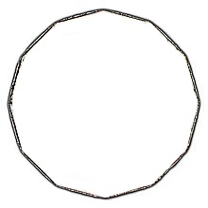
- These are all the coins

- These are all the notes

- When I add all these coins, it makes....
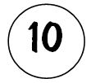
- When I add all these coins, I get...
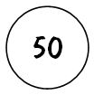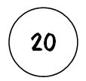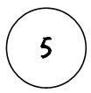
- I can make $2 in three ways
- I have $1. I spend 80c. How much do I have left?

- I have $10.00 I spend $4.50. How much do I have left?
My Learning Achievements for
Name: ____________________
Money Stations I Have Done...
Matching Cards |  |  |  |  | Money Ordering
Money Spinners |  |  |  |  | Guess the Coin
Catalogue Shopping |  |  |  |  | Book Shop
Coin Lotto |  |  |  |  | Ways to Make
Money Dominoes |  |  |  |  | Shopping game
Counting Money sheets |  |  |  |  | Hard Cards!
Money Videos |  |  |  |  | Money Bags game

I can name all the coins and notes | 5 10 20 50 1 2  5 10 20 50 100
I can name the properties of the coins and notes | Colours Pictures
I can skip count by 5s, 10s, 20s and 50s | 5s 20s  10s 50s
I can add coins and notes | Coins Notes Coins & Notes
I can order coins and notes by their value
I can use notes and coins to make equivalent amounts
I can make change from $1.00 and higher (up to $10.00)

