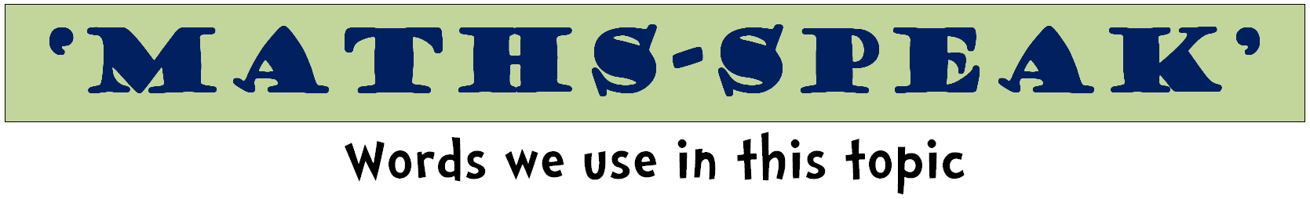
equation | equal to |  | symbol
total | answer |  | equals
compare | plus |  | check
same as | total |  | solve
equals | count |  | operation
unequal | correct |  | incorrect
symbol | sign |  | plus
sum | add |  | difference
subtract | take away |  | product
times | share |  | how many
shared between |  | number sentence
order | right |  | wrong
missing number | less than |  | greater than
halve | double |  | rule

add | plus | addition
sum | increase | altogether
more | subtract | subtraction
left | difference between
minus | decrease | take away
equation | operation | symbol
total | score | sign
number facts | leaves | same as
multiply | times | multiplication
array | row | column
repeated addition |  | multiplied by
group | groups of | lots of
equal groups | product | number facts
divide | divided by | division
share equally | how many | split
left over | equation | operation
symbol | sign | same as

