MATHEMATICS WEEKLY/UNIT PLANNER
Level: Gr 3/4 Term: 1 2017 Weeks: 5 - 9
Teachers: Sinead, Kellie and Marg
Dimension: Number and Algebra
Specific Focus for Unit: Place Value
Victorian Curriculum Content Descriptions  http://victoriancurriculum.vcaa.vic.edu.au/mathematics/introduction/rationale-and-aims | Key Concepts  https://drive.google.com/file/d/0B3ydL4IWBSAbbk5laWtLOEprYXc/edit
Gr 2:  Recognise, model, represent and order numbers to at least 1000 (VCMNA104)  Group, partition and rearrange collections up to 1000 in hundreds, tens and ones to facilitate more efficient counting (VCMNA105)  Gr 3:  Recognise, model, represent and order numbers to at least 10 000 (VCMNA130)  Apply place value to partition, rearrange and regroup numbers to at least 10 000 to assist calculations and solve problems (VCMNA131)  Gr 4:  Recognise, represent and order numbers to at least tens of thousands (VCMNA152)  Apply place value to partition, rearrange and regroup numbers to at least tens of thousands to assist calculations and solve problems (VCMNA153)  Gr 5:  Use estimation and rounding to check the reasonableness of answers to calculations(VCMNA182)  Recognise, represent and order numbers to at least hundreds of thousands (VCMNA186) | Partitioning  - Recognising that numbers can be ‘broken up’ in different ways e.g. 154= 15 tens and 4 ones or 14 tens and 14 ones  Base 10 System  - Recognising that our number system is based on grouping quantities in tens. Each place has a value that is 10 times greater than the place to its right and one tenth to the value to its left  Digit position  - The place of a digit determines its value, including recognising zero as a place holder

Pre-Assessment | NAPLAN misconceptions | Learning Intentions
Task:  SINE Number Assessment Year A  Misconceptions:  -Understandings of equal signs (same as)  -Algorithms can be written backwards and forward  -Creating visual representations of multiplication and division  - Recognising that zero is a place holder  - 1000 more and 1000 less  - 10 less than 201 is 191.  Strengths:  - Sequencing numbers  - | - Reading number lines  - (Q29) - Reading, recognising and interpreting place value.  - Place value (reading and writing 4 digit numbers), particularly that zero is a placeholder (q14)  - Solving number sentences such as 20 = 25 - ___ | We need to understand our number system so we can handle larger and more difficult numbers.  The value of a number depends on its position or place.  Our number system is based on grouping quantities in tens and using 0,1,2,3,4,5,6,7,8,9 to record these.  We can ‘break up’ numbers in different ways - eg. 154= 15 tens and 4 ones or 14 tens and 14 ones  We can use 0 as a place holder - eg. in 208 the zero means there are no tens  A number with many digits can be hard to read. We cluster the digits in groups of three,  starting from the ones place  Multiplying a number by ten shifts each digit one place to the left.

SESSION NUMBER  KEY IDEA  LEARNING INTENTION | TOOL SESSION  A short, sharp task relating to fluency in mental computation or the focus of the lesson.  WHOLE CLASS FOCUS  Sets the scene/context for what students do in the independent session. | INVESTIGATION SESSION  Extended opportunity for students to work in pairs, small groups or individually. A time for teacher to probe children’s thinking or work a small group for part of the time. | REFLECTION  Focused teacher questions and summary to draw out the mathematics and assist chn to make link/s. | TEACHER ASSESSMENT  We are looking for...
Session 1  LEARNING INTENTION  We need to understand our number system so we can handle larger and more difficult numbers. | TOOL SESSION  https://em-ccss.everydaymathonline.com/pdf/gameboards/BKG_G3_base10.pdf  or  Number of the Moment  WHOLE CLASS FOCUS  Introduction of topic and guide through the learning intentions on the cover sheet.  https://www.youtube.com/watch?v=21l3Jg5_MCg&list=PLDQlSh98XAywTatIwQKMAyPa4rtMl6Ft5&t=10s&index=19  Introduction to place value  https://www.youtube.com/watch?v=a4FXl4zb3E4  Place Value Song For Kids | Ones, Tens, and Hundreds and shows the pattern  ‘Where’s My Number?’ game. Class designates a number between 0 and 9. Use the random number generator (set between 0 -100). If designated number is in ones position, students put hands on knees, tens - hips, hundreds - shoulders, thousands - heads (Can be extended to tens of thousands - hands in air)  Can be played as elimination game where kids who are out sit down. | INVESTIGATION  Task: Rip Apart 100  Give children counters, beans icy-pole sticks or coloured matchsticks. Ask them to count out 100. Use the counters to show how 100 can be ripped apart in many different ways. Ask the children to make statements about the different ways they  have ‘ripped part’ the number 100. For example, 87 + 13 = 100 Record and check with a calculator  Then investigate: if one of the parts must be a multiple of ten, how many different ways can you rip apart 100? Students record answers  Extending Prompts:  Use 1000  Enabling Prompts:  Begin with 10 | REFLECTION  Share results  Use post-its and half post-its to show numbers eg.  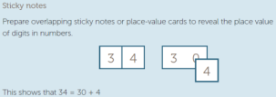 | That student have mastery over numbers to 100 and planning alternatives for those who don’t.

Session 2  LEARNING INTENTION  The value of a number depends on its position or place. | TOOL SESSION  ‘Where’s My Number?’ game  WHOLE CLASS FOCUS  https://www.youtube.com/watch?v=qJJugG1bTf4&index=22&list=PLDQlSh98XAywTatIwQKMAyPa4rtMl6Ft5  How to read numbers in the millions  How Much am I Worth?  Use the random number generator to display numbers. From a cup pull a post it (post-its say ones, tens, hundreds, thousands - more if needed) Students must identify the correct number that is worth that was pulled out place and show it with MAB | INVESTIGATION  Task: Roll, Write and Value  Students roll dice (number of dice determined by their ability to cope with 2,3,4,5,6 -digit numbers) to produce a number which they write. Then pull from cup a value and write is beside. Students then write in what that place is worth  Extending Prompts:  Using more numbers into tens and hundreds of thousands, millions  Enabling Prompts:  Keeping it to 2 and 3 digit numbers | REFLECTION  This task can also be done with cards with any picture card designated as a 0 (Aces = 1)  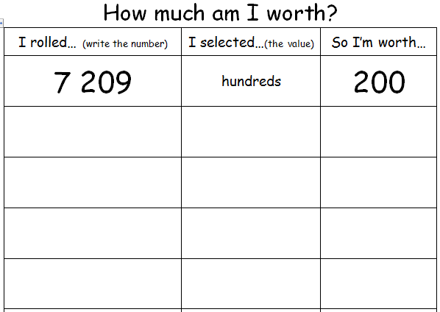 | Can students correctly identify numbers by their position?  Students’ level of mastery of numbers for their grade standard (Vic Curric)  Gr 3: to at least 10 000  Gr 4: to at least tens of thousands
Session 3  LEARNING INTENTION  Our number system is based on grouping quantities in tens and using 0,1,2,3,4,5,6,7,8,9 to record these.  We can use 0 as a place holder - eg. in 208 the zero means there are no tens | TOOL SESSION  ‘Where’s My Number?’ game  WHOLE CLASS FOCUS  Place Value ‘It’s All Connected Mats’  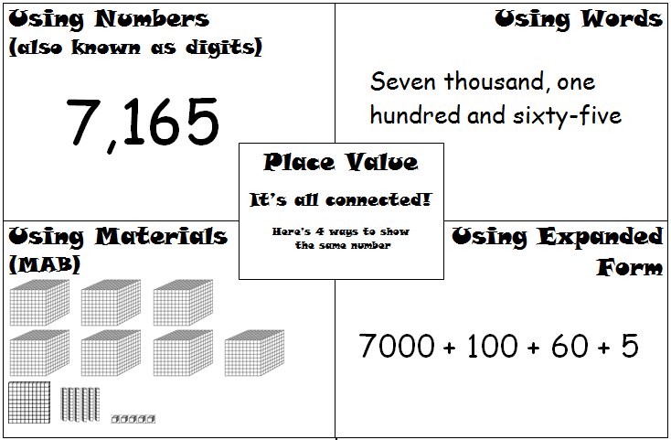 | INVESTIGATION  Task: ‘It’s All Connected’  Students use ‘All Connected’ mats (under whiteboard screens)  Extending Prompts:  Using more numbers into tens and hundreds of thousands, millions  Enabling Prompts:  Keeping it to 2 and 3 digit numbers | Follow up extended notation by showing that the order does not matter eg. 200 + 1000 + 5 = 1205  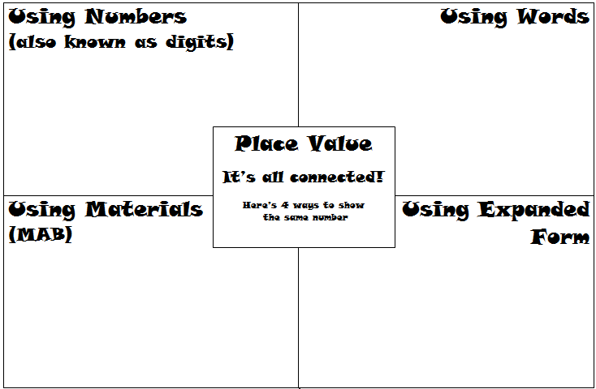 | Students’ level of mastery of numbers for their grade standard (Vic Curric)  Gr 3: to at least 10 000  Gr 4: to at least tens of thousands  Check if misconception from SINE test has been cleared up

Session 4  LEARNING INTENTION  Our number system is based on grouping quantities in tens and using 0,1,2,3,4,5,6,7,8,9 to record these.  We can use 0 as a place holder - eg. in 208 the zero means there are no tens | TOOL SESSION  ‘Where’s My Number?’ game and ‘It’s All Connected’  WHOLE CLASS FOCUS  Establishing rules for the Trading Game  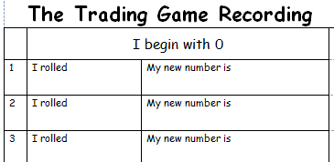 | INVESTIGATION  Task: The Trading Game  Students play in turn by rolling the die and taking the appropriate amount of units, longs, flats, etc. e.g. a roll of 19 = 1 long (10) and 9 units (1s) and placing them on the place value mats. Students record then continue and make appropriate exchanges as needed. The winner is the first to reach the highest number after 10 rolls.  Extending Prompts:  Vary the types of die used and extend the place value mat.  Enabling Prompts:  Simplify the type of die and use the basic place value mats. | REFLECTION  Students choose 1 or 2 of the sentences to complete  (could be done orally or written in Learning Journal)  I was able to…  My success rate…  I learnt that…  I can … (refer to learning intentions)  Next time I would...  . | Students’ level of mastery of numbers for their grade standard (Vic Curric)  Gr 3: to at least 10 000  Gr 4: to at least tens of thousands
Session 5  LEARNING INTENTION  Our number system is based on grouping quantities in tens and using 0,1,2,3,4,5,6,7,8,9 to record these.  We can use 0 as a place holder - eg. in 208 the zero means there are no tens | TOOL SESSION  The Trading Game and ‘It’s All Connected’  WHOLE CLASS FOCUS  Lead students through worksheet | INVESTIGATION  Task: Worksheet of various problems taken from ‘Targeting Maths’  Extending Prompts:  Study Ladder extension  Enabling Prompts:  Teaching table intervention and support |  | Worksheet correction

Session 6  LEARNING INTENTION  We can ‘break up’ numbers in different ways - eg. 154= 15 tens and 4 ones or 14 tens and 14 ones | TOOL SESSION  The Trading Game and ‘It’s All Connected’  WHOLE CLASS FOCUS  Take a whole number and break it up using a place value mat. Do in a standard way first then try some alternative ways - eg. 154= 14 tens and 14 ones | INVESTIGATION  Task: Which of the Following  see worksheet  Extending Prompts:  Use bottom sheet  Enabling Prompts:  Use top sheet | 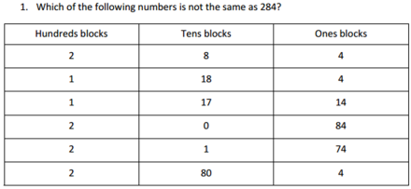  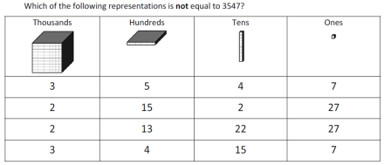
Session 7  LEARNING INTENTION  A number with many digits can be hard to read. We cluster the digits in groups of three,  starting from the ones place | TOOL SESSION  ‘Where’s My Number?’ game  WHOLE CLASS FOCUS  https://www.youtube.com/watch?v=2S0XCrzXvgw&list=PLDQlSh98XAywTatIwQKMAyPa4rtMl6Ft5&t=53s&index=22  Placing the commas song | INVESTIGATION  Task:  The Trading Game and ‘It’s All Connected’  Extending Prompts:  As in above lessons  Enabling Prompts:  As in above lessons | REFLECTION  Students choose 1 or 2 of the sentences to complete  (could be done orally or written in Learning Journal)  I was able to…  My success rate…  I learnt that…  I can … (refer to learning intentions)  Next time I would... | Check for correct writing of numbers

Session 8  LEARNING INTENTION  Multiplying a number by ten shifts each digit one place to the left. | TOOL SESSION  ‘Where’s My Number?’ game  WHOLE CLASS FOCUS  https://www.youtube.com/watch?v=U8hZae6hYpw&list=PL4nm3JnkRG--ApYd5WgHTg7T2x0PHNQ4m&index=1  "Hiking the Place Value Chart" | INVESTIGATION  Task: Place Value Hiking  Students are given a number and must increase this number by multiplying different parts of this number by 10. Choosing ones, tens, or hundreds from a cup of post-its, students multiply that value by ten and record the new number Repeat four times and compare beginning and ending numbers.  Extending Prompts:  Use 5 and 6 digit numbers  What happens if you want to go back the other way?  Enabling Prompts:  Use 2 and 3 digit numbers

