Editing Experts Name__________________
This paragraph needs 5 capital letters, 4 full stops and 1 question mark. Rewrite the passage with the corrections
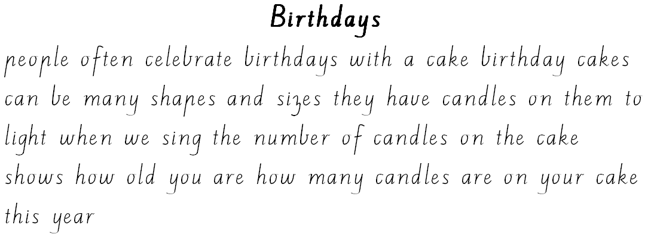
/ 10

Editing Experts Name__________________
This story needs 8 capital letters, 4 full stops and 1 exclamation mark. Five things are listed in one sentence so put 3 commas in this sentence.
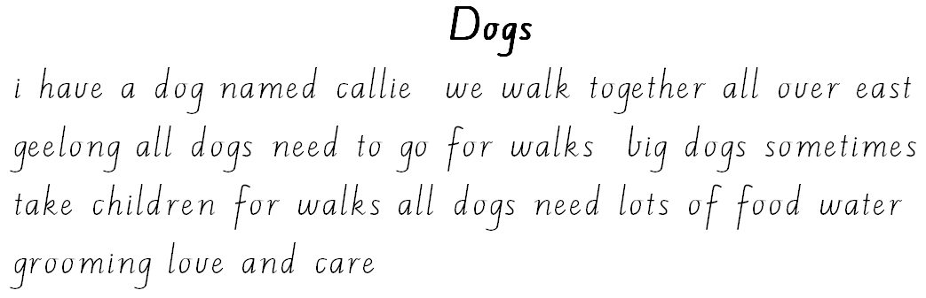
/ 16

Editing Experts Name__________________
This story needs 5 capital letters, and 4 full stops. You also need to choose the 3 correctly spelled words from the brackets to put in the paragraph.
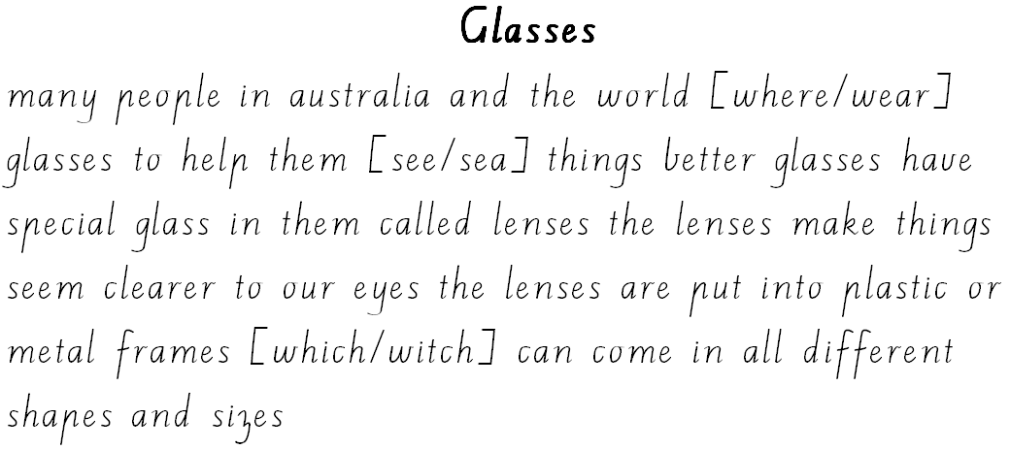
/ 12

Editing Experts Name__________________
This story needs 6 capital letters and 6 full stops. Five things are listed in one sentence so put 3 commas in this sentence. You also need to choose the 2 correctly spelled words from the brackets to put in the paragraphs.
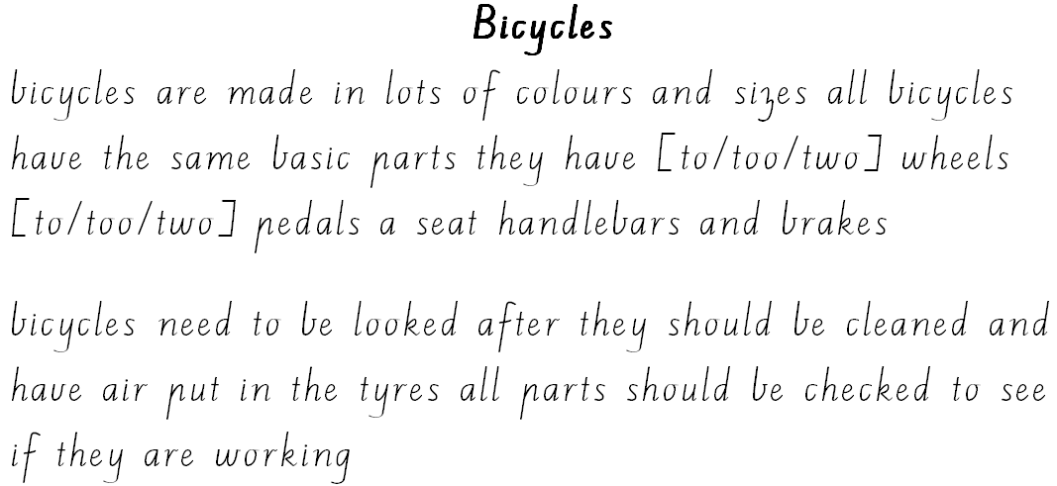
/ 17

Editing Experts Name__________________
This story needs 7 capital letters, 5 full stops and 2 commas. Two of the words are contractions so you need to put 2 apostrophes in the correct positions.
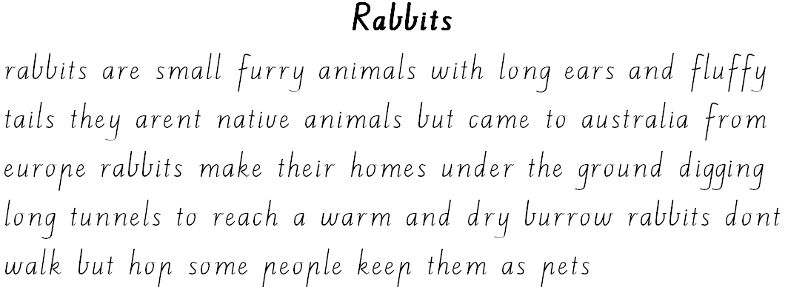
/ 16

Editing Experts Name__________________
This story needs 13 capital letters, 7 full stops and 1 question mark. One word is a contraction so you need to put 1 apostrophe in the correct position. There are two people talking so you need 2 sets of talking marks. Remember that each time a new person talks, we start a new line.
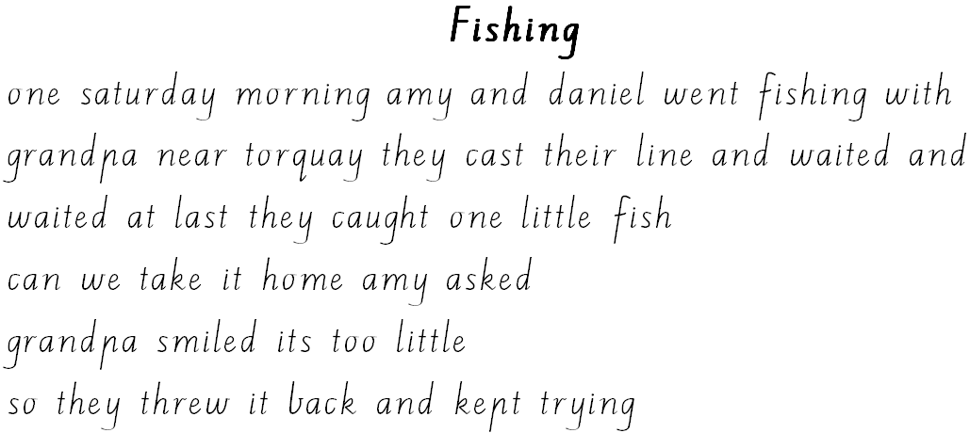
/ 23

Editing Experts Name__________________
This story needs 7 capital letters, 1 comma and 5 full stops. You also need to choose the 2 correctly spelled words from the brackets to put in the paragraphs.
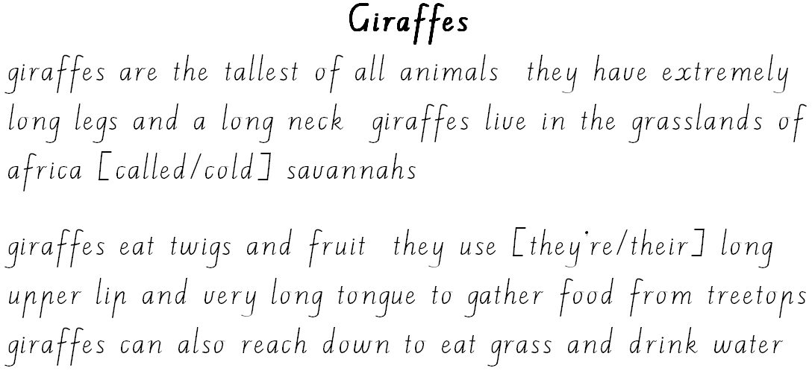
/ 15

Editing Experts Name__________________
This story needs 8 capital letters, and 4 full stops. Two words need apostrophes of possession so you need to put 2 apostrophes in the correct positions.
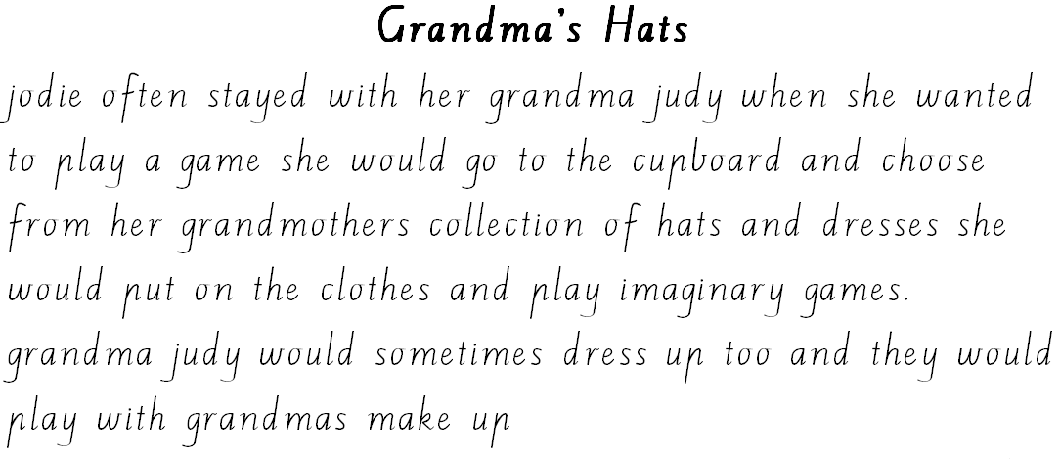
/ 14

Editing Experts Answers
This story needs 5 capital letters, 4 full stops and 1 question mark. You also need to choose the 2 correctly spelled words from the brackets to put in the paragraphs.

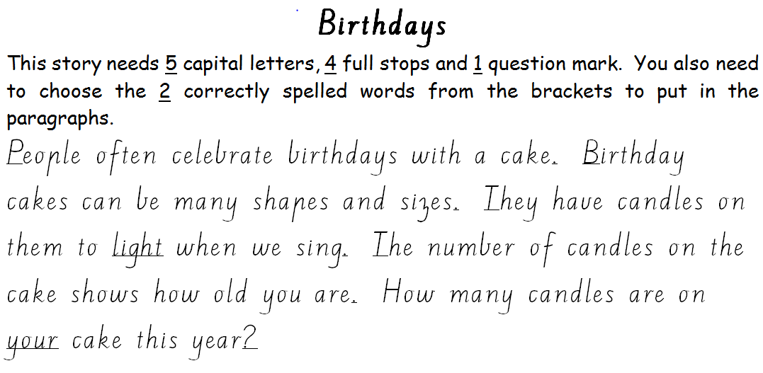

Editing Experts Answers
This story needs 8 capital letters, 4 full stops and 1 exclamation mark. Five things are listed in one sentence so put 3 commas in this sentence.

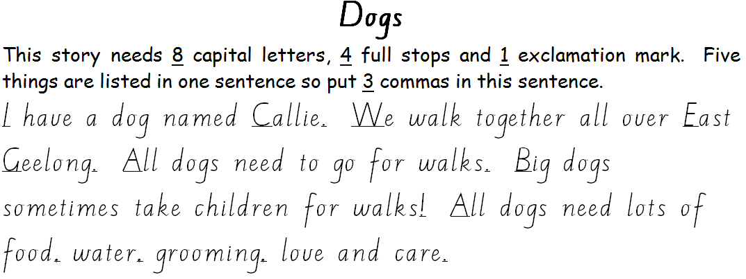

Editing Experts Answers
This story needs 5 capital letters, and 4 full stops. You also need to choose the 3 correctly spelled words from the brackets to put in the paragraph.
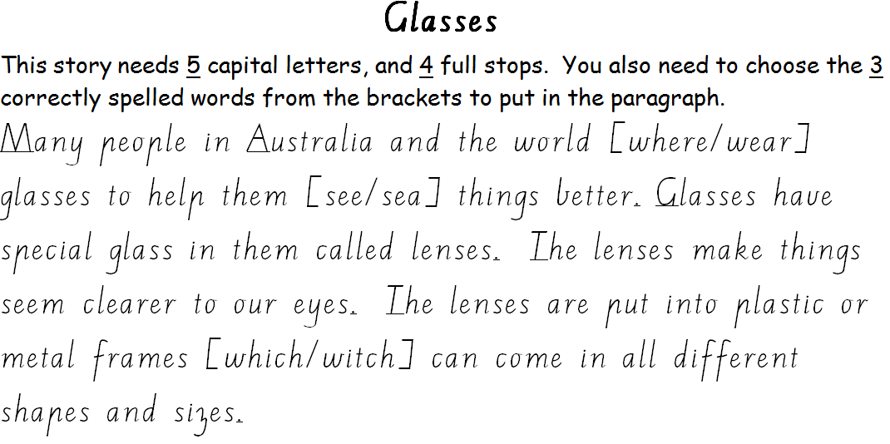

Editing Experts Answers
This story needs 6 capital letters and 6 full stops. Five things are listed in one sentence so put 3 commas in this sentence. You also need to choose the 2 correctly spelled words from the brackets to put in the paragraphs.

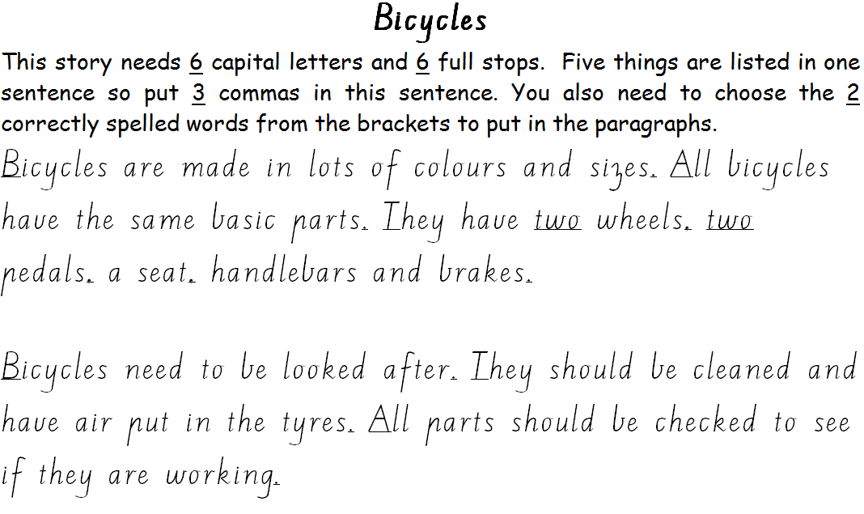

Editing Experts Answers
This story needs 7 capital letters, 5 full stops and 2 commas. Two of the words are contractions so you need to put 2 apostrophes in the correct positions.

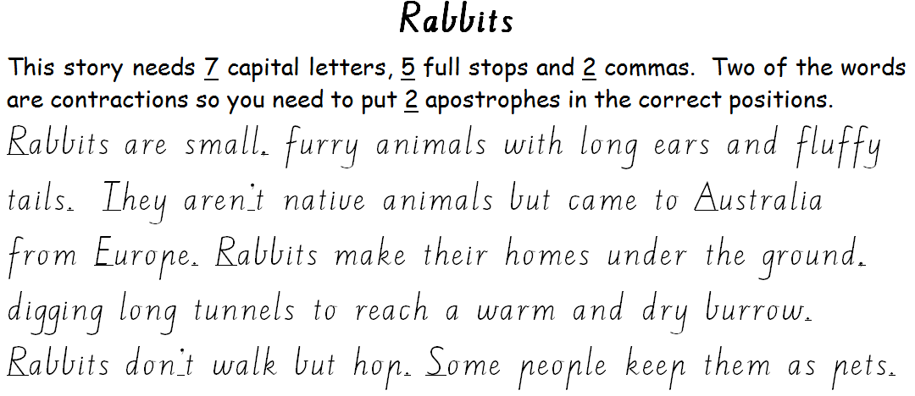

Editing Experts Answers
This story needs 13 capital letters, 7 full stops and 1 question mark. One word is a contraction so you need to put 1 apostrophe in the correct position. There are two people talking so you need 2 sets of talking marks. Remember that each time a new person talks, we start a new line.

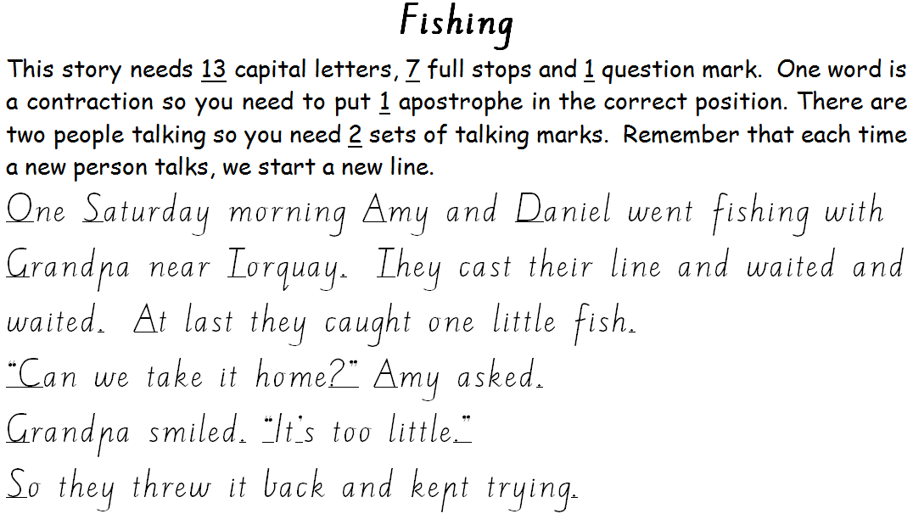

Editing Experts Answers
This story needs 7 capital letters, 1 comma and 5 full stops. You also need to choose the 2 correctly spelled words from the brackets to put in the paragraphs.

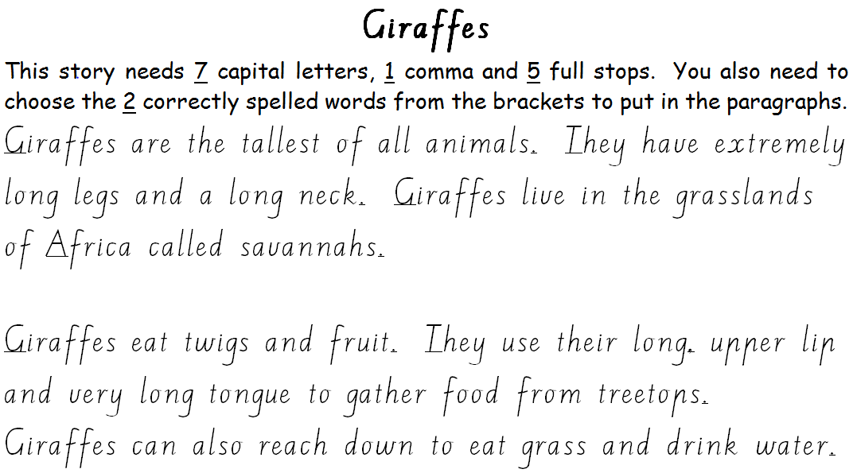

Editing Experts Answers
This story needs 8 capital letters, and 4 full stops. Two words need apostrophes of possession so you need to put 2 apostrophes in the correct positions.

