Reading Strategies

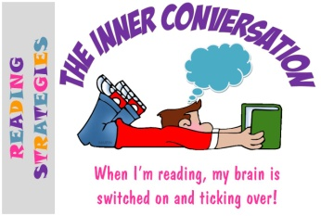 | The Inner Conversation  When I’m reading, my brain is switched on and ticking over!
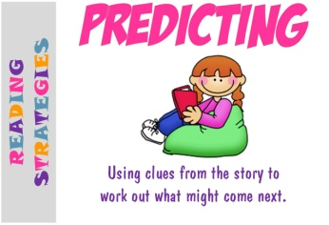 | Predicting  Using clues from the story to work out what might come next.
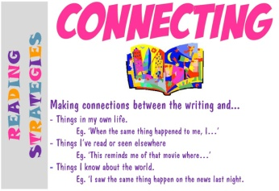 | Connecting  Making connections between the writing and...  - Things in my own life.  Eg. ‘When the same thing happened to me, I…’  - Things I’ve read or seen elsewhere  Eg. ‘This reminds me of that movie where…’  - Things I know about the world.  Eg. ‘I saw the same thing happen on the news last night.
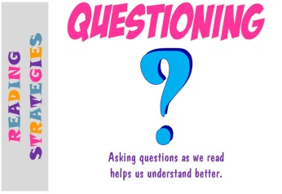 | Questioning  Asking questions as we read helps us understand better.
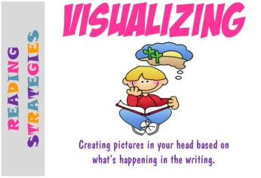 | Visualizing  Creating pictures in your head based on what’s happening in the writing.
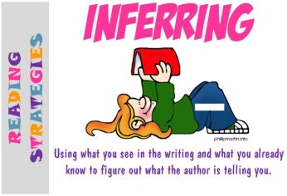 | Inferring  Using what you see in the writing and what you already know to figure out what the author is telling you.

Reading Strategies

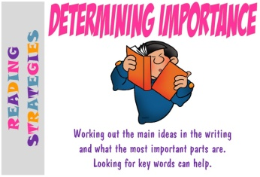 | Determining Importance  Working out the main ideas in the writing and what the most important parts are.  Looking for key words can help.
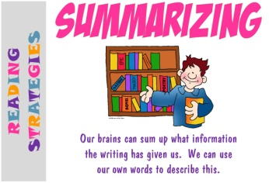 | Summarizing  Our brains can sum up what information the writing has given us.  We can use our own words to describe this.
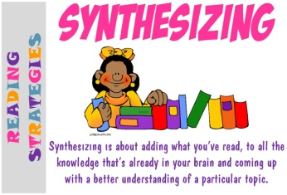 | Synthesizing  Synthesizing is about adding what you’ve read, to all the knowledge that’s already in your brain and coming up with a better understanding of a particular topic.
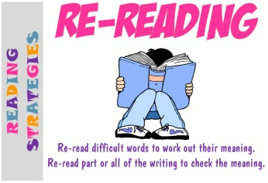 | Re-Reading  Re-read difficult words to work out their meaning.  Re-read part or all of the writing to check the meaning.
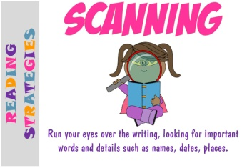 | Scanning  Run your eyes over the writing, looking for important words and details such as names, dates, places.
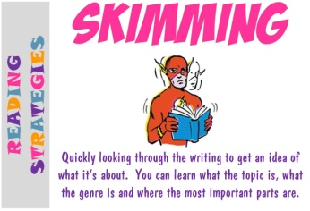 | Skimming  Quickly looking through the writing to get an idea of what it’s about.  You can learn what the topic is, what the genre is and where the most important parts are.

Reading Strategies

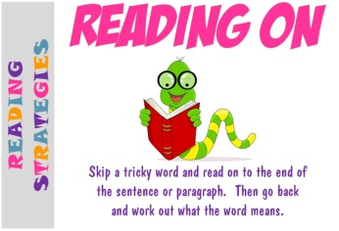 | Reading On  Skip a tricky word and read on to the end of the sentence or paragraph.  Then go back and work out what the word means.
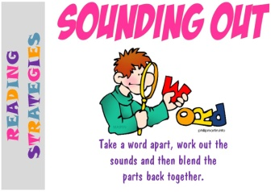 | Sounding Out  Take a word apart, work out the sounds and then blend the parts back together.
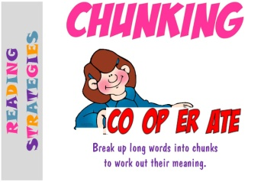 | Chunking  Break up long words into chunks to work out their meaning.
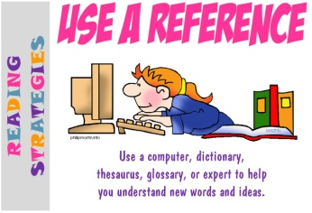 | Use a Reference  Use a computer, dictionary, thesaurus, glossary, or expert to help you understand new words and ideas.
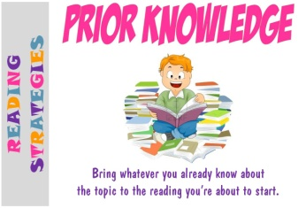 | Prior Knowledge  Bring whatever you already know about the topic to the reading you’re about to start.
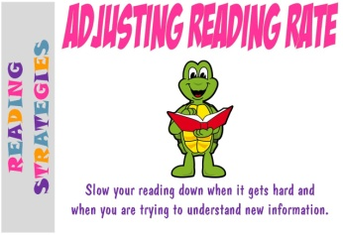 | Adjusting Reading Rate  Slow your reading down when it gets hard and when you are trying to understand new information.

