Kids’  names | Kids’  names | Kids’  names | Kids’  names
Poetry  Read to Self Box | Magazines  My Book Box | Where’s Wally  Author Collections  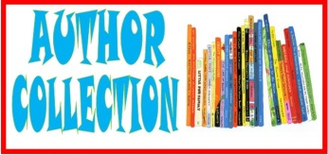 | Information  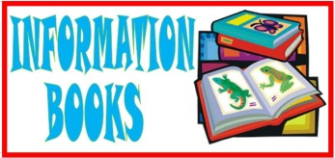  Computer Stories
Kids’  names | Kids’  names | Kids’  names | Kids’  names
Read to Self Box  Poetry | My Book Box  Magazines | Author Collections  Where’s Wally? | Computer Stories  Information Books

MargD

