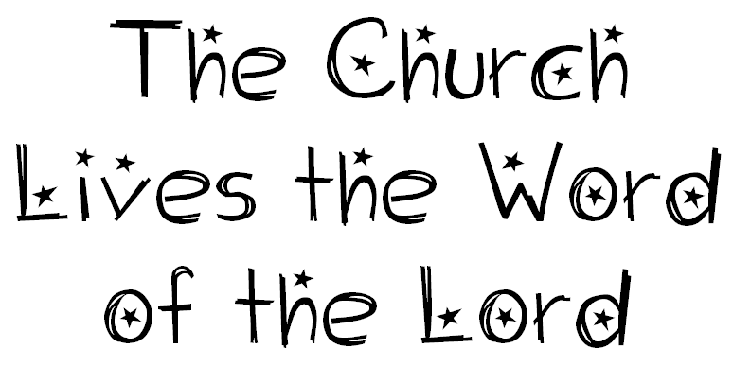

Seeking Discoveries
What do we learn about God and God’s people in the Bible?
What do we learn about Jesus Christ and the early Christian community in the Bible?
Why is it important to read the Scriptures?
How do people live the word of God today?
Understandings
Scripture is one important way that we can come to know God, Jesus Christ and the Holy Spirit and the story of God’s people.
The Old Testament tells us about God’s love for the Chosen People.
The New Testament tells us about the life and teachings of Jesus Christ and the growth of the early Church.
People can be inspired to live the Word of God when they read, think about and pray the Scriptures.
People can live the Word of God through the things they think, say and do.
Scripture Text
Mt 13: 4–9 The Parable of the Sower; Ex 16: 1–17.

