What can you tell me about this picture?
What information can you see in the picture?
How come the animals are in lines?
What could you call this picture?
Can you make up a story about this picture?

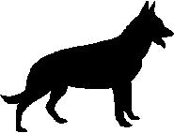 | 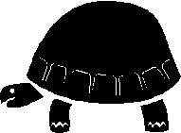 | 