MATHEMATICS WEEKLY/UNIT PLANNER
Level: Gr 3/4 Term: 1 2019 Weeks: 2-4
Teachers: Leonie Cann, Fran Stafford and Marg Dunn
Dimension: Statistics and Probability
Specific Focus for Unit: Chance

Victorian Curriculum Content Descriptions  http://victoriancurriculum.vcaa.vic.edu.au/mathematics/introduction/rationale-and-aims | Key Concepts  https://drive.google.com/file/d/0B3ydL4IWBSAbbk5laWtLOEprYXc/edit
Grade 2  Identify practical activities and everyday events that involve chance. Describe outcomes as ‘likely’ or ‘unlikely’ and identify some events as ‘certain’ or ‘impossible’ (VCMSP125)  Grade 3  Conduct chance experiments, identify and describe possible outcomes and recognise variation in results(VCMSP147)  Grade 4  Describe possible everyday events and order their chances of occurring (VCMSP175)  Identify everyday events where one cannot happen if the other happens (VCMSP176)  Identify events where the chance of one will not be affected by the occurrence of the other (VCMSP177)  Grade 5  List outcomes of chance experiments involving equally likely outcomes and represent probabilities of those outcomes using fractions (VCMSP203)  Recognise that probabilities range from 0 to 1(VCMSP204) | Probability  Explores the likelihood of events occurring:  - subjective probability – personal experiences and judgements ‘colour’ thinking about probability; this understanding may not necessarily be mathematically correct.  - experimental probability – the relative frequency of an event can be used as an estimate of the exact probability of an event; the more trials within an experiment, the more experimental probability aligns to theoretical probability.  - theoretical probability – based on a logical analysis of the experiment not on the experimental results, i.e. favourable outcomes compared to possible outcomes, e.g. when looking for an even number on a die, there are three favourable outcomes {2,4,6} out of a possible six outcomes {1,2,3,4,5,6}  Chance Descriptions  The probability of events can be described using language and/or numerical terms:  - language descriptions – a future event can be characterised along a continuum using language description from impossible to certain  Independence and Dependence of Events  An independent event is not affected by the outcome of another, e.g. if a coin is tossed, lands heads and then is tossed again, it is still equally likely to land heads or tails.  A dependent event occurs when the second event depends on the result of the first, e.g. the probability of drawing a red counter from a bag holding 5 red counters and 5 black counters is affected by whether the counters are replaced (with replacement) or not replaced (without replacement) after previous draws  Randomness  Not influenced by any factor other than chance; chance has no memory  Fairness  Not affected by any bias.

Reporting Statements:
Grade 3 - Conduct chance experiments and describe outcomes.
Grade 4 - Identify and order the chance of everyday events occurring.

Pre-Assessment | Insights | Learning Intentions
Task:  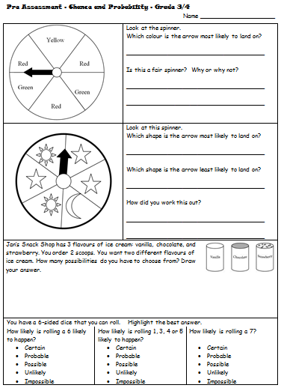 | Most students were able to complete the two spinner activities accurately.  Some students confuse probable with certain.  Most students were able to give some description of why the spinners were unfair.  Some students not able to identify all the possibilities.  (Next time use the word ‘likely’ instead of ‘probable’) | We are learning to describe everyday happenings that involve chance.  I will be successful if:  I can identify daily events that involve chance.  We are learning to use the language of chance to make predictions about the likelihood of everyday events.  I will be successful if:  I can talk and write about chance events using the language of ‘likely’, ‘unlikely,’ impossible’, ‘probable’, ‘possible’, ‘certain’.  We are learning to explain why some actions are more possible than others.  I will be successful if:  I can talk about some of the reasons that make things more possible than other things.  I can put events in order of their chance of happening or not happening.  We are learning to recognize the ways that ‘fairness’ can be affected.  I will be successful if:  I can discover ways to change games to make them fairer or less fair.  I can identify how making chances more equal connects with fairness.

Videos

Math Antics - Basic Probability https://www.youtube.com/watch?v=WqTioYM0L7I Extension

Chance - Stage 2 https://www.youtube.com/watch?v=7JUdfn6r5wA focus on vocabulary

Site http://education.abc.net.au/res/i/L2380/index.html need to enable flash

SESSION NUMBER  LEARNING INTENTION  & SUCCESS CRITERIA | TOOL SESSION  A short, sharp task relating to fluency in mental computation or the focus of the lesson.  WHOLE CLASS FOCUS  Sets the scene/context for what students do in the investigation session. | INVESTIGATION SESSION  Extended opportunity for students to work in pairs, small groups or individually. A time for the teacher to probe children’s thinking or work with a small group for part of the time. | REFLECTION  Focused questions and summary to draw out the mathematics and assist children to make links. | TEACHER ASSESSMENT  We are looking for...
Session 1  We are learning to describe everyday happenings that involve chance.  I will be successful if:  I can identify daily events that involve chance.  We are learning to use the language of chance to make predictions about the likelihood of everyday events.  I will be successful if:  I can talk and write about chance events using the language of ‘likely’, ‘unlikely,’ impossible’, ‘probable’, ‘possible’, ‘certain’.  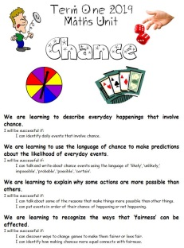 | TOOL SESSION  Card Game: ‘Pay Me’  WHOLE CLASS FOCUS  Introduction to learning intentions of unit on cover sheet.  Tuning in  Game: ‘Heads and Tails’  Students all stand and place hands on head or hands on tail (bottom) Teacher throws a coin and those with correct hand positions stay in the game and the rest are out. Get one child to record results. Continue ‘til someone wins. Extend to 2 coins  Talk about the experience; how it involves chance and whether it’s possible to employ strategies that will help you win | INVESTIGATION  Task:  Read story: ‘Alexander and the Terrible Horrible No Good Very Bad Day’ Discuss the chances of all the events happening and record the language of chance.  Have students make lists of things that happen to them that are like to happen every day and others that are unlikely to happen every day. Eg. waking up, getting a kiss from a parent, going to the beach, having a shower, eating fruit, getting barked at by a dog, stubbing your toe, reading a book.  (Could present in a T-chart)  Extending Prompts:  Think about the reasons why students’ lists will be different  Enabling Prompts:  Think about some things you did today and if you would put them on the likely or unlikely side | REFLECTION  How have you been successful in maths today?  (Revisit success criteria)  Who’d like to share one a maths finding from today either from the ‘Heads and Tails’ game, the story, or our list making? | ASSESSMENT  We are looking for:  -the types of answers students used in ‘Heads and Tails’ discussion.  -the data provided on the lists (T-charts)

Session 2  LEARNING INTENTION  & SUCCESS CRITERIA  We are learning to use the language of chance to make predictions about the likelihood of everyday events.  I will be successful if:  I can talk and write about chance events using the language of ‘likely’, ‘unlikely,’ impossible’, ‘probable’, ‘possible’, ‘certain’. | TOOL SESSION  Game: ‘Heads and Tails’  Game: ‘Card Corner’ – like ‘Heads and Tails’ but using playing card suits and the four corners of the room  WHOLE CLASS FOCUS  Video:  https://www.youtube.com/watch?v=7JUdfn6r5wA  Chance - Stage 2 –this short video focuses on vocabulary  Make a whole class probability line and use post-it notes to place events on the line according to their chance of happening.  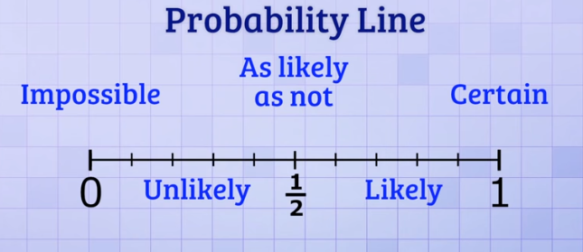 | INVESTIGATION  Task:  Students make their own probability line and write (or draw) one event under each category  Extending Prompts:  Also include a ‘weekend’ version – how does this differ?  Enabling Prompts:  Use the whole class example to support.  Extension: Have students make up a short story using the language of chance and post this as a video on SeeSaw | REFLECTION  How have you been successful in maths today?  (Revisit success criteria) | ASSESSMENT  Check probability lines

Session 3  LEARNING INTENTION  & SUCCESS CRITERIA  We are learning to explain why some actions are more possible than others.  I will be successful if:  I can talk about some of the reasons that make things more possible than other things.  I can put events in order of their chance of happening or not happening. | TOOL SESSION  Game: ‘Heads and Tails’  Game: ‘Card Corner’ – like ‘Heads and Tails’ but using playing card suits and the four corners of the room  WHOLE CLASS FOCUS  Tuning in  Use the games for discussion on where each possible coin toss appears on the number line and compare this with where each card draw appears on the number line  Coin toss ½  Card draw ¼ | INVESTIGATION  Studyladder and Matific - both have good activities to choose from and set up for the class. | REFLECTION | ASSESSMENT  Studyladder and Matific stats

Session 4  LEARNING INTENTION  & SUCCESS CRITERIA  We are learning to explain why some actions are more possible than others.  I will be successful if:  I can talk about some of the reasons that make things more possible than other things.  I can put events in order of their chance of happening or not happening. | TOOL SESSION  Game: ‘Heads and Tails’  Game: ‘Card Corner’  WHOLE CLASS FOCUS  Chance Picks: Experiment with pulling counters from a bag. Use 3 red and 2 blue  Which colour will be more likely to be chosen?  How many picks will I need to make certain I get a blue?  Is it possible to get a yellow? | INVESTIGATION  Chance Picks:  Students use a bag into which they put 6 coloured counters. Students experiment with working out the chances of getting a particular colour.  Students record their findings (could post to SeeSaw)  I put _(numbers & colours)_ in the bag.  The chance of pulling out a _(colour)_ is _(number)_ in 6.  It is possible to pull out a ___  It is impossible to pull out a ___  Extending Prompts:  Increase the amount of counters / pose questions involving more than 1 counter.  Enabling Prompts:  Decrease the amount of counters.  Extension: Matific & Studyladder | REFLECTION  (20 mins before lesson end)  What have you discovered?  (Revisit success criteria)  What might someone find difficult?  Who’d like a study buddy to help them finish? | ASSESSMENT  Check recording

Session 5  LEARNING INTENTION  & SUCCESS CRITERIA  We are learning to use the language of chance to make predictions about the likelihood of everyday events.  I will be successful if:  I can talk and write about chance events using the language of ‘likely’, ‘unlikely,’ impossible’, ‘probable’, ‘possible’, ‘certain’. | TOOL SESSION  Game: ‘Build or Bust’ Dice is rolled and student collect counters. May ‘sit’ after each roll. If a 1 is rolled, they are bust. (variation – if a 3 is rolled, everyone’s back in)  WHOLE CLASS FOCUS  Chance Problems: Using dice (6- and 10-sided) and our chance number line, students work on the problems in the Powerpoints:  Chance Problems 1  Chance Problems 2  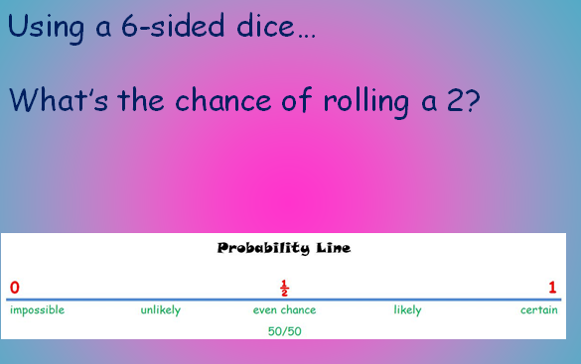 | INVESTIGATION  Worksheet: Chance problems  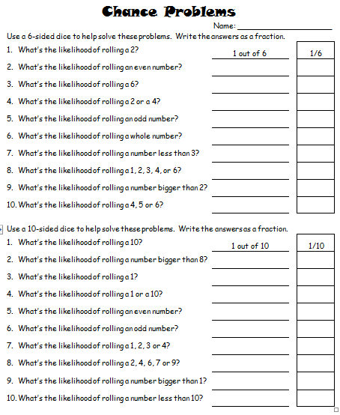 | REFLECTION  (20 mins before lesson end)  What have you discovered?  (Revisit success criteria)  What might someone find difficult?  Who’d like a study buddy to help them finish? | ASSESSMENT  Check recording

Session 6  LEARNING INTENTION  & SUCCESS CRITERIA  We are learning to use the language of chance to make predictions about the likelihood of everyday events.  I will be successful if:  I can talk and write about chance events using the language of ‘likely’, ‘unlikely,’ impossible’, ‘probable’, ‘possible’, ‘certain’. | TOOL SESSION  Game: ‘Build or Bust’ Dice is rolled and student collect counters. May ‘sit’ after each roll. If a 1 is rolled, they are bust. (variation – if a 3 is rolled, everyone’s back in)  WHOLE CLASS FOCUS  Possible Paths: Using picture on screen students identify all possible ways of going from entry to exit.  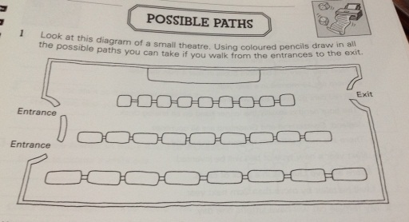 | INVESTIGATION  Box of Bears: Using the box of bears students draw all the different ways the bears could be made. (12)  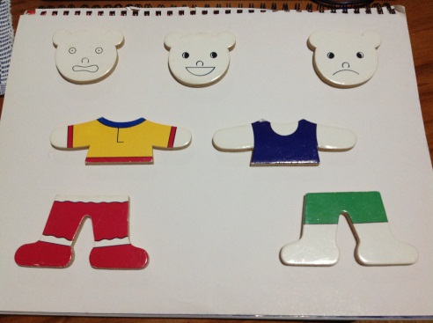  Extending Prompts:  Can you work out a number sentence that will predict the answer each time?  Enabling Prompts:  Decrease the amount of bear pieces.  Extension: Matific & Studyladder | REFLECTION  (20 mins before lesson end)  What have you discovered?  (Revisit success criteria)  What might someone find difficult?  Who’d like a study buddy to help them finish? | ASSESSMENT  Check recording

Session 7  LEARNING INTENTION  We are learning to recognize the ways that ‘fairness’ can be affected.  I will be successful if:  I can discover ways to change games to make them fairer or less fair.  I can identify how making chances more equal connects with fairness. | TOOL SESSION  Card Game: ‘Pay Me’  WHOLE CLASS FOCUS  Beat the Teacher: Students first choose a suit, either heart, diamond, club, or spade. Then, you let them choose a card. If they get a card with the suit they guessed they get a point. If they don’t match the suit, then the teacher gets a point. Repeat 10 times. Ask students to figure out why this game was unfair. (The teacher had 3 chances of winning and the students had 1 chance).  Apply this to other games played. | INVESTIGATION  Games Session: Students play a variety of games using spinners, dice and cards and discuss how to change the rules to change the chances of them winning.  Video: Math Antics - Basic Probability https://www.youtube.com/watch?v=WqTioYM0L7I  Revision and extension discussion | REFLECTION  How have you been successful in maths today?  (Revisit success criteria) | ASSESSMENT

