Maths Unit Planner
Statistics

Grade 2 Term IV Week 1- 2015
AusVELS
Gr 1:
Students describe data displays. They ask questions to collect data and draw simple data displays. Students classify outcomes of simple familiar events.
Gr 2:
Students collect data from relevant questions to create lists, tables and picture graphs with and without the use of digital technology. They interpret data in context. Students describe outcomes of familiar events using everyday language.
Gr 3:
Students carry out simple data investigations for categorical variables. They interpret and compare data displays.

Key Ideas for Concept Development in Maths
Classification
Decisions made about the categorisation of objects
Data Process
4-step process
- Question posing
- Data collection – eg. surveys, questionnaires, interviews, experiments, tables, tallies
- Data representation – eg. tables, pictographs, bar/column graphs etc
- Data interpretation/analysis

Learning Activities
- Initial Assessment task:
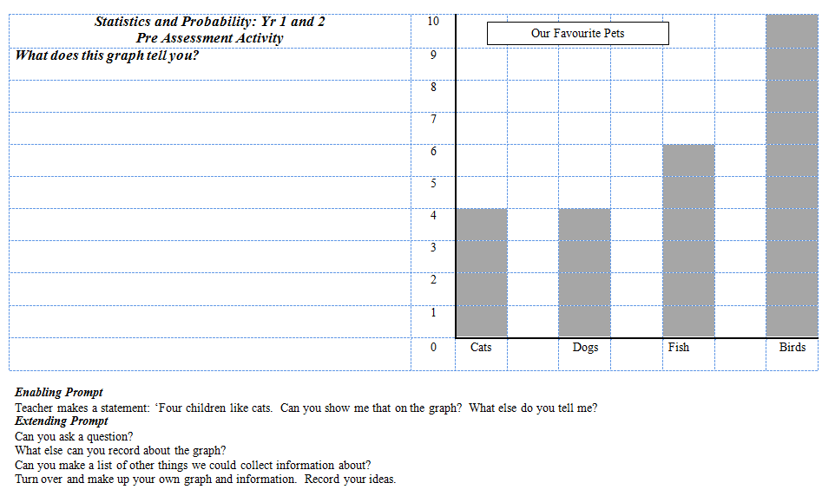

Discoveries from the pre-assessment

- Gathering Information About Our Class Talking about data as information. Gathering information about our class activity
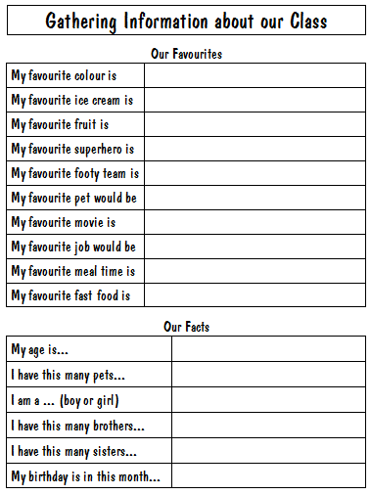
- Using the collected data from Wednesday, how can we present the information about our class. Teacher models the graphing of one piece of information from yesterday. Students may work individually or in small groups to present a section of information to the class. Students given large pieces of paper to present information.

- Interpreting data – what conclusions can we draw about the graphs we have made? What do they tell us? What can we learn from this? When would this sort of information be helpful?

- Nelson Maths Book activities – see the book!!

Lesson Timetable
Term IV Week 1
Monday | Tuesday | Wednesday | Thursday | Friday
SINE number assessment | Specialist Day | Data unit intro and pre-assessment activity  Gathering Information About Our Class activity | Short session before PE  Number kits and games | Using Gathering Information About Our Class activity to present information

Term IV Week 2
Monday | Tuesday | Wednesday | Thursday | Friday
Using Gathering Information About Our Class activity to present information | Specialist Day | Using Gathering Information About Our Class activity to present information | Short session before PE  Number kits and games | What does data tell us? Interpreting and gathering information from our graphs  Nelson maths data activities

Term IV Week 3
Monday | Tuesday | Wednesday | Thursday | Friday
What does data tell us? Interpreting and gathering information from a graph  Nelson maths data activities | Specialist Day | Geelong Cup Holiday | No PE | Nelson maths data activities  Answering questions about graphs

Unit Evaluation
Due to classroom teacher being away, this unit was rather disjointed – being planned by both support teacher and two replacement teachers.
Needed more time on the interpretation of data

