Broken Clocks
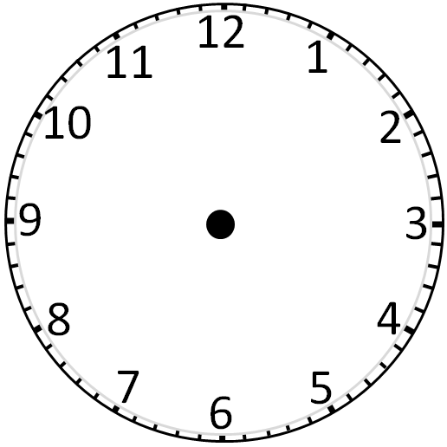

Broken Clocks - Answers
1:00 or 1 o’clock | 9:30 or ½ past 9 | 5:30 or ½ past 5
1:45 or ¼ to 2 | 8:15 or ¼ past 8 | 12:15 or ¼ past 12
3.30 or ½ past 3 | 10:15 or ¼ past 10 | 6:45 or ¼ to 7
7:30 or ½ past 7 | 11:15 or ¼ past 11 | 5:00 or 5 o’clock

