 | 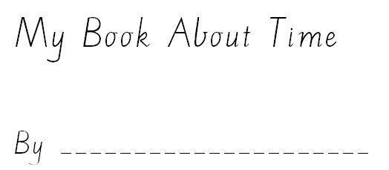
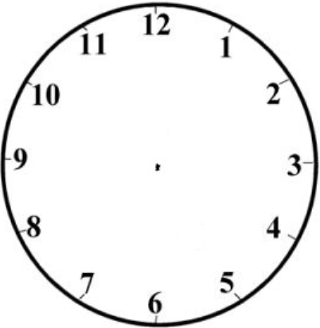 | 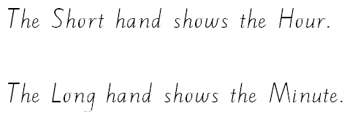  Draw the hands and label them minute hand and hour hand
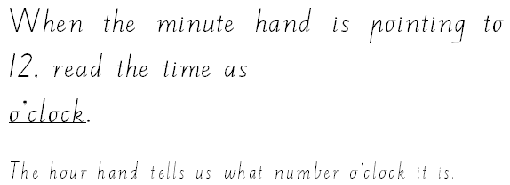

Make this clock say 10 o’clock
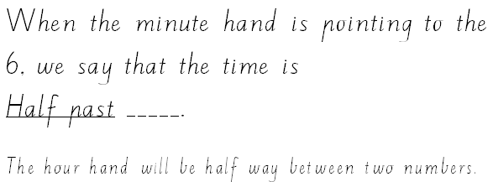

Make this clock show half past 2

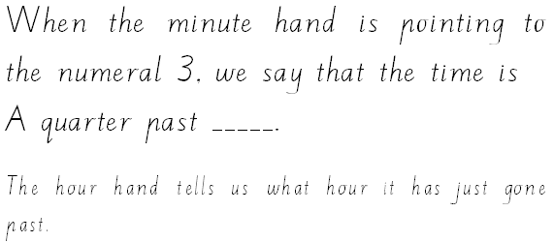

Make this clock say a quarter past 7
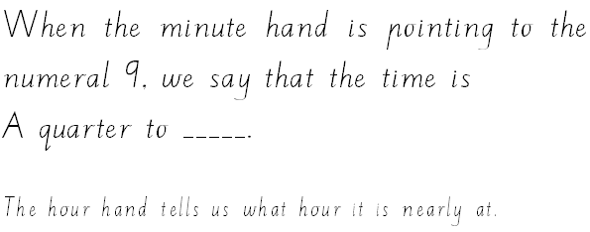

Make this clock say a quarter to 5
I get up at | School begins at |  | We begin maths at
We have lunch at | I have tea at |  | My bedtime is

