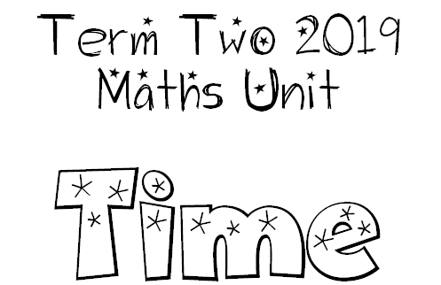

We are learning to tell the time in hours and minutes with both analogue and digital clocks.
I will be successful if…
- I can identify the different parts of a clock and what they do (analogue and digital).
- I can tell the time accurately.
- I can explain how hours, minutes and seconds connect to each other.

We are learning to solve problems involving time.
I will be successful if…
- I am able to use a clock to calculate the time between events.

