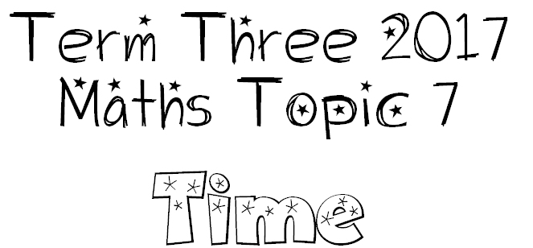

We are learning how to use a calendar.
I will be successful if…
I can name and order months (and seasons).
I can work out the number of days in any month.

We are learning to tell the time in hours and minutes with both analogue and digital clocks.
I will be successful if…
I can identify the different parts of a clock and what they do (analogue and digital).
I can tell the time accurately.
I can explain how hours, minutes and seconds connect to each other.

We are learning to solve problems involving time (calendar & clocks).
I will be successful if…
I am able to calculate the time between dates using a calendar.
I am able to use a clock to calculate the time between events.

