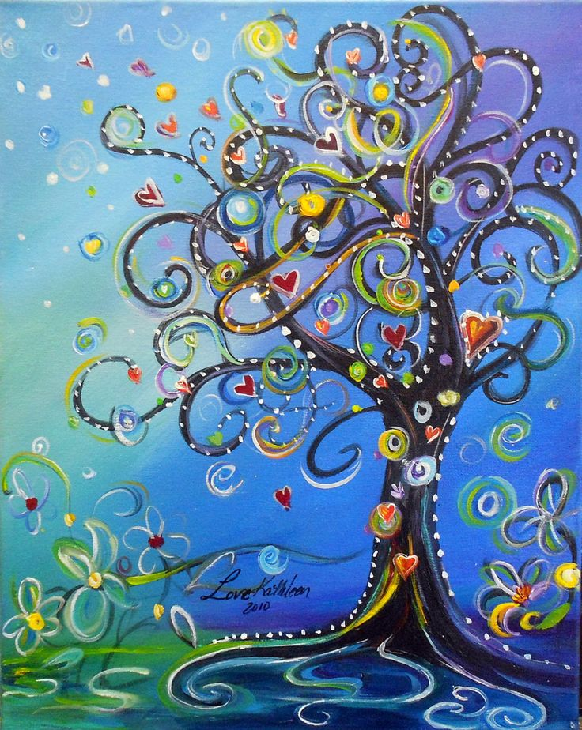 | YOU LEARN SOMETHING EVERYDAY…  IF  YOU PAY ATTENTION.  RAY LEBOND

MargD

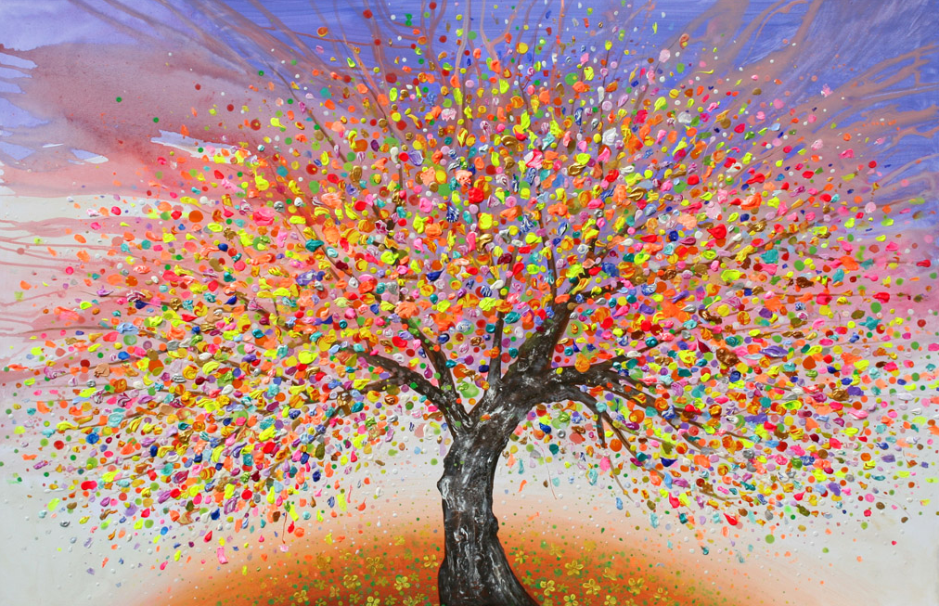
The beautiful thing about learning
is no one can take it away from you.
BB King

MargD

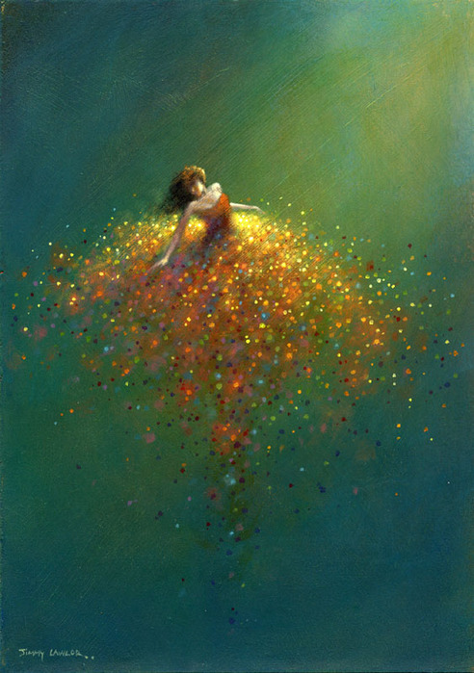 | MISTAKES  ARE  PROOF  THAT YOU ARE  TRYING.

MargD

DO THE
RIGHT
THING,
EVEN WHEN
NO ONE IS
LOOKING.

MargD

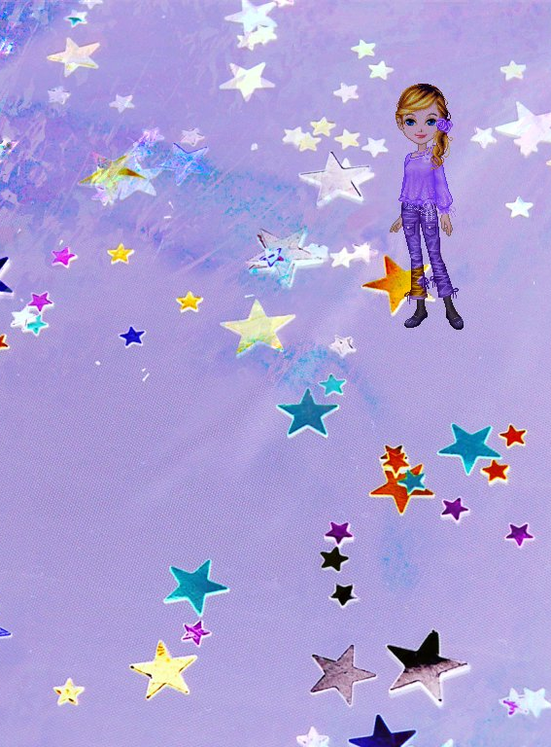 | RAISING YOUR HAND SHOWS THAT YOU’RE HERE  GIVING AN ANSWER SHOWS THAT YOU’RE LISTENING  EXPLAINING WHY THAT’S YOUR ANSWER SHOWS THAT YOU’RE THINKING  MARIE COLE

MargD

it’s okay to not know
but it’s not okay to not try.

MargD

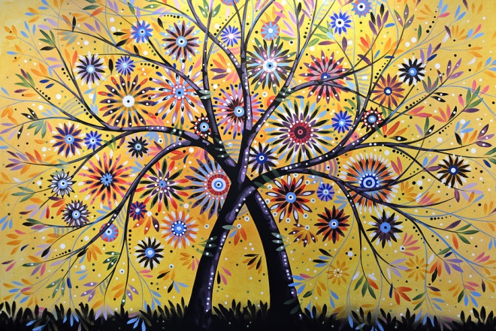
TREAT OTHERS THE WAY
YOU WANT TO BE TREATED.

MargD

HARD WORK BEATS TALENT
WHEN TALENT DOESN’T WORK HARD
KEVIN DURANT

MargD

WAG
MORE
BARK LESS

MargD

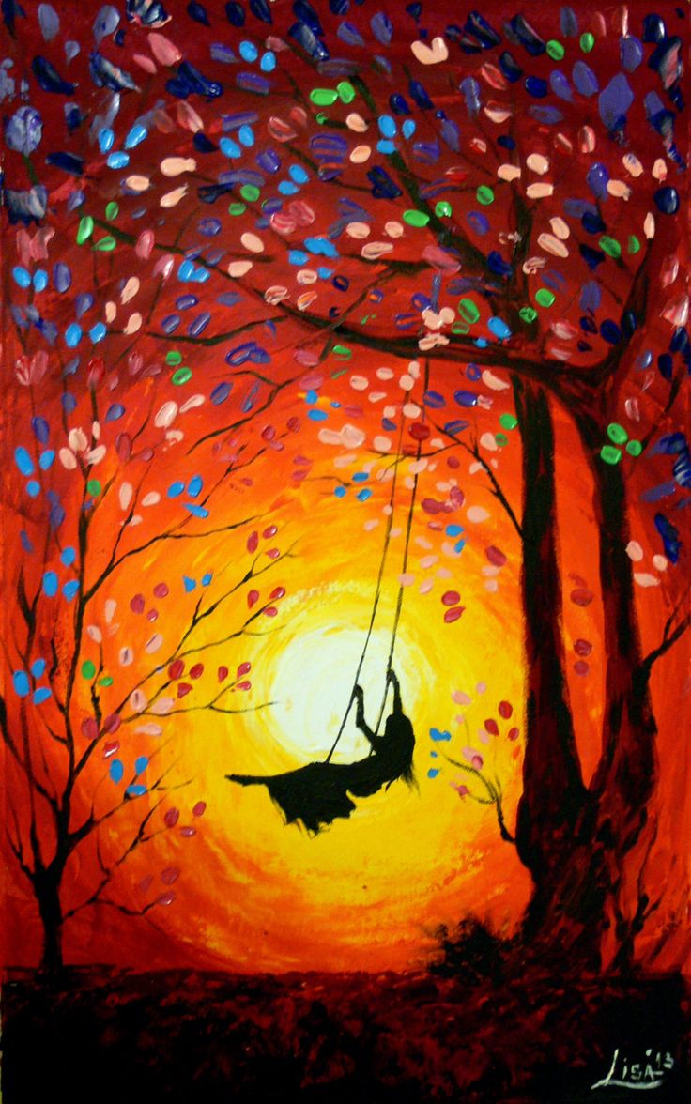 | LEARNING  IS NOT A SPECTATOR SPORT SO  LET’S PLAY!

MargD

TODAY A  READER.  TOMORROW A  LEADER. | 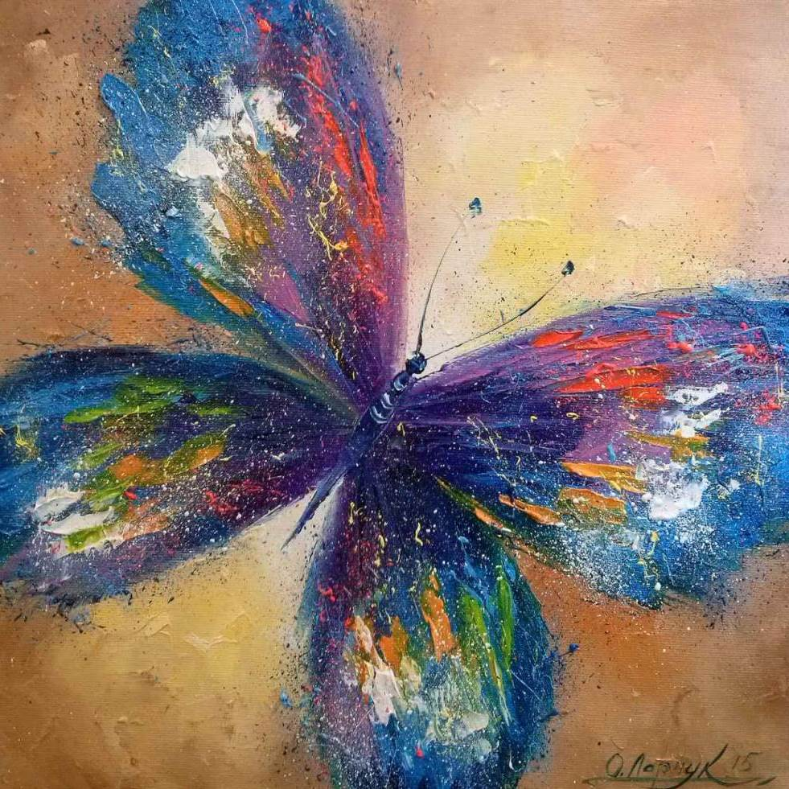

MargD

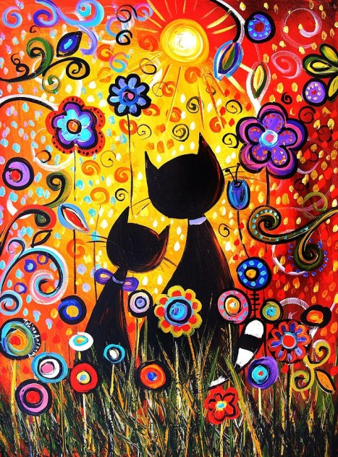 | TELL ME AND I  FORGET.  TEACH ME AND I  REMEMBER.  INVOLVE ME AND I  LEARN.  BENJAMIN FRANKLIN

MargD

A child who reads
will be an
adult who thinks.

MargD

IF YOU THINK
READING
IS BORING,
YOU’RE DOING
IT WRONG.

MargD

You can
borrow
a
book.
But you get to
keep
the
ideas.

MargD

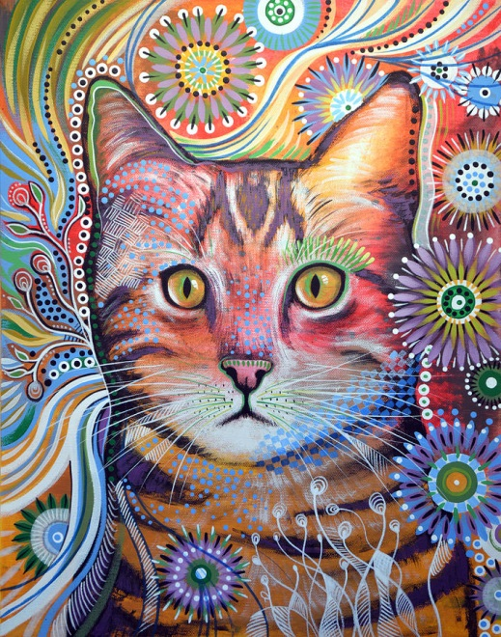 | Go  out there  and do  amazing  things.

MargD

DON’T WAIT  FOR PEOPLE  TO BE  FRIENDLY.  SHOW THEM  HOW. | 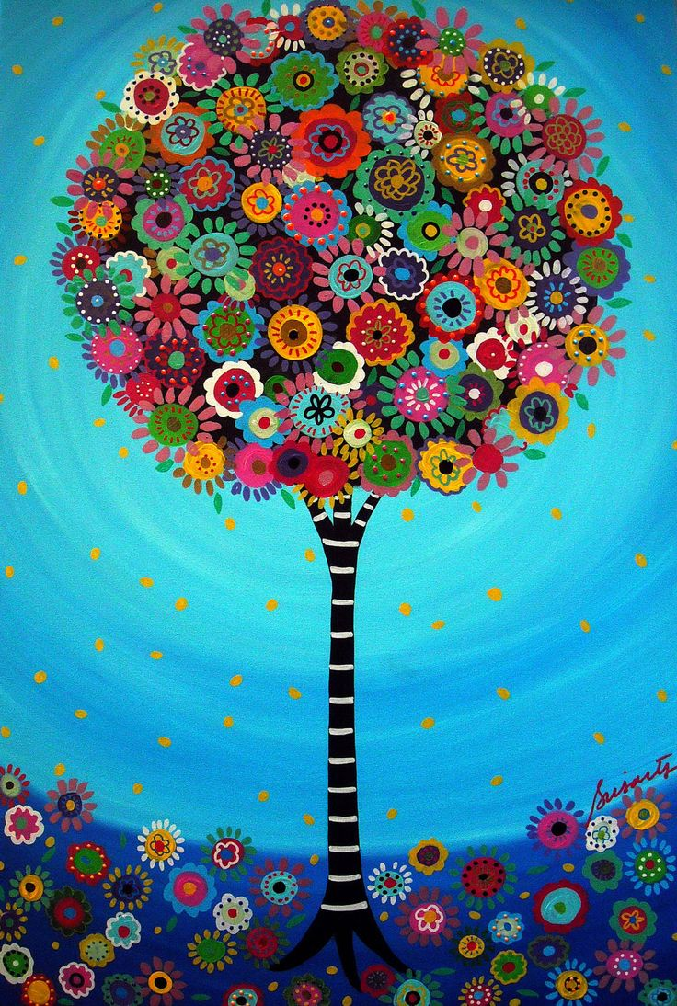

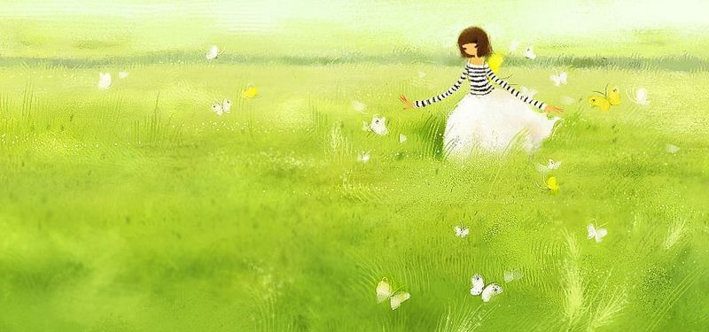
The only way to
learn maths is to do maths.

MargD

A DAY
WITHOUT
LAUGHTER
IS A DAY
WASTED.
CHARLIE CHAPLIN

MargD

GOOD MATHEMATICS IS NOT ABOUT HOW MANY ANSWERS YOU KNOW... IT’S HOW YOU BEHAVE WHEN YOU DON’T KNOW.

TRUST THAT
LITTLE VOICE
THAT SAYS,
‘THIS MIGHT WORK
– I’LL TRY IT.”

MargD

Shoot for the moon. Even if you miss, you will land among the STARS.
Les Brown

MargD

Never Be Afraid
To Try Something
New

MargD

A good GOAL is like EXERCISE
- it makes you STRETCH.

MargD

Minds
are
like parachutes- they
only
function when
they
are
open.

MargD

ALONE
WE ARE
SMART.
TOGETHER
WE ARE
BRILLIANT.
STEVEN ANDERSON

MargD

When you talk, you are only repeating what you
already know. But if you listen, you may
learn something new.
Dalai Lama

MargD

EVERY STUDENT CAN
LEARN…
JUST NOT ON THE SAME DAY
OR IN THE SAME WAY.
GEORGE EVANS

MargD

THE MORE THAT YOU
READ,
THE MORE THINGS
YOU WILL
KNOW.
THE MORE THAT YOU
LEARN,
THE MORE PLACES
YOU’LL GO.
DR. SEUSS

MargD

MargD

