WATCHING OUR WORDS
DON’T LET THEM SLIDE TOO FAR!
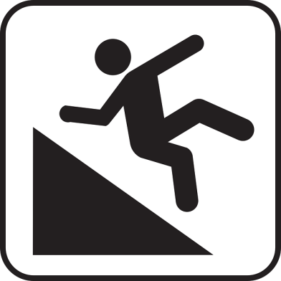
FUNNY

(this, we love!)

CHEEKY
(uh-oh!)
(nooooooo!)
DISRESPECTFUL

