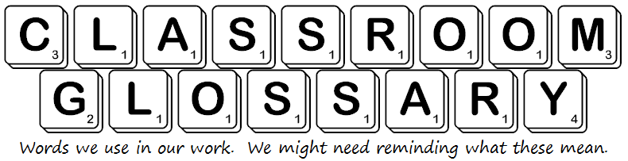

interesting  – this holds my attention | exciting  – I am thrilled by this
moving  – this makes me feel emotions | absorbing  – I am totally into this  – it has sucked me in!
appearance  – how a character looks | attributes  – how a character behaves, what their personality is like

