 | W | 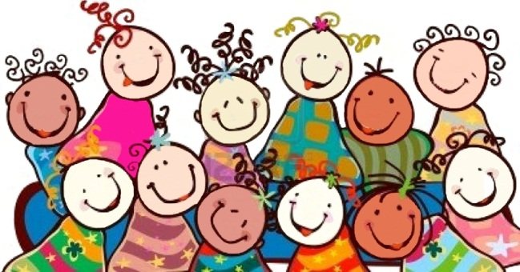  hen you
 | E | nter our
 | L | ovely room,
 | C | onsider yourself
 | O | ne of the special
 | M | embers of a group who
 | E | njoy learning together!

MargD

