On May 13th, 1787, 11 ships left England. On board were around 1030 people:
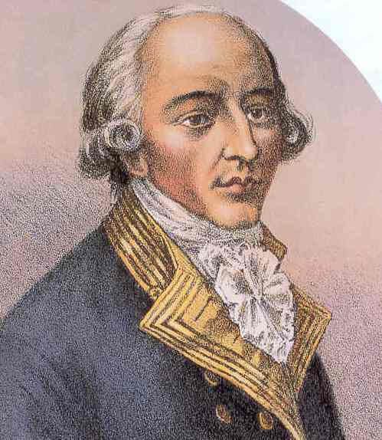
550 male convicts
190 female convicts & some convict children
Marines (sailor soldiers)
Officers and their families
Captain of the fleet, Arthur Phillip

Their destination was a mysterious land over the other side of the world which no one knew very much about. These 11 ships were…

1787 England.
England was a crowded country with many people and not enough food and work for everyone, so many people turned to crime. The British were very strict with people who broke the law and England’s prisons were so full, they used to put prisoners onto old ships floating on the river. They also used to ‘transport’ their ‘convicts’. This meant they would send their prisoners to others lands. They used to send them to America, but the Americans fought a War of Independence against the British so they were no longer able to do this. Instead, it was decided that a new colony would be set up.

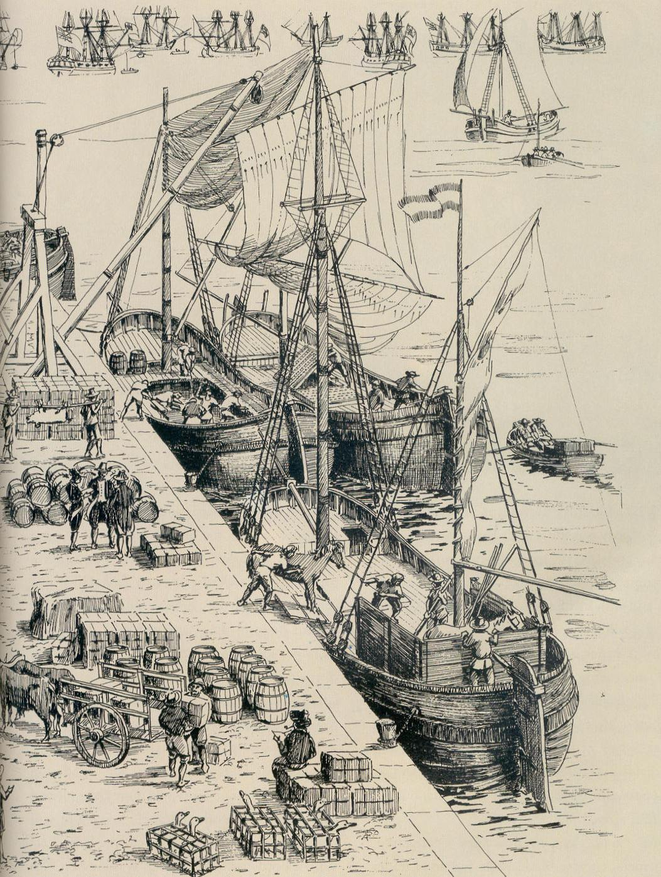
A few years before this an explorer called Captain James Cook had mapped the eastern side of the mysterious ‘Great South Land’ and suggested an area that would make a good British colony, so the government decided to set up a convict colony that they would call New South Wales.

There was another reason the British wanted to set up a colony - they wanted to beat other European countries that might do the same thing!

Dreamtime. The Great South Land.
For many thousands of years, Aboriginal people had lived in what we now call Australia. At the time when Europeans came to this land, there were about 750 000 Aboriginal people living all over the different parts of Australia. There were about 600 different nations (clans or tribes) each with their own territory. Most were nomadic and would move from place to place within their clan’s territory, hunting and gathering for their food, tools and shelter.

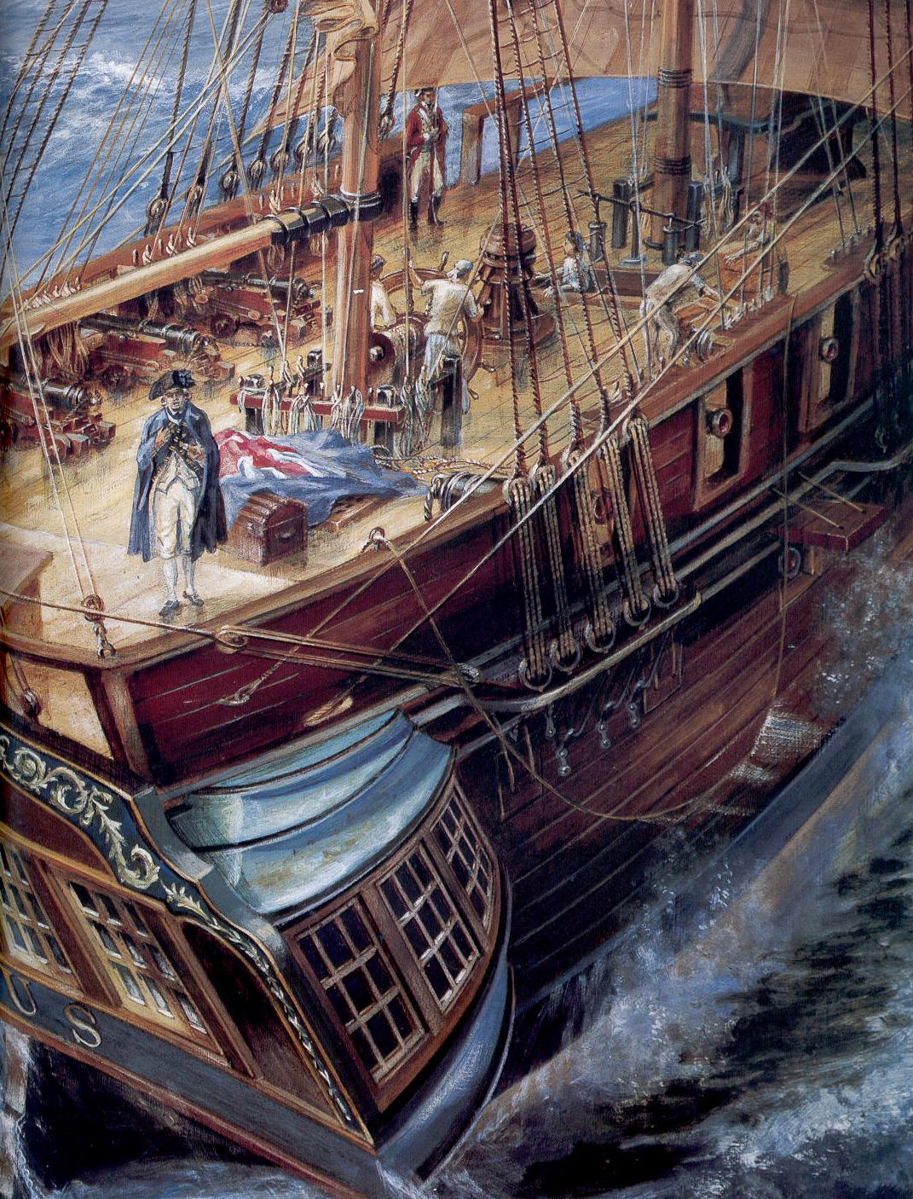
The First Fleet, captained by Arthur Phillips left England on May 13th 1787. Sailing ships did not travel very fast. They had to carry enough food to feed over 1000 people so they had to stop along the way to restock. Today a flight from England to Australia takes around 24 hours. The First Fleet took 36 weeks (eight months).
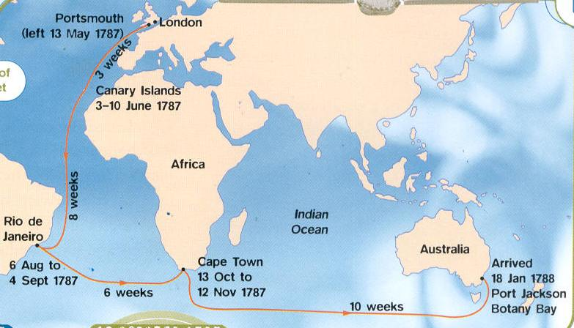
The first stop was the Canary Islands which took 3 weeks to get to. They spent a week there, and then it took another 8 weeks to get to Rio de Janeiro where they stayed for 4 weeks.
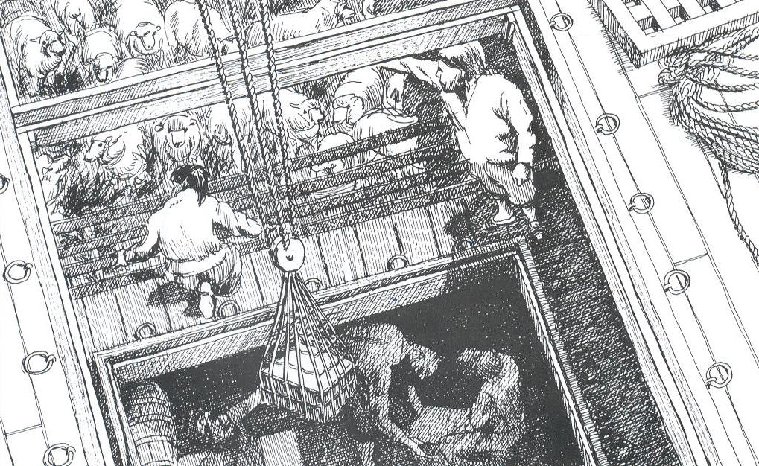
6 weeks later they stopped at Cape Town and stayed for nearly five weeks. Here they had to take on supplies that would help them set up the colony, like stock, seeds, dry foods and all the tools they would need to survive in a new land.
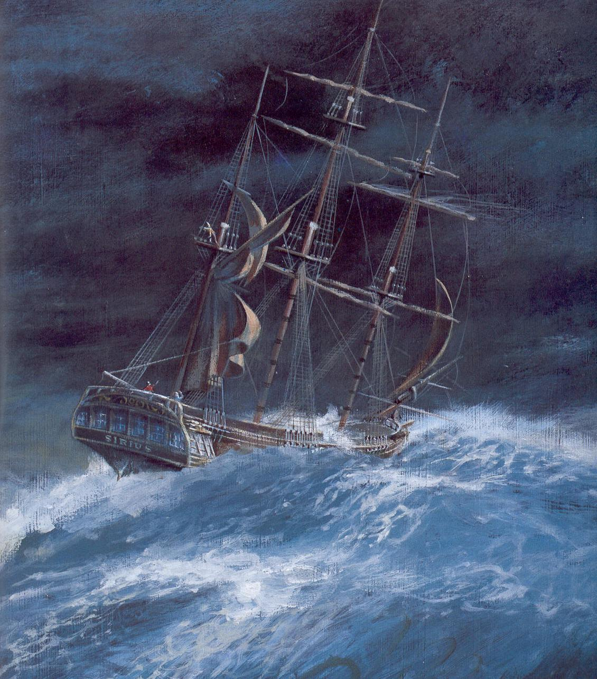

Finally they got to the place Captain Cook had called Botany Bay, and suggested would make a good colony. It was January 18th, 1788. Arthur Phillip and his officers explored the area and decided it would be too marshy for farming and went looking for a better area. They found one and named it Sydney Cove. It was here they decided to set up camp.
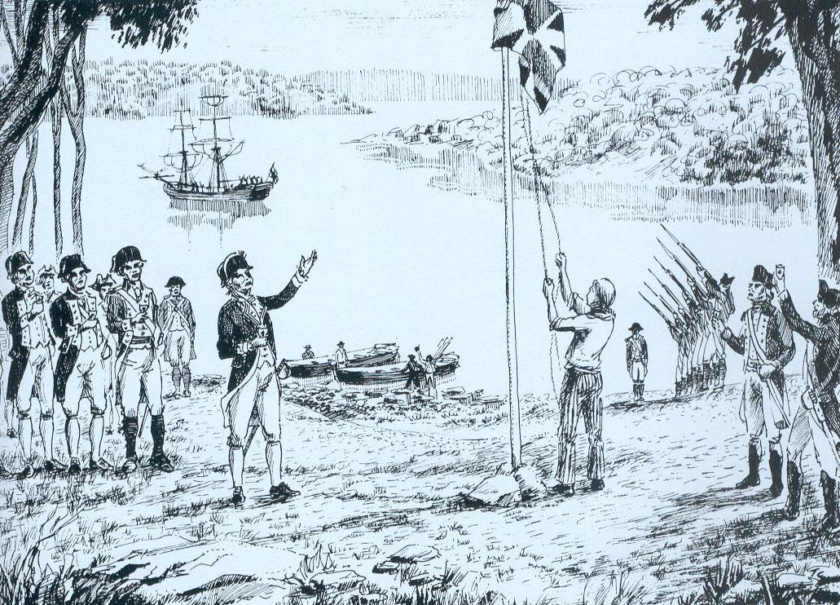
On January 26th, 1788, Captain Arthur Phillip became Governor Arthur Phillip. With 40 convicts and marines, he raised the British Flag, toasted the King, gave 3 cheers and declared the land to be the British Colony of New South Wales.

This is why we celebrate Australia day on the 26th of January, as a remembrance of our birth as a nation.
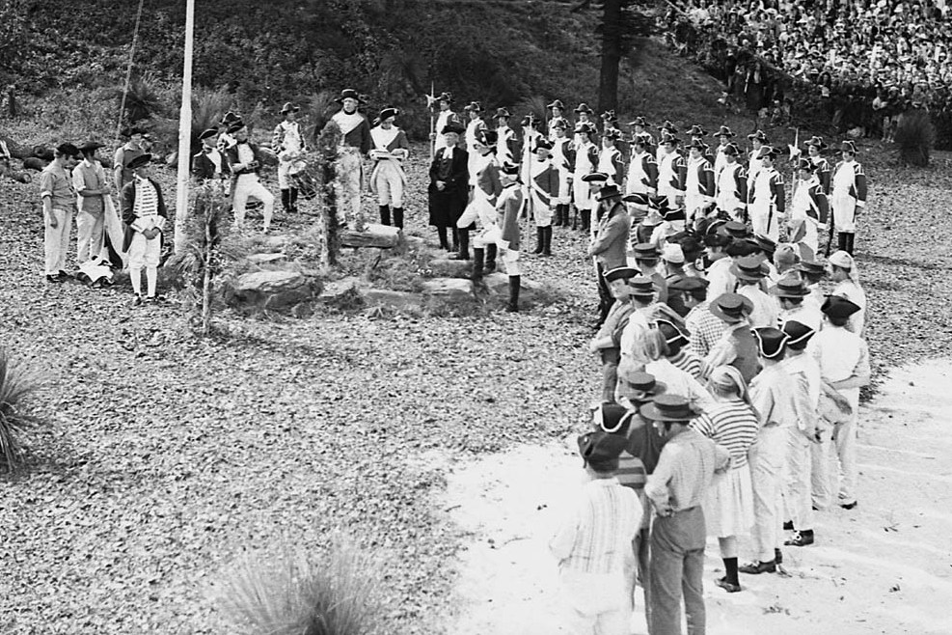
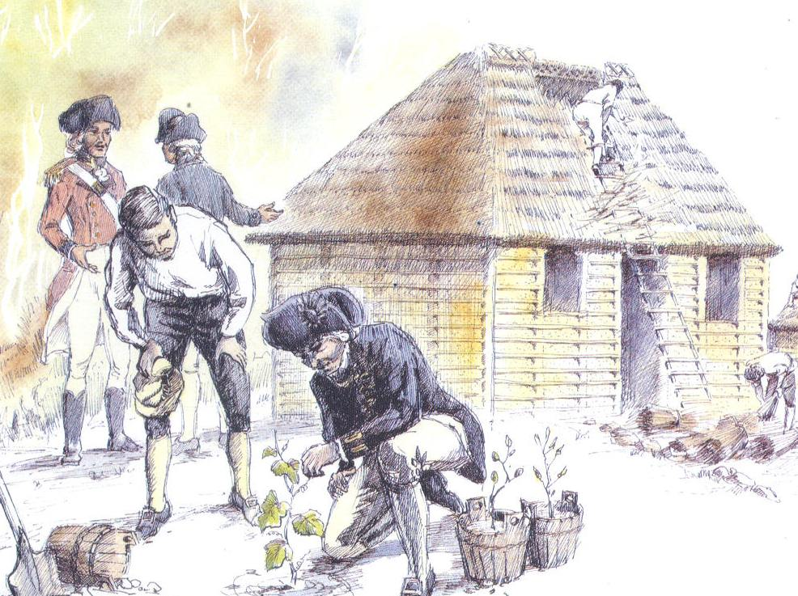
Then came the hard work of setting up camp, clearing land, building fences for stock and sowing crops that would feed the convicts, the soldiers and their families.

Aboriginal people from the clans that lived in the area witnessed the arrival of the Europeans with curiosity and wonder. One member of the first fleet wrote that the native people “shouted at us and held up their weapons over their heads.” They had never seen such pale coloured people and strange ships before.

When it became clear that the Europeans weren’t going to leave and intended to take their land, the local clans decided to fight and would attack outlying farms, burn crops and kill stock, but the Europeans had two weapons that would defeat the Aborigines: Guns and disease.
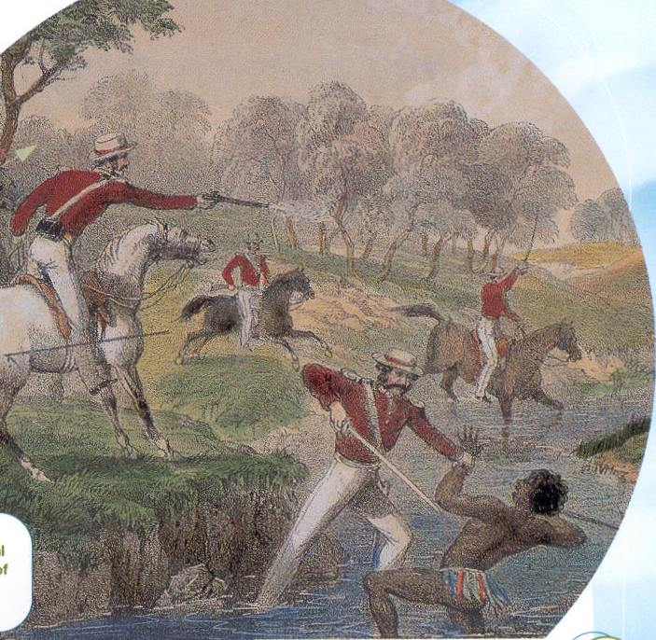
By 1800, Aboriginal resistance in this area was over and Aboriginal people were forced to move away as European settlement spread.

To the Aboriginal people, ‘Australia Day’ was more like ‘Invasion Day’.

The colony struggled to survive in those early years. They came at a time of drought, and farming conditions were very different from England. The colony nearly starved and a ship had to be sent to Cape Town for more supplies. Before long - in 1790 - a second fleet of ships with more convicts arrived and in 1791 a third fleet landed.



