English Unit Planner
Level: Gr 3/4 Term: 1 2019 Weeks: 5 - 10
Teachers: Leonie, Fran and Marg
Language Mode: Writing

Victorian Curriculum Content Descriptions
http://victoriancurriculum.vcaa.vic.edu.au/english/curriculum/f-10

Grade 2
Create short imaginative, informative and persuasive texts using growing knowledge of text structures and language features for familiar and some less familiar audiences, selecting print and multimodal elements appropriate to the audience and purpose (VCELY230)
Grade 3
Plan, draft and publish imaginative, informative and persuasive texts demonstrating increasing control over text structures and language features and selecting print and multimodal elements appropriate to the audience and purpose (VCELY266)
Grade 4
Plan, draft and publish imaginative, informative and persuasive texts containing key information and supporting details for a widening range of audiences, demonstrating increasing control over text structures and language features (VCELY299)
Grade 5
Plan, draft and publish imaginative, informative and persuasive print and multimodal texts, choosing text structures, language features, images and sound appropriate to purpose and audience (VCELY329)

Reporting Statements
Grade 3
Create clearly structured sentences using correct grammar and punctuation.
Develop clearly structured text and use detailed paragraphs.
Grade 4
Select vocabulary from a range of resources and use accurate spelling.
Accurately select words and punctuation to add detail and interest to writing.
Develop writing pieces that are creative, informative and detailed for different audiences.

Learning Intentions and Success Criteria
We are learning to capture our audience with a bold beginning.
I will be successful if…
I can talk about what makes writing enjoyable or boring.
I can create bold beginnings.
I can use action at the start of my writing.
I can use great words to make my beginnings come to life.
I can backfill details later.
I can listen to others beginnings and give them warm and cool feedback.

SESSION 1
WHOLE CLASS FOCUS >> INDIVIDUAL / SMALL GROUP / CLASS SESSION
Tuning In:
Stories with bold beginnings. Choose from the following picture story books:
Diary of a Wombat – Jackie French
Fox – Margaret Wild
The Paw – Natalie Jane Prior
When Frank was Four – Alison Lester

Learning Intention and Success Criteria
We are learning to capture our audience with a bold beginning.
I will be successful if…
I can talk about what makes writing enjoyable or boring.
I can use action at the start of my writing.
I can listen to others beginnings and give them warm and cool feedback.

Focus: Bold Beginnings
Text sample: ‘SEDA Footy Clinic’
Read first sample and ‘measure’ for enjoyment – what warm and cool feedback would you give?
Intro ‘Sneezy’ (his stories start like a sneeze – not quiet, with a bang) Have Sneezy give feedback (cut, cut, cut, boring, everyone does this, like the bit with the shoe.)
Text sample: ‘SEDA Footy Clinic’
Discuss and compare.

Task: 3 x Bold Beginnings
- Students put into groups of 3 or 4 to ‘spark ideas’ (brainstorm)
In your group, read title 1. Talk to each other about all the different topics and ideas that come into your head when you think about the words in this title. Make sure everyone gets lots of turns. You can say just a word or a whole sentence. No writing, just talking and listening. Do the same thing for topics 2-5.
- Students write in own seats.
You have 1 minute to write a Bold Beginning for each topic. Use ideas from what you said and heard in your group.
Start with action!
Be bold!
Grab your readers!
Use humour and emotion!
- Students return to group to share. Each person shares their bold beginning for each topic. Give warm and cool feedback.
I liked how you…
What about…
Even better if…
As a reader I think…
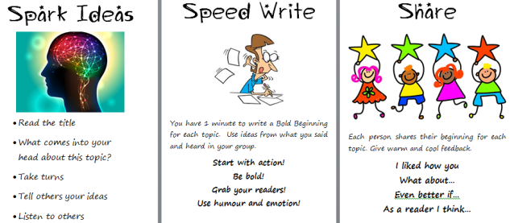
- Return to whole class and discuss: What was hard? What did you enjoy? Remember: We’re not good at something until we’ve practised. You may find today hard, but with practise, it will get easier and fun!
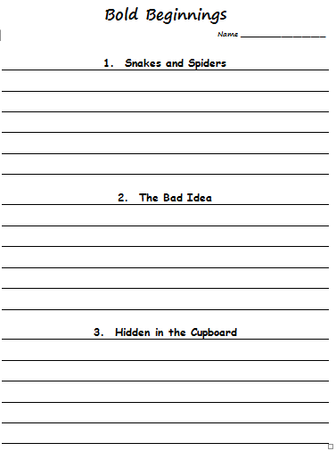
REFLECTION |  | ASSESSMENT
Revisit success criteria and use the ‘Where Am I At with My Learning?’ poster:  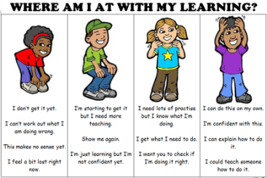 | We are looking for...  - Engagement level of students and whether they are contributing in groups.  - Whether students are able to write their own beginnings – who was confident, who needed prompts.

SESSIONS 2 - 10
Tuning In:
Choose from the following picture story books:
Diary of a Wombat – Jackie French
Fox – Margaret Wild
The Paw – Natalie Jane Prior
When Frank was Four – Alison Lester
or
Use sample texts from the Seven Steps program

We are learning to capture our audience with a bold beginning.
I will be successful if…
I can talk about what makes writing enjoyable or boring.
I can create bold beginnings.
I can use action at the start of my writing.
I can use great words to make my beginnings come to life.
I can backfill details later.
I can listen to others’ beginnings and give them warm and cool feedback.

Task: 3 x Bold Beginnings
Repeat the first session’s procedure for creating Bold Beginnings.
As students become more adept at writing, include the following teaching points:
Backfill – the orientation details needed in a text but can come after the Bold Beginning
Feedback – ways to give warm and cool feedback
Vocabulary – choosing powerful words
Using humour and emotions – showing your personality

