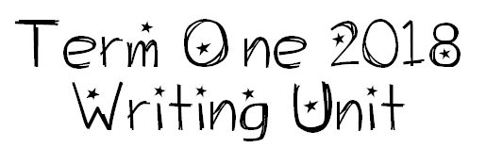

We are learning to write interesting sentences.
I will be successful if…
- I am able to correctly identify what’s in a sentence and use this to write my own sentences.
- I am able to put detail in my sentences.
- I am able to use interesting words in my sentences.
- I am able to write simple and complex sentences.
- I am able to begin sentences in a variety of ways.

