English Unit Planner
Level: Gr 3/4 Term: 1 2019 Weeks: 2 - 5
Teachers: Leonie, Fran Marg
Language Mode: Writing

Victorian Curriculum Content Descriptions
http://victoriancurriculum.vcaa.vic.edu.au/english/curriculum/f-10

Grade 2
Create short imaginative, informative and persuasive texts using growing knowledge of text structures and language features for familiar and some less familiar audiences, selecting print and multimodal elements appropriate to the audience and purpose (VCELY230)
Grade 3
Plan, draft and publish imaginative, informative and persuasive texts demonstrating increasing control over text structures and language features and selecting print and multimodal elements appropriate to the audience and purpose (VCELY266)
Grade 4
Plan, draft and publish imaginative, informative and persuasive texts containing key information and supporting details for a widening range of audiences, demonstrating increasing control over text structures and language features (VCELY299)
Grade 5
Plan, draft and publish imaginative, informative and persuasive print and multimodal texts, choosing text structures, language features, images and sound appropriate to purpose and audience (VCELY329)

Pre Assessment  Choose a topic and write around 50 words.  Your teachers are looking to see:  - Whether your writing make sense.  - What you know about how sentences work in writing.  - What we need to teach you about sentences. | Notes  Observations noted:
Learning Intentions and Success Criteria
We are learning to write interesting sentences.
I will be successful if…
I am able to correctly identify the subject and verb in a sentence and use this to write my own sentences.
I am able to correctly identify the object in a sentence and use this to write my own sentences.
I am able to correctly identify when to finish a sentence with punctuation and use this to write my own sentences.
I am able to correctly identify pronouns and use this to write my own sentences.
I am able to put detail in my sentences.
I am able to identify and use adjectives.
I am able to identify and use adverbs.
I am able to write simple and complex sentences.
I am able to identify and use connectives (conjunctions).
I am able to begin sentences in a variety of ways.

SESSION 1
WHOLE CLASS FOCUS >> INDIVIDUAL / SMALL GROUP / CLASS SESSION
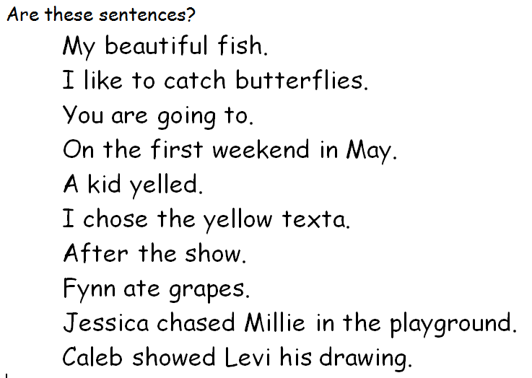
Tuning In:
Are these sentences?
My beautiful fish.
I like to catch butterflies.
You are going to.
On the first weekend in May.
A kid yelled.
I chose the yellow texta.
After the show.
Fynn ate grapes.
Jessica chased Millie in the playground.
Caleb showed Levi his drawing.

Learning Intention and Success Criteria
We are learning to write interesting sentences.
I will be successful if…
- I am able to correctly identify the subject and verb in a sentence and use this to write my own sentences.
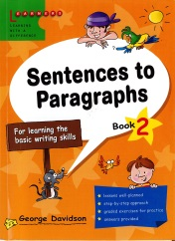
Focus: What’s a Sentence?
Davidson Scans ‘Unit 1 Subjects and Verbs’ Teach with examples
Exercises A, B, C, D orally as a class (five or so from each)
Students write 3-5 sentences independently – use picture prompts in Exercise E if needed
Share and discuss

REFLECTION | ASSESSMENT
Revisit success criteria and use the ‘Where Am I At with My Learning?’ poster:  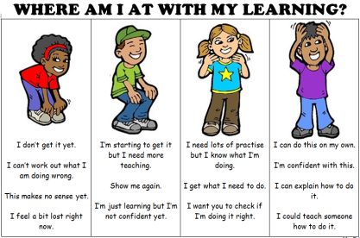 | We are looking for...  - Engagement level of students and whether they are contributing answers  - Whether students are about to write their own sentences – who was confident, who needed prompts

SESSION 2
Tuning In:
Game: ‘Mixed Up Sentences’ students take a word each on individual slips and reorganize themselves to make a sentence.
Kate has a big brother .
Caitlyn likes music .
Andrei reads books.
Miss Costa plays the guitar.
Hudson kicks the ball .
After school we are going to the beach.
I usually have a yummy banana every day
Revise previous lesson’s work by identifying subject and verb in each sentence.

Learning Intention and Success Criteria
We are learning to write interesting sentences.
I will be successful if…
I am able to correctly identify the object in a sentence and use this to write my own sentences.

Focus: What Else is in a Sentence?
‘Sentence to Paragraphs’ Scans ‘Unit 4 Objects’ Teach with examples
Exercises A, B, C, D orally as a class (five or so from each)
Students write 3-5 sentences independently – use picture prompts in Exercise E if needed
Share and discuss

REFLECTION | ASSESSMENT
Revisit today’s success criteria. | We are looking for...  - Students to correctly identify the object of the sentences.

SESSION 3
Tuning In:
Video: https://www.youtube.com/watch?v=2OcmbV-7N20&t=9s
Sentence Song (explain predicate as verb and object, period as full stop)

Learning Intention and Success Criteria
We are learning to write interesting sentences.
I will be successful if…
I am able to correctly identify when to finish a sentence with punctuation and use this to write my own sentences.

Focus: Good Sentences
‘Sentence to Paragraphs’ Scans ‘Unit 5 Good Sentences’ Teach with examples.
Exercise A orally
Exercise B orally and write 2
Exercise E orally and write 1-2

REFLECTION | ASSESSMENT
How have you been successful?  What might someone else find hard? How would you help them? | We are looking for...  - Students accurately writing sentences (check individual sentences)

SESSION 4
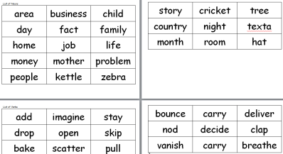
Tuning In:
Game: Superman Loves Verbs. Batman Loves Nouns
Everybody stands behind their chair. If a verb is called –Superman gets ready to fly.
If a noun is called –Batman grabs his utility belt.
Who can stay in?!

Learning Intention and Success Criteria
We are learning to write interesting sentences.
I will be successful if…
I am able to correctly identify pronouns and use this to write my own sentences.

Focus: Pronouns
Videos: https://www.youtube.com/watch?v=ZADSyQZlvCc Pronouns Song
https://www.youtube.com/watch?v=MagsCvE99zY&t=7s Is Am Are Verb Song
‘Sentence to Paragraphs’ Scans Unit 6 ‘Pronouns’ Teach with examples.
Exercise A orally
Exercise B orally and write 2

REFLECTION | ASSESSMENT
Revisit today’s success criteria. | We are looking for...  - Whether students can change nouns to pronouns and write sentences correctly

SESSION 5
Tuning In:
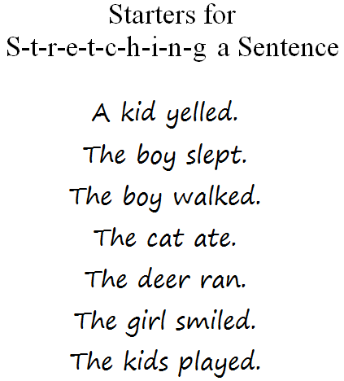
Video: https://www.youtube.com/watch?v=UrrMEex1_lg Good Charlotte - "Who, What, Where, When, Why & How"
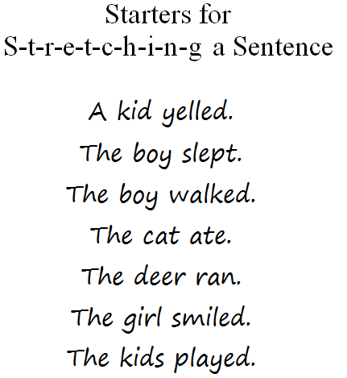
Learning Intention and Success Criteria
We are learning to write interesting sentences.
I will be successful if…
I am able to put detail in my sentences.

Focus: Adding Detail
Use a slinky to take a simple sentence and stretch to add detail
Who? Did what? When? Where? Why? How?
Use a combination of above (not necessarily all)
Experiment with changing the sentence order around.
Use ‘Starters for Stretching a Sentence’ for students to practise their own 3-5 examples

REFLECTION | ASSESSMENT
Revisit success criteria and use the  ‘Where Am I At with My Learning?’  poster: | We are looking for...  - Detail included in each sentence the student stretches.

SESSION 6
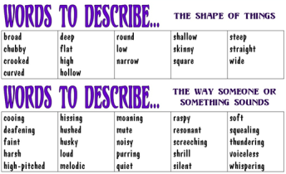
Tuning In:

Video: https://www.youtube.com/watch?v=A4XZDyxJ23Q

Song: All About That Adjective

Learning Intention and Success Criteria
We are learning to write interesting sentences.
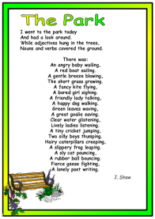
I will be successful if…
- I am able to put detail in my sentences.
- I am able to identify and use adjectives.
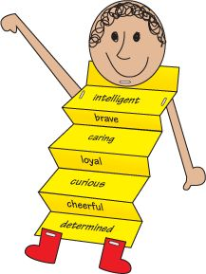
Focus: Adjectives
(Display ‘Words to Describe’ posters)
Poem: ‘The Park’
Powerpoint: Adjectives 2018
Give a selection of simple sentences. Students choose 3-5 to expand and enrich with adjectives.
Make a stick figure person with a concertina fold body on which the students write words to describe themselves – use posters for help with words.

REFLECTION | ASSESSMENT
Sharing exemplar student work. | We are looking for...  - Students’ stick figures to include well-chosen adjectives

SESSION 7
Tuning In:
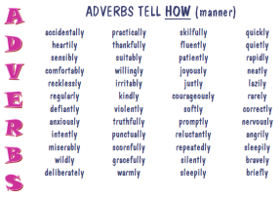
Game: Everybody stands. If a noun is called – don’t move. If a verb is called – sit. (or dab, or do a superman pose)

Learning Intention and Success Criteria
We are learning to write interesting sentences.
I will be successful if…
- I am able to put detail in my sentences.
I am able to identify and use adverbs.

Focus: Adverbs
(Display ‘Adverbs’ posters)
Powerpoint: Adverbs 2018
Give a selection of simple sentences. Students choose 3-5 to expand and enrich with adverbs.
(Use the stretching sentences poster to assist).

REFLECTION | ASSESSMENT
How have you been successful?  What might someone else find hard? How would you help them?  Who’d like a study buddy to help them finish? | We are looking for...  - Students write detailed sentences including an adverb.

SESSION 8
Tuning In:
Game: ‘Mixed Up Sentences’ students take a word each on individual slips and reorganize themselves to make a sentence.
Kate has a big brother .
Caitlyn likes music .
Andrei reads books.
Miss Costa plays the guitar.
Hudson kicks the ball .
After school we are going to the beach.
I usually have a yummy banana every day
Revise previous lesson’s work by identifying subject and verb in each sentence.

Learning Intention and Success Criteria
We are learning to write interesting sentences.
I will be successful if…
- I am able to write simple and complex sentences.
- I am able to identify and use connectives (conjunctions).

Focus: Compound and Complex Sentences
‘Sentence to Paragraphs’ Scans Unit 9 ‘Joining Sentences’ Teach with examples.
Exercise A orally
Exercise C orally
Exercise D orally
‘Sentence to Paragraphs’ Scans Unit 10 ‘More Ways of Joining Sentences’ Teach with examples.
Exercise B orally
Exercise C orally
Exercise D orally
Students write 2 of their own

REFLECTION | ASSESSMENT
Students use ‘Looking at My Learning’ posters to make statements about what they’ve achieved.  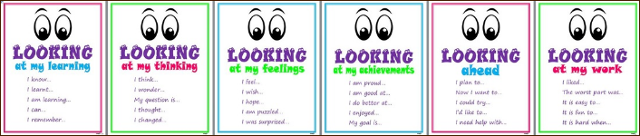 | We are looking for...  - Students accurately writing sentences (check individual sentences)

SESSION 9
Tuning In:

Video: Student requests from unit

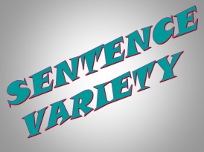
Learning Intention and Success Criteria
We are learning to write interesting sentences.
I will be successful if…
- I am able to begin sentences in a variety of ways.

Focus: Sentence Variety
Powerpoint: ‘Sentence Variety’ – Count the words in each sentence in the first 3 slides and compare. Discuss how varying sentence length is a simple way to make writing interesting Move on to the variety of ways to begin sentences differently and invite students to practise using these ‘tricks’
Students write 2-5 sentences showing some of these ‘tricks’ – individually or with a partner. This may take a few sessions of practise.

REFLECTION | ASSESSMENT
Revisit today’s success criteria. | We are looking for...  - Students showing sentence variety in their own writing

Post Assessment
Choose a topic and write around 50 words about this topic.
Your teachers are looking to see if:
I am able to correctly identify what’s in a sentence and use this to write my own sentences.
I am able to put detail in my sentences.
I am able to use interesting words in my sentences.
I am able to write simple and complex sentences.
I am able to begin sentences in a variety of ways.

